**DATABASE SYSTEM AND APPLICATION(CS7594)**

**MINI PROJECT**

**ORGAN DONATION MANAGEMENT SYSTEM**

**SUBMITTED TO**

Mrs.R.S Rampriya

* JM Karthikeyan

2018506049

B.Tech IT

**TOPIC:**

ORGAN DONATION AND TRANSPLANT MANAGEMENT SYSTEM

**AIM:**

To create a solution that effectively deals with the problems of finding donors and also providing statistical data of the transplants that can help the government to form better rules and regulations.

**OBJECTIVE AND DESCRIPTION:**

**Organ transplantation** is a medical procedure in which an organ is removed from one body and placed in the body of a recipient, to replace a damaged or missing organ. The donor and recipient may be at the same location, or organs may be transported from a donor site to another location.

Organ Donation and Procurement Organizations play a pivotal role in today’s medical institutions. Such organizations are responsible for the evaluation and procurement of organs for organ transplantation. These organizations represent the front-line of organ procurement, having direct contacts with the hospital and the family of a recently deceased donor. The work of such organizations includes to identify the best candidates for the available organs and to coordinate with the medical institutions to decide on each organ recipient. They are also responsible for educating the public to increase the awareness of and participation in the organ donation process. Also, it keeps track of all transplantation operations carried till date.

The Organ Donation and Transplantation Management System is a database management system that uses database technology to construct, maintain and manipulate various kinds of data about a person’s donation or procurement of a particular organ. It maintains a comprehensive medical history and other critical information like blood group, age, etc of every person in the database design. In short, it maintains a database containing statistical information regarding network of organ donation and procurement of different countries.

**Organ Wastage** is a major issue that can only be solved by having a proper database of all Patient and Donors in a well-formed way, that can be processed easily.

Records of donor and patients are created when a person donates or procures an organ from a Medical Institution. Records may include the following information Personal Information, Medical History, Medical insurance, if any, Allergies to any medicine, if any, the need for an organ presently, Medical Insurance provided by any private or government insurers., Address.

This record serves a variety of purposes and is critical to the proper functioning of Organ Donation and Transplantation Network, especially in today’s complicated health care environment. These records provide statistical information regarding the number of organs needed and available at a particular point of time. It is essential for planning, evaluating and coordinating organ donation and procurement.

**IDEA FOR IMPLEMENTATION:**

• Every user has an account with can only be registered by a government certified hospital, which will keep all the information.

• Only Hospitals are eligible to request for a donation or procurement transaction.

• Government organizations will keep a watch on the pairing of donors and Patients and can approve a transplantation operation if all the rules are satisfied.

• Collecting Statistical Data through the history of Transplantation Transaction.

**ER DIAGRAM:**

**ENTITY SETS:**

**User**

* User ID (primary key)
* Name
* Date of birth
* Phone Number (multi-valued attribute)
* Medical Insurance
* Medical History
* Address

**Patient**

* Patient_ID (primary key)
* Organ Required
* Reason of procurement
* User_ID ( foreign key)

**Donor**

* Donor_ID (primary key)
* Organ Donated
* Reason of donation
* User_ID (foreign key)

**Organ Available**

* Organ_ID (primary key)
* Organ Name
* Donor_ID (foreign key)

**Organization**

* Organization ID (primary key)
* Organization Name
* Location
* Government approved organization or not
* Phone Number (multi-valued)

**Doctor**

* Doctor ID (primary key)
* Doctor Name
* Phone Number (multi-valued)

**Organization Head**

* Head Name
* Date of Joining
* Term Length

**RELATIONSHIP SETS:**

1. **Donates** – The act of donation of an organ from a donor

* Date – Date of donation

2. **Procures** - The act of procuring an organ by the patient.

3. **Transaction**

* Date of transaction
* Status – whether the surgery was successful or not

4**. Organ Donated** -The organ donated by an donor, which is then stored in Organ_available table.

5. **Attended By** -The transplantation performed by doctor – procuring an organ from a donor and transplanting it to the patient by surgery.

6. **Registers** - Donor is registered in which organization.

7. **Works in** – The organization where the doctor works.

8. **Headed By** – The organization is headed by which person.

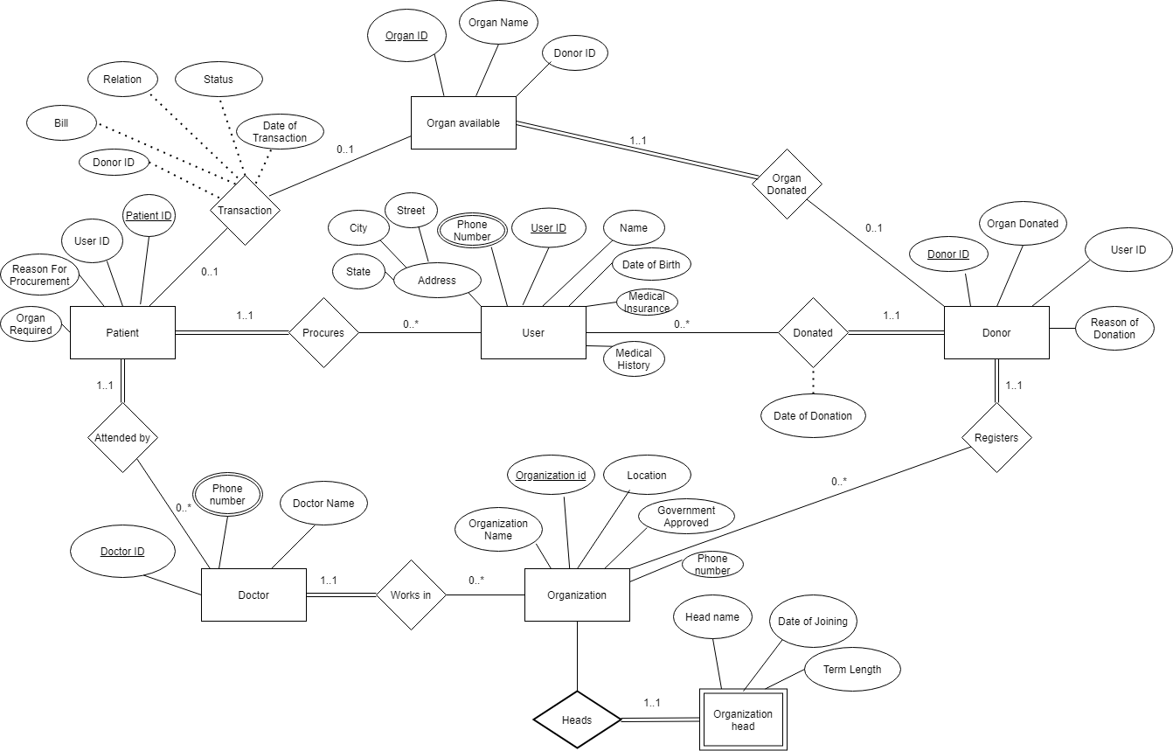

ER DIAGRAM

**Entity Sets:**

**1.User**

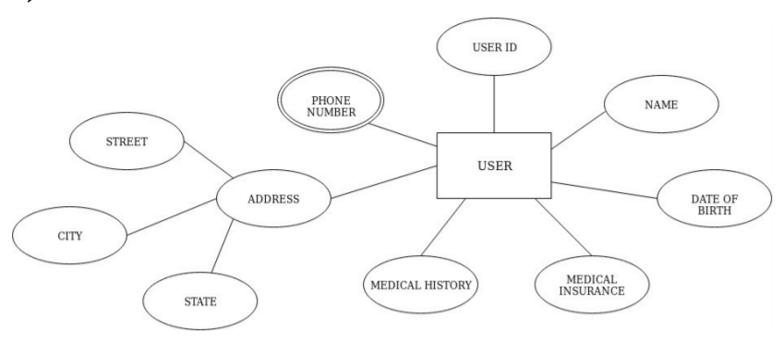

**2. Donor**

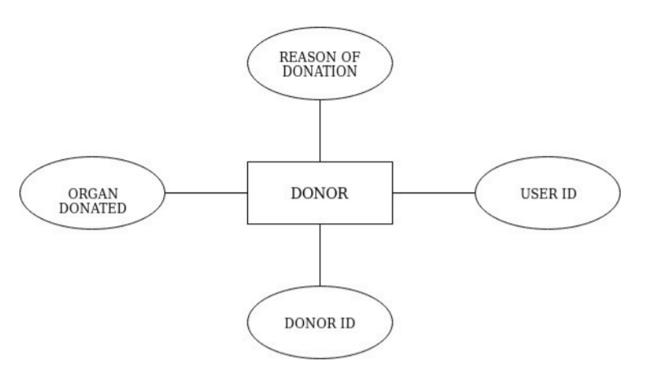

**3. Patient**

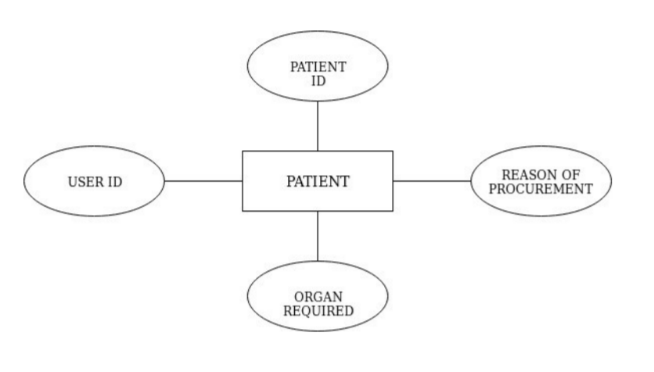

**4. Organization**

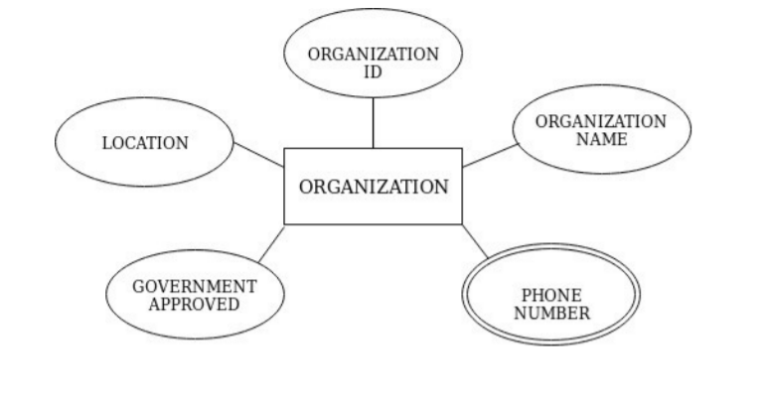

**5. Doctor**

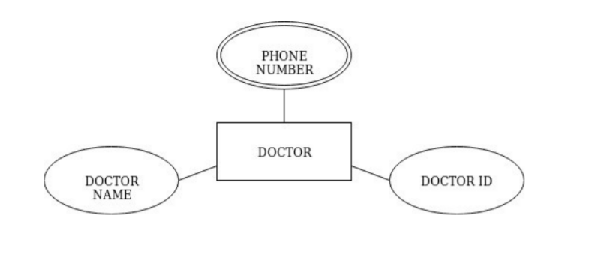

**6. Organization Head**

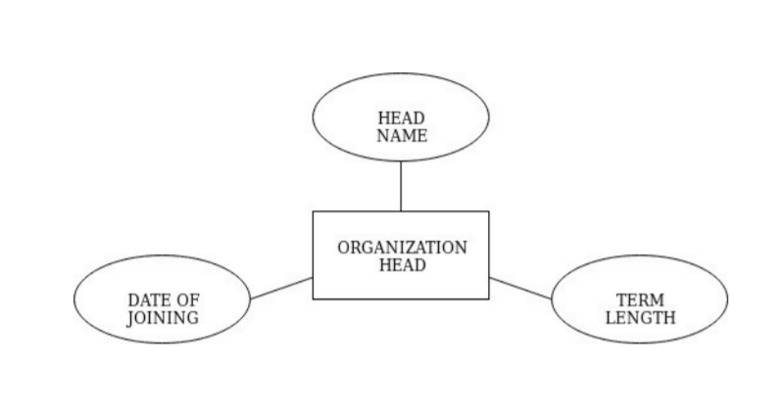

**7. Organ available**

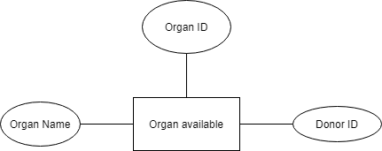

**RELATIONS AND FUNCTIONAL DEPENDENCIES:**

1) **User**(User_ID, Name, Date _of_birth, Medical_Insurance, Medical_History, Street, City, State)

**FD**={User_ID → Name, Date _of_birth, Medical Insurance, Medical History, Street, City, State}

2) **User_phone_no**(User_ID, phone_no)

**FD**={User_ID -> phone_no} {User_ID} is foreign key constraint

3) **Patient**(Patient_ID, organ_req, reason_of_procurement, Doctor_ID, User_ID)

**FD**={Patient_ID, organ_req -> reason_of_procurement, Doctor_ID, User_ID} {User_ID, Doctor_ID} are foreign key constraints

4) **Donor**(Donor_ID, organ_donated, reason_of_donation, Organization_ID, User_ID)

**FD**={Donor_ID, organ_donated -> reason_of_donation, Organization_ID, User_ID} {User_ID, Organization_ID} are foreign key constraints

5) **Organ** Available(Organ_ID,Organ_name, Donor_ID)

**FD**={Organ_ID -> Organ_name,Donor_ID} {Donor_ID} is foreign key constraint

6) **Transaction**(Patient_ID, Organ_ID, Donor_ID, Date_of_transaction, Status) **FD**={Patient_ID, Organ_ID -> Donor_ID,Date_of_transaction, Status} {Patient_ID, Donor_ID} are foreign key constraints

7) **Organization**(Organization_ID, Organization_name, Location, Government_approved)

**FD**={Organization_ID -> Organization_name, Location, Government_approved}

8) **Organization_phone_no**(Organization_ID, phone_no)

**FD**={Organization_ID -> phone_no} {Organization_ID} are foreign key constraints

9) **Doctor**(Doctor_ID, Doctor_name, Department_name, Organization_id) **FD**={Doctor_ID -> Doctor_name, Organization_id} {Organization_ID} is foreign key constraint

10) **Doctor_phone_no**(Doctor_ID, phone_no)

**FD**={Doctor_ID -> phone_no} {Doctor_ID} is foreign key constraint

11) **Organization_head**(Organization_ID, Employee_ID, Name, Date_of_joining, Term_length)

**FD**={Organization_ID, Employee_ID -> Name, Date_of_joining, Term_length}

**IMPLEMENTATION OF TABLES:**

**Database Creation:**

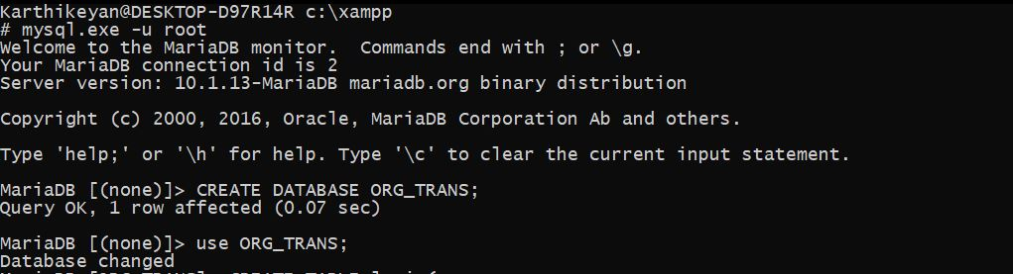

**Login**

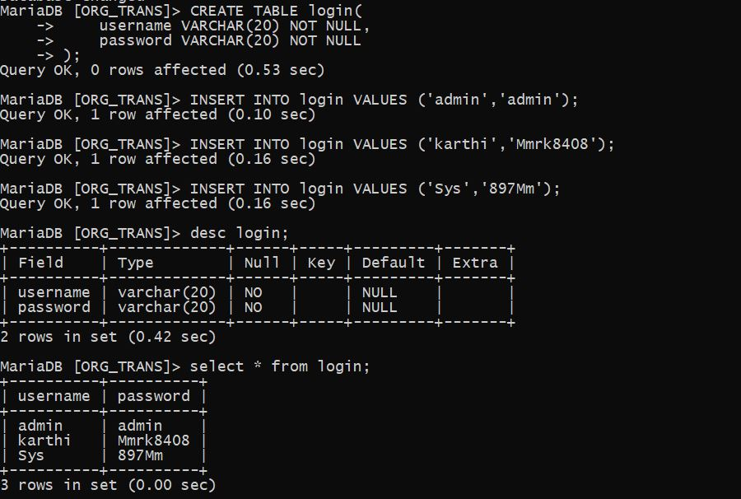

**User**

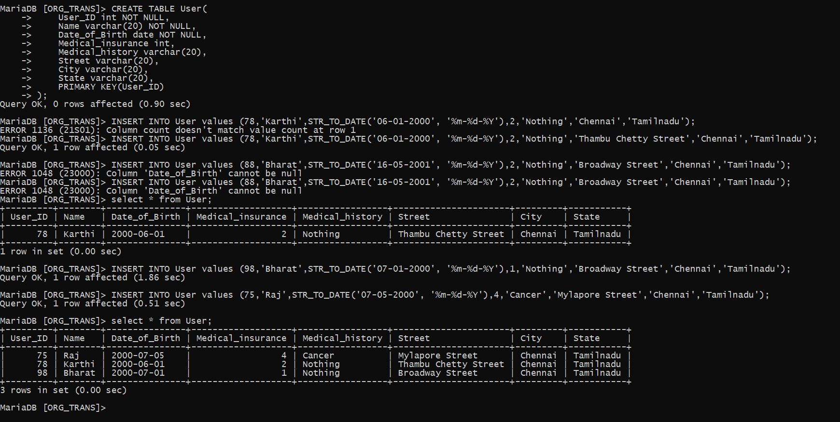

**User_phone_no**

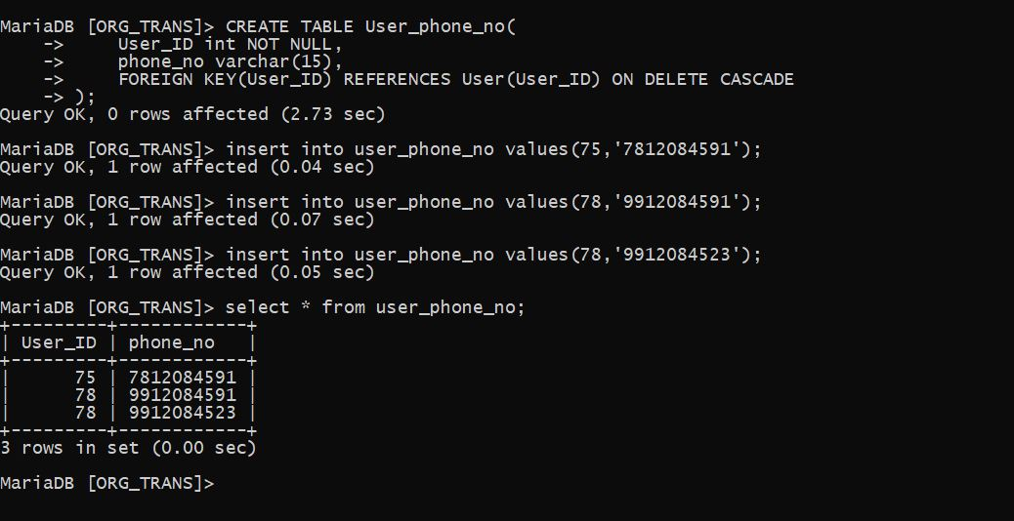

**Organization**

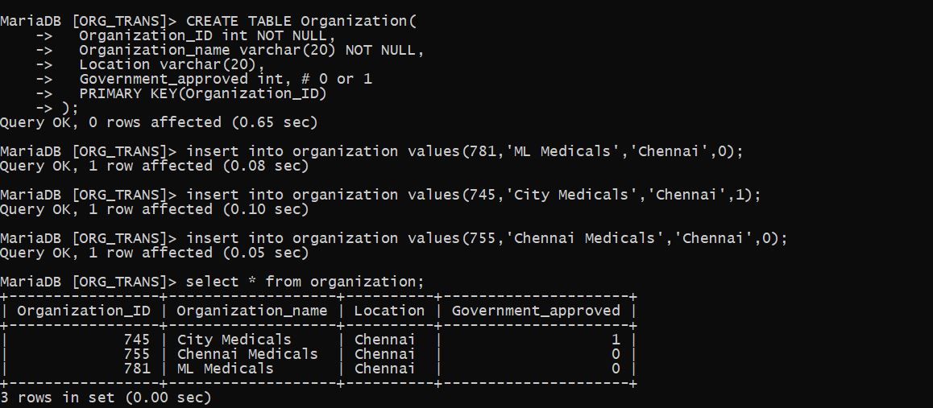

**Doctor**

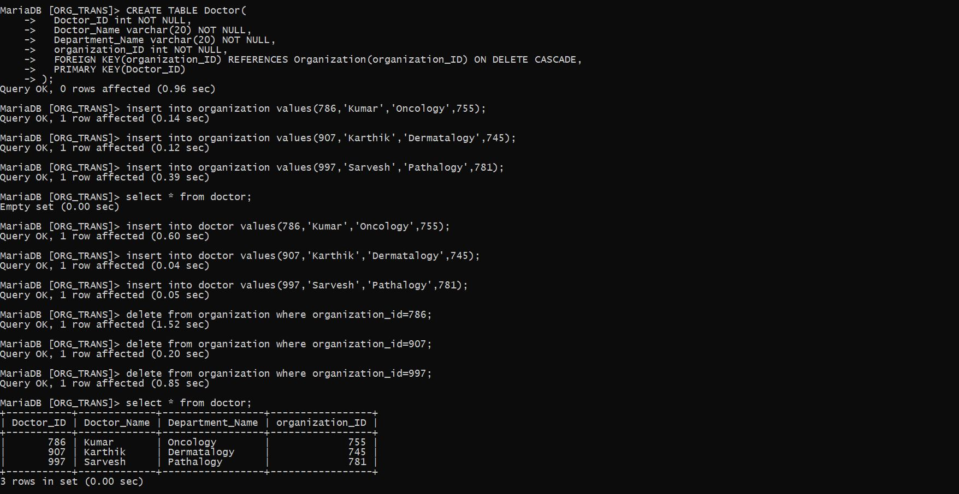

**Patient**

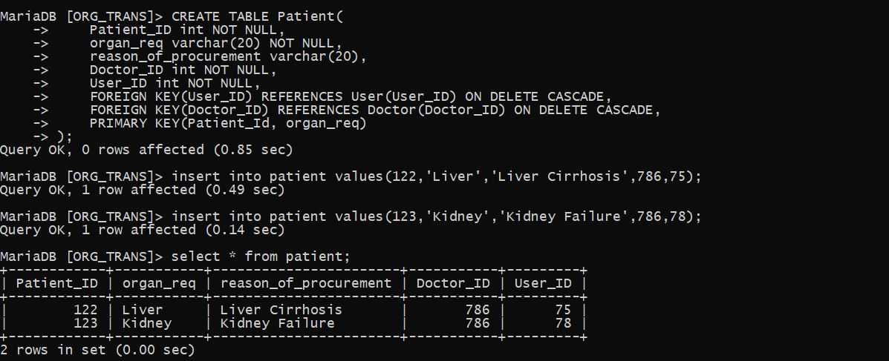

**Donor**

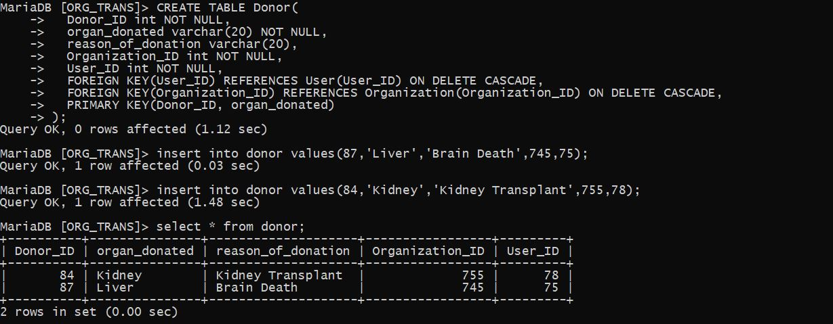

**Organ_available**

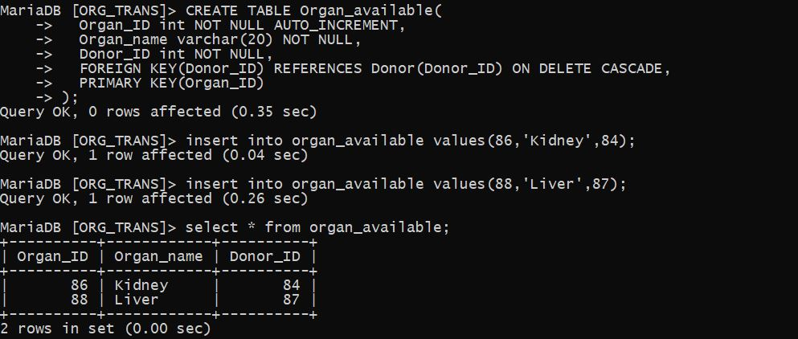

**Transaction**

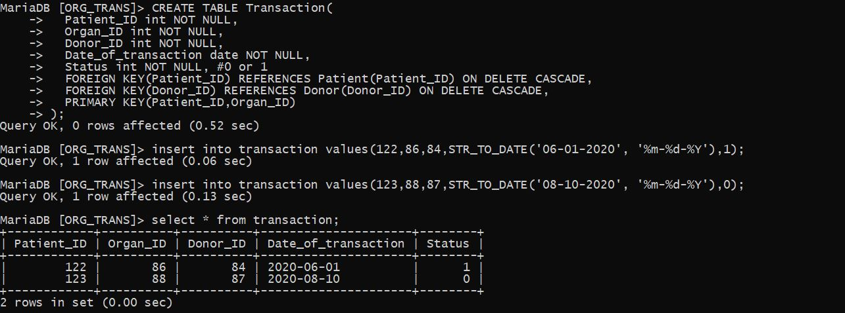

**Organization_phone_no**

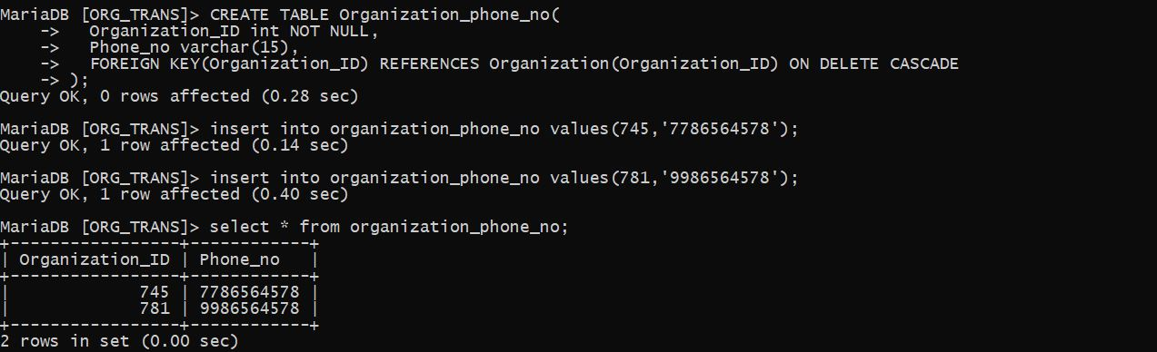

**Doctor_phone_no**

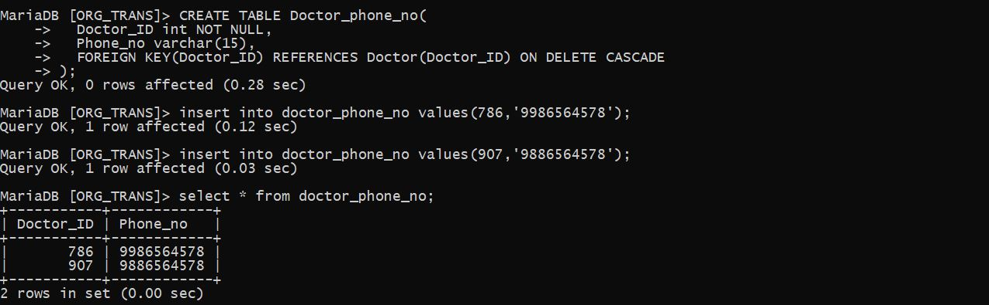

**Organization_head**

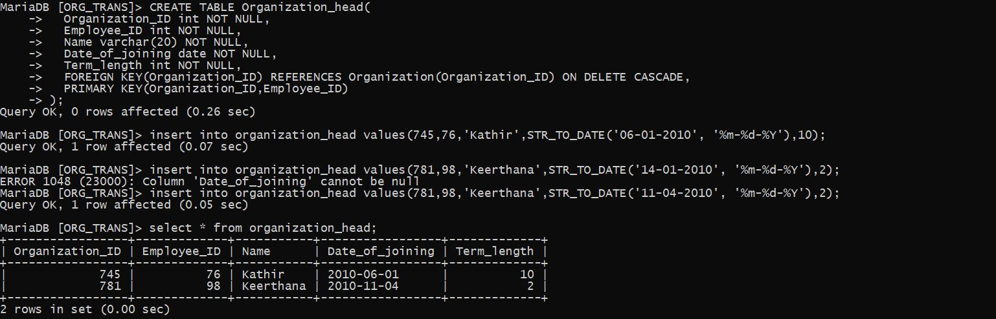

**Implementation**

Here we see the implementation of the project that we have designed before with ER diagram. Here we implement the project as a web application connecting the web application(front-end) to the backend database and server.

**TECHNOLOGY STACK:**

* MySQL version 8
* HTML 5
* Python
* Flask Framework
* CSS+BOOTSTRAP
* JavaScript

**DESCRIPTION:**

* **MySQL**- creating database with tables, values and triggers.
* **HTML, CSS, BOOTSTRAP, JAVASCRIPT** – for creating the template webpages for interacting with the database created.
* **Python, Flask** – for creating the backend with routing the webpages and to connect with the database for interaction with the application created.

**Implementation and Source Code:**

**Database:**

For creating database, tables and triggers I used MySQL workbench 8.0 editor which is a user-friendly GUI based approach in place of MySQL terminal shell.

**1.Creating database:**

CREATE DATABASE Organ_Transplant;

USE Organ_Transplant;

**Output:**

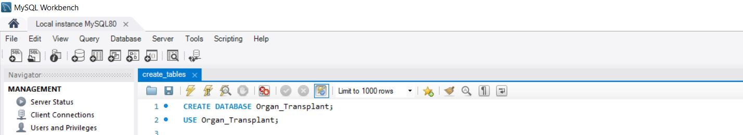

**2.Creating Tables in the database:**

**Login:**

CREATE TABLE login(

username VARCHAR(30) NOT NULL,

password VARCHAR(20) NOT NULL

);

OUTPUT:

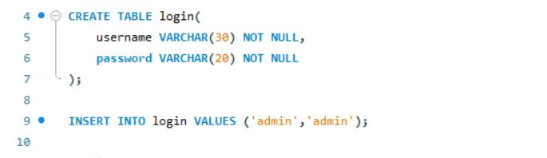

**User:**

CREATE TABLE User(

User_ID int NOT NULL,

Name varchar(30) NOT NULL,

Date_of_Birth date NOT NULL,

Medical_insurance int,

Medical_history varchar(50),

Street varchar(100),

City varchar(30),

State varchar(30),

PRIMARY KEY(User_ID)

);

OUTPUT:

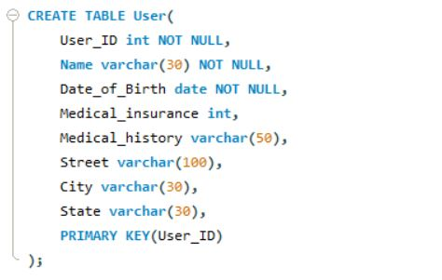

**User phone number:**

CREATE TABLE User_phone_no(

User_ID int NOT NULL,

phone_no varchar(15),

FOREIGN KEY(User_ID) REFERENCES User(User_ID) ON DELETE CASCADE

);

OUTPUT;

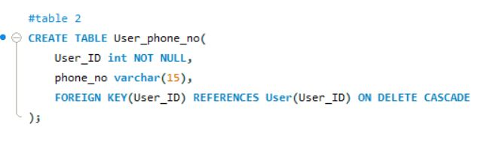

**Organization:**

CREATE TABLE Organization(

Organization_ID int NOT NULL,

Organization_name varchar(30) NOT NULL,

Location varchar(40),

Government_approved int, # 0 or 1

PRIMARY KEY(Organization_ID)

);

OUTPUT:

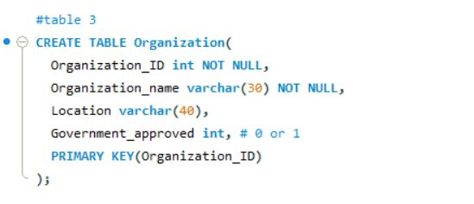

**Doctor:**

CREATE TABLE Doctor(

Doctor_ID int NOT NULL,

Doctor_Name varchar(30) NOT NULL,

Department_Name varchar(30) NOT NULL,

organization_ID int NOT NULL,

FOREIGN KEY(organization_ID) REFERENCES Organization(organization_ID) ON DELETE CASCADE,

PRIMARY KEY(Doctor_ID)

);

OUTPUT:

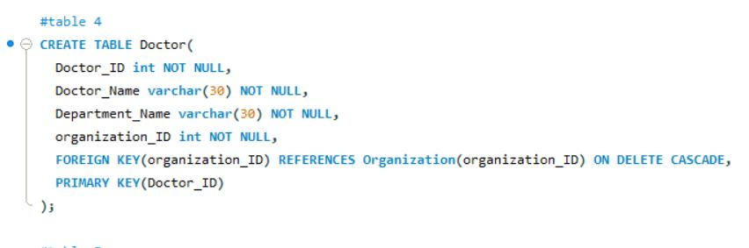

**Patient:**

CREATE TABLE Patient(

Patient_ID int NOT NULL,

organ_req varchar(40) NOT NULL,

reason_of_procurement varchar(100),

Doctor_ID int NOT NULL,

User_ID int NOT NULL,

FOREIGN KEY(User_ID) REFERENCES User(User_ID) ON DELETE CASCADE,

FOREIGN KEY(Doctor_ID) REFERENCES Doctor(Doctor_ID) ON DELETE CASCADE,

PRIMARY KEY(Patient_Id, organ_req)

);

OUTPUT:

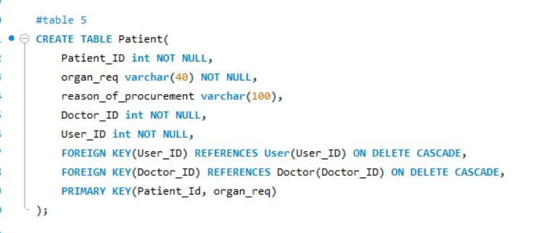

**Donor:**

CREATE TABLE Donor(

Donor_ID int NOT NULL,

organ_donated varchar(40) NOT NULL,

reason_of_donation varchar(100),

Organization_ID int NOT NULL,

User_ID int NOT NULL,

FOREIGN KEY(User_ID) REFERENCES User(User_ID) ON DELETE CASCADE,

FOREIGN KEY(Organization_ID) REFERENCES Organization(Organization_ID) ON DELETE CASCADE,

PRIMARY KEY(Donor_ID, organ_donated)

);

OUTPUT:

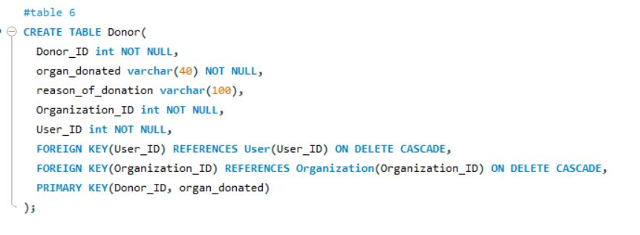

**Organ Available:**

CREATE TABLE Organ_available(

Organ_ID int NOT NULL AUTO_INCREMENT,

Organ_name varchar(50) NOT NULL,

Donor_ID int NOT NULL,

FOREIGN KEY(Donor_ID) REFERENCES Donor(Donor_ID) ON DELETE CASCADE,

PRIMARY KEY(Organ_ID));

OUTPUT:

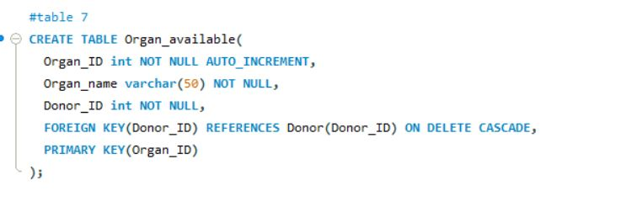

**Transaction:**

CREATE TABLE Transaction(

Patient_ID int NOT NULL,

Organ_ID int NOT NULL,

Donor_ID int NOT NULL,

Date_of_transaction date NOT NULL,

Status int NOT NULL, #0 or 1

FOREIGN KEY(Patient_ID) REFERENCES Patient(Patient_ID) ON DELETE CASCADE,

FOREIGN KEY(Donor_ID) REFERENCES Donor(Donor_ID) ON DELETE CASCADE,

PRIMARY KEY(Patient_ID,Organ_ID)

);

OUTPUT:

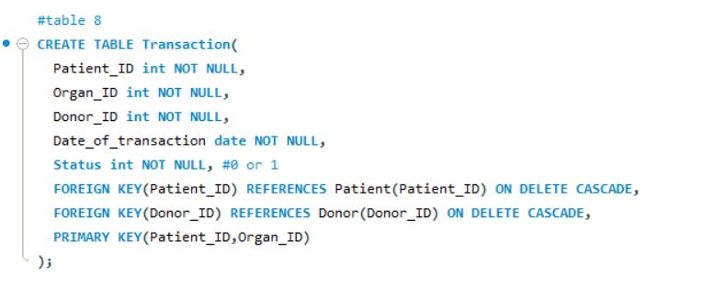

**Organization phone number:**

CREATE TABLE Organization_phone_no(

Organization_ID int NOT NULL,

Phone_no varchar(15),

FOREIGN KEY(Organization_ID) REFERENCES Organization(Organization_ID) ON DELETE CASCADE

);

OUTPUT:

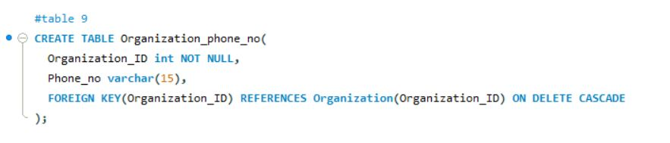

**Doctor phone number:**

CREATE TABLE Doctor_phone_no(

Doctor_ID int NOT NULL,

Phone_no varchar(15),

FOREIGN KEY(Doctor_ID) REFERENCES Doctor(Doctor_ID) ON DELETE CASCADE

);

OUTPUT:

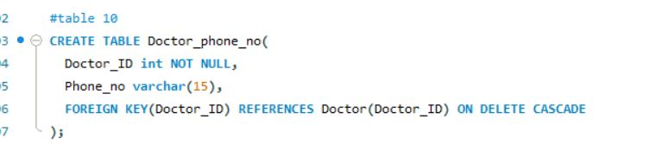

**Organization Head:**

CREATE TABLE Organization_head(

Organization_ID int NOT NULL,

Employee_ID int NOT NULL,

Name varchar(20) NOT NULL,

Date_of_joining date NOT NULL,

Term_length int NOT NULL,

FOREIGN KEY(Organization_ID) REFERENCES Organization(Organization_ID) ON DELETE CASCADE,

PRIMARY KEY(Organization_ID,Employee_ID)

);

OUTPUT:

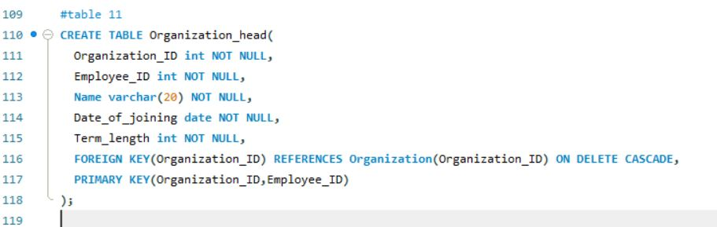

**Log:**

create table log (

querytime datetime,

comment varchar(255)

);

OUTPUT:

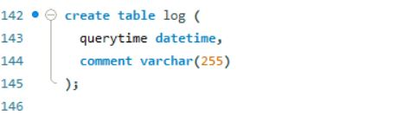

**3.TRIGGERS:**

**Add Donor Log:**

delimiter //

create trigger ADD_DONOR_LOG

after insert

on Donor

for each row

begin

insert into log values

(now(), concat("Inserted new Donor", cast(new.Donor_Id as char)));

end //

OUTPUT:

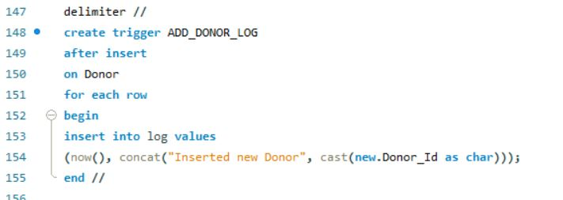

**Update Donor Log:**

create trigger UPD_DONOR_LOG

after update

on Donor

for each row

begin

insert into log values

(now(), concat("Updated Donor Details", cast(new.Donor_Id as char)));

end //

OUTPUT:

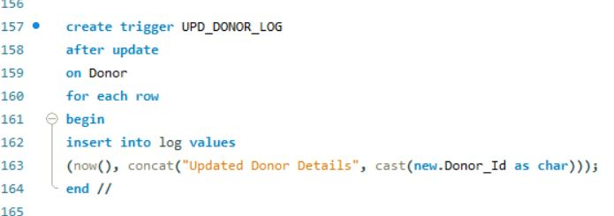

**Delete Donor Log:**

delimiter //

create trigger DEL_DONOR_LOG

after delete

on Donor

for each row

begin

insert into log values

(now(), concat("Deleted Donor ", cast(old.Donor_Id as char)));

end //

OUTPUT:

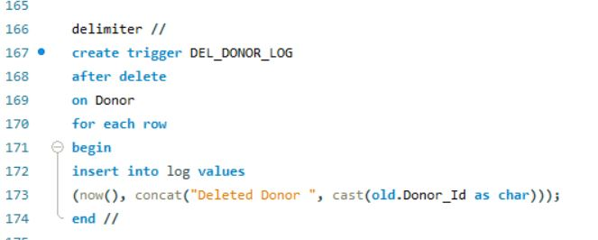

**Add Patient Log:**

create trigger ADD_PATIENT_LOG

after insert

on Patient

for each row

begin

insert into log values

(now(), concat("Inserted new Patient ", cast(new.Patient_Id as char)));

end //

OUTPUT:

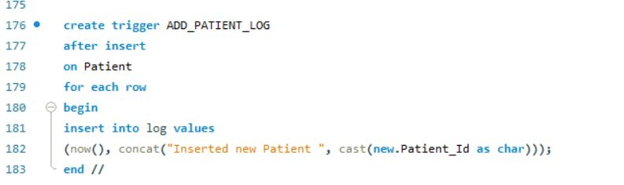

**Update Patient Log:**

create trigger UPD_PATIENT_LOG

after update

on Patient

for each row

begin

insert into log values

(now(), concat("Updated Patient Details ", cast(new.Patient_Id as char)));

end //

OUTPUT:  
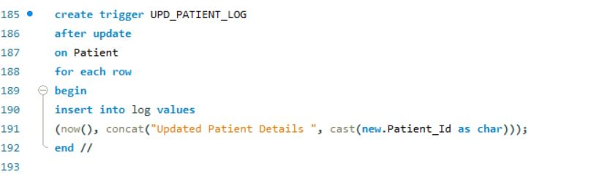

**Delete Patient Log:**

create trigger DEL_PATIENT_LOG

after delete

on Donor

for each row

begin

insert into log values

(now(), concat("Deleted Patient ", cast(old.Donor_Id as char)));

end //

OUTPUT:

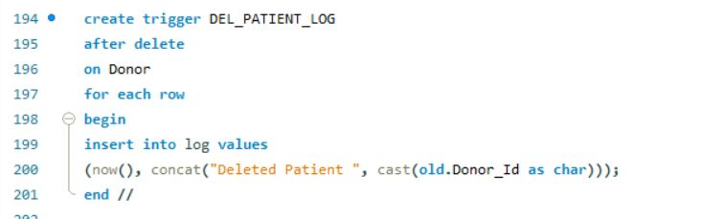

**Add Transaction Log:**

create trigger ADD_TRASACTION_LOG

after insert

on Transaction

for each row

begin

insert into log values

(now(), concat("Added Transaction :: Patient ID : ", cast(new.Patient_ID as char), "; Donor ID : " ,cast(new.Donor_ID as char)));

end //

OUTPUT:  
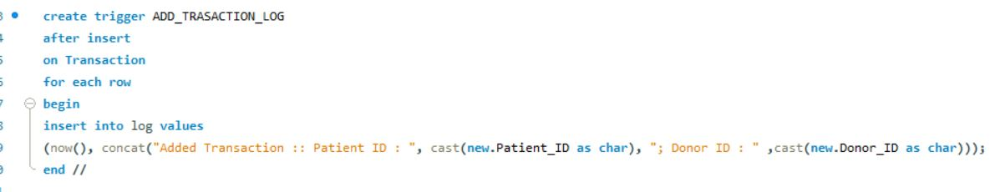

**4.INSERTING VALUES:**

**User:**

insert into user values(1,'Karthi','2000-12-08',1,'NIL','313,Thambu Chetty Street','Chennai','TamilNadu');

insert into user values(2,'Kiran','2001-11-22',0,'NIL','32,Mount Road Street','Chennai','TamilNadu');

OUTPUT:

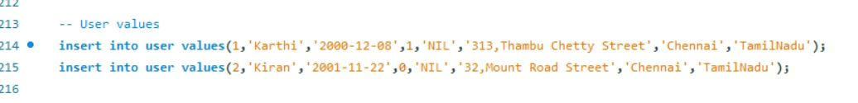

**User phone numbers:**

insert into User_phone_no values (1,'8939212290');

insert into User_phone_no values (2,'9939212295');

OUTPUT:

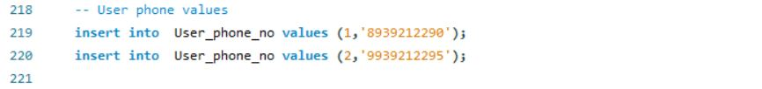

**Organization:**

insert into Organization values(1, 'New World','New Delhi',1);

insert into Organization values(2, 'Heritage','Chennai',0);

OUTPUT:



**Doctor:**

insert into doctor values(1,'Suresh','Oncology',1);

insert into doctor values(2,'Ganesh','Dermatology',2);

OUTPUT:



**Patient:**

insert into patient values(1,'Kidney','Needed for transplant surgery',1,2);

insert into patient values(2,'Heart','Since needed for transplant ',2,1);

OUTPUT:



**Donor:**

insert into donor values(1,'Heart','Brain death',2,1);

insert into donor values(2,'Kidney','Brain death',1,2);

OUTPUT:



**Organ Available:**

insert into organ_available values(1,'Heart',1);

insert into organ_available values(2,'Kidney',2);

OUTPUT:



**Transaction:**

insert into Transaction values(1,2,2,'2014-9-19',1);

insert into Transaction values(2,1,1,'2018-9-19',0);

OUTPUT:

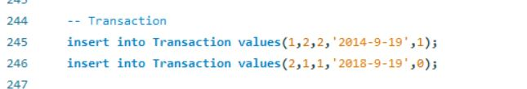

**Organization Phone number:**

insert into Organization_phone_no values(1,'7389002810');

insert into Organization_phone_no values(2,'7389452810');

OUTPUT:

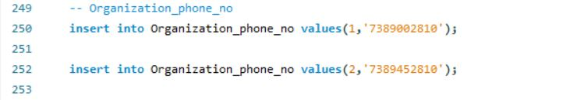

**Doctor Phone number:**

insert into Doctor_phone_no values(1,'8898201238');

insert into Doctor_phone_no values(2,'9898201234');

OUTPUT:



**Organization head:**

insert into Organization_head values(1,1,'Sainath','2000-12-08',19);

insert into Organization_head values(2,2,'Kavin','2010-12-08',5);

OUTPUT:



**Login:**

INSERT INTO login VALUES ('admin','admin');

INSERT INTO login VALUES ('Karthi','1245');

Insert into login values('Keyan','Jm08');

OUTPUT:

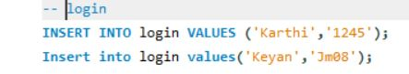

**5.Tables:**

select * from Organization_head;

select * from User;

select * from Doctor;

select * from Patient;

select * from Donor;

select * from Organization;

select * from User_phone_no;

select * from organ_available;

select * from Organization_phone_no;

select * from Transaction ;

select * from Doctor_phone_no;

select * from login;

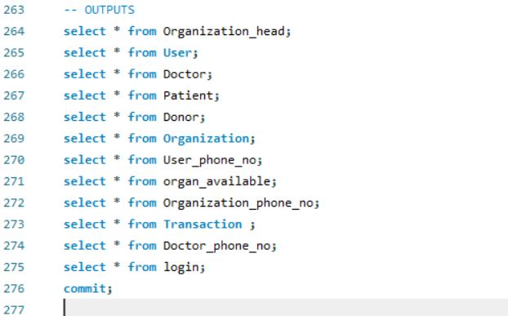

Doctor:

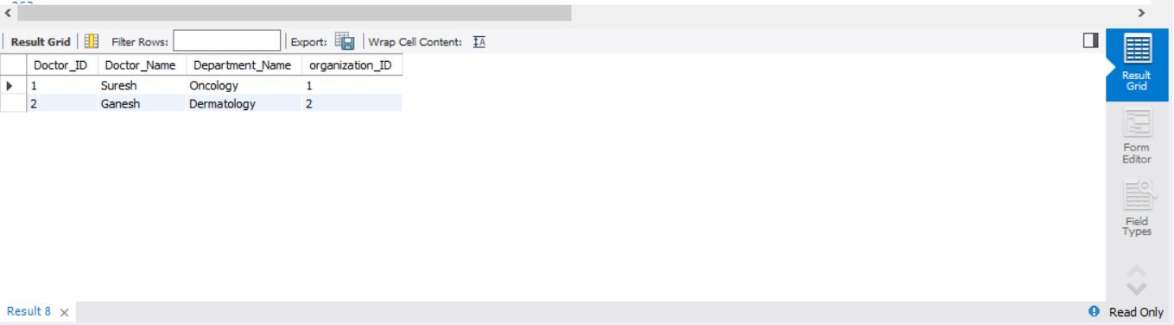

Donor:

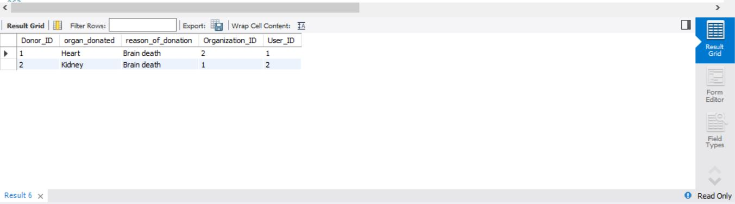

Login: 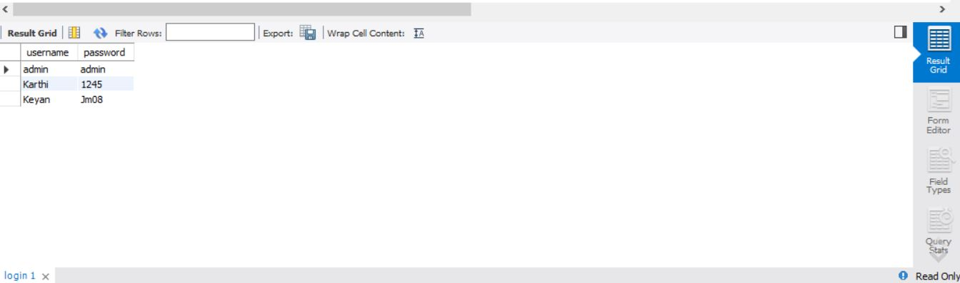

Organ Available:

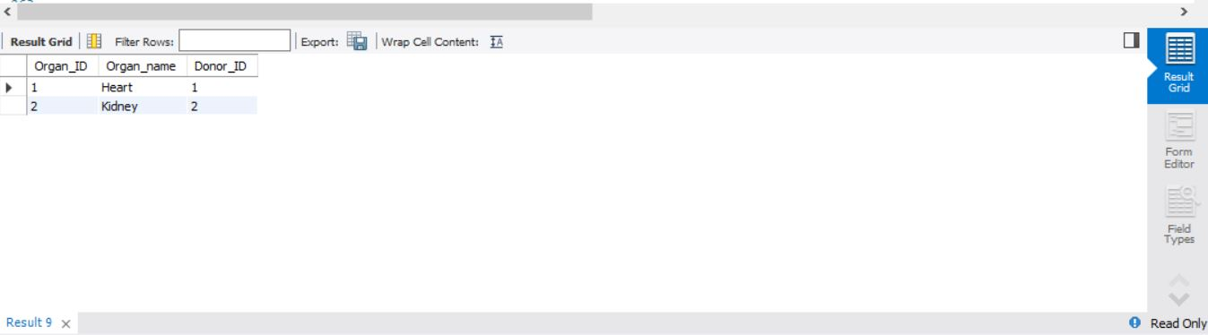

Organization head:

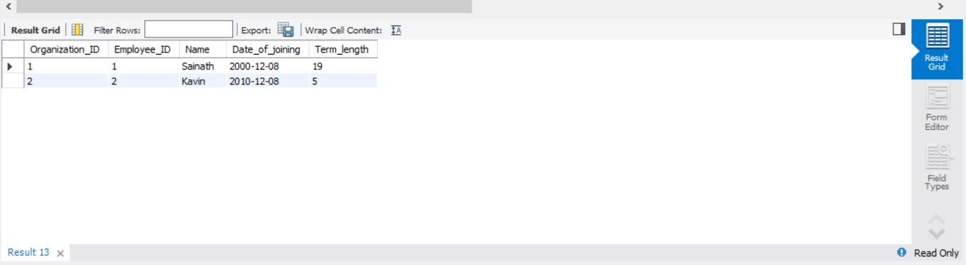

Organization phone number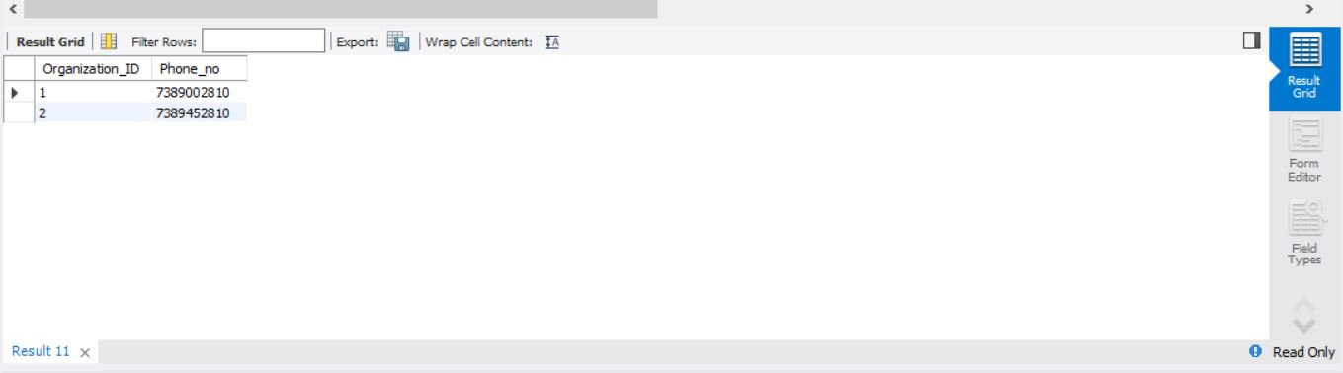

Organization:

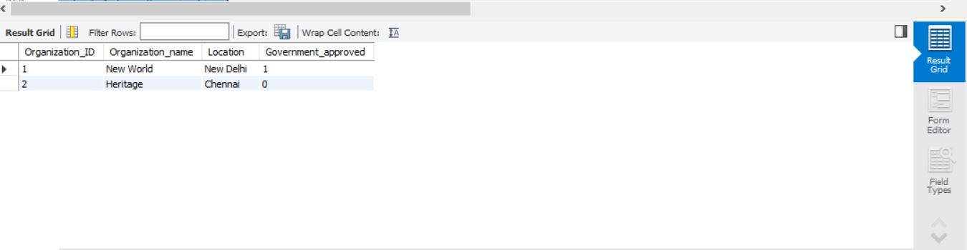

Patient:

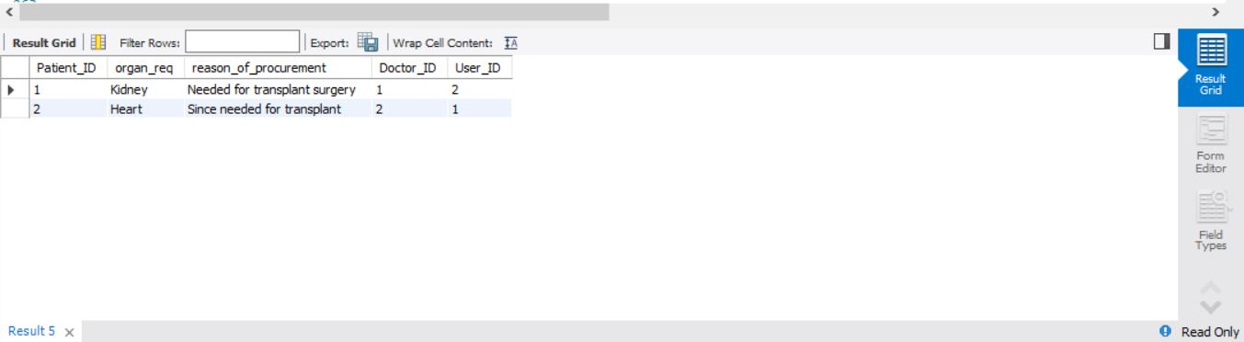

Transactions:

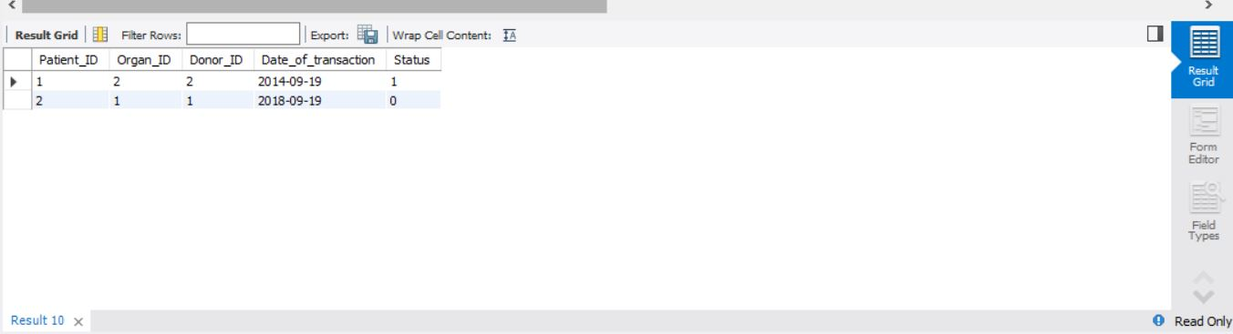

User phone number:

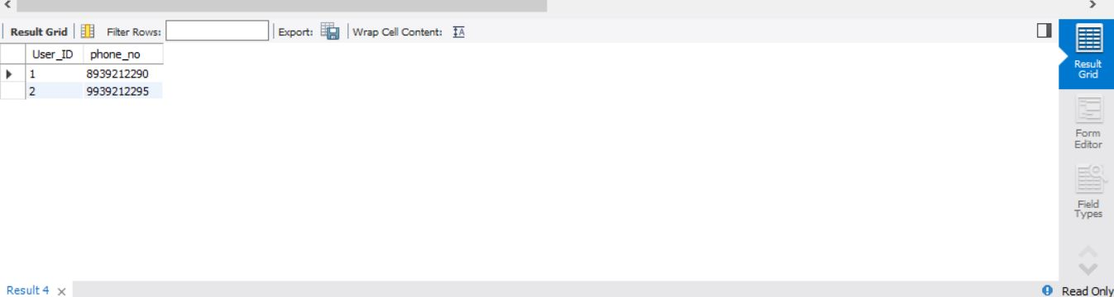

User:

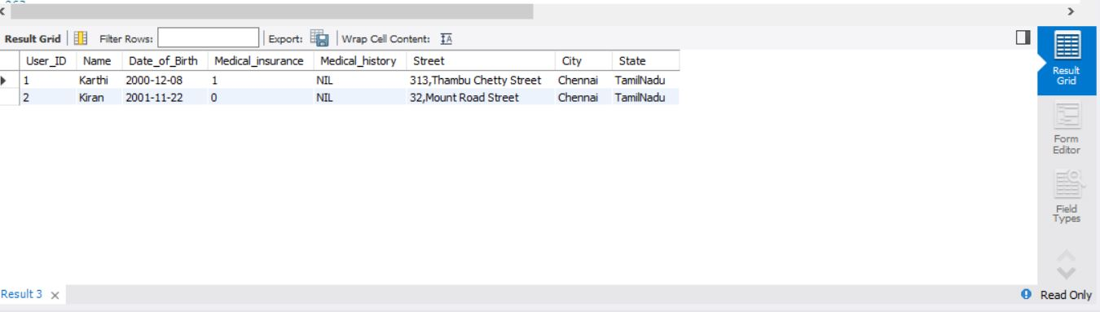

Doctor phone number:

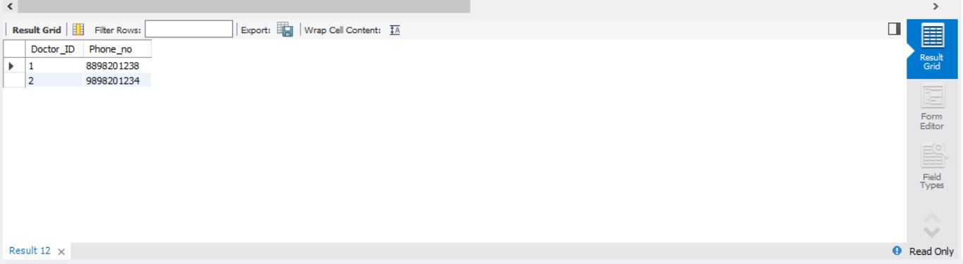

(**Note:** In this project I have used MySQL version 8 since in the previous assignment of the designing of the database I used MySQL version 5 in MariaDB using XAMPP, but I changed to this new version due to that we cannot create two triggers on same table in previous versions so I chose this version and it worked.)

**Output from MySQL Workbench Editor:**

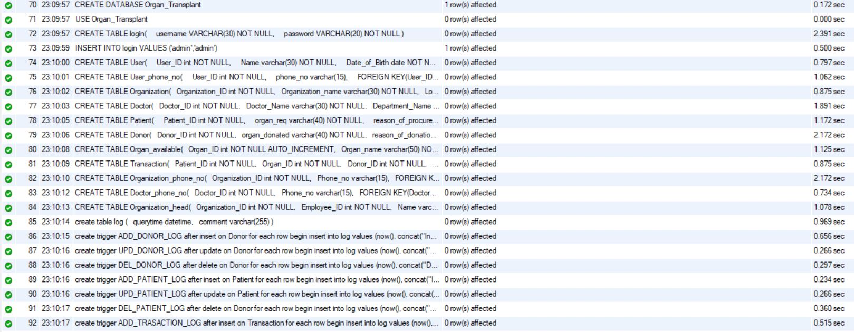

**Website:(Backend):**

In this part I used Sublime Text as my editor with cmd for running the flask web server on localhost with port 5000.Here we used python and flask framework to create the paths to the website by rendering the webpages created using html, css, bootstrap and javascript.

**Stages:**

1.Importing all the necessary packages and libraries.

2.Connecting the backend (flask) with the MySQL server with mentioning the user credentials, host and project name.

3.Create all the required paths to the web applications by rendering the webpages created using the web technology stack.

4.In main program starting an instance of this app and defining the file system and security key for encryption if needed.

5.Run the program in cmd to start the server on localhost with port 5000.

#importing all the necessary packages and libraries

from flask import Flask,render_template,session,request,redirect,url_for,flash

import mysql.connector,hashlib

import matplotlib.pyplot as plt

import numpy as np

#connection to the mysql

mydb = mysql.connector.connect(

host='localhost',

user='root',

password=’*********',#here include the password that is associated with your server

database = 'Organ_Transplant'

)

mycursor = mydb.cursor(buffered=True)

#initializing Flask app

app = Flask(__name__)

#defining the root and home pages with POST and GET methods

@app.route("/",methods = ['POST', 'GET'])

@app.route("/home",methods = ['POST','GET'])

def home():

if not session.get('login'):

return render_template('login.html'),401

else:

if session.get('isAdmin') :

return render_template('home.html',username=session.get('username'))

else :

return home_student()

#defining the login page with POST and GET methods

@app.route("/login",methods = ['GET','POST'])

def login():

if request.method=='POST' :

query = """SELECT * FROM login WHERE username = '%s'""" %(request.form['username'])

mycursor.execute(query)

res = mycursor.fetchall()

if mycursor.rowcount == 0:

return home()

if request.form['password'] != res[0][1]:

return render_template('login.html')

else:

session['login'] = True

session['username'] = request.form['username']

session['password'] = request.form['password']

session['isAdmin'] = (request.form['username']=='admin')

return home()

return render_template('login.html')

def home_student():

if request.method=='POST' :

query = """SELECT * FROM login WHERE username = '%s'""" %(request.form['username'])

mycursor.execute(query)

res = mycursor.fetchall()

if mycursor.rowcount == 0:

return home()

if request.form['password'] != res[0][1]:

return render_template('login.html')

else:

session['login'] = True

session['username'] = request.form['username']

session['password'] = request.form['password']

return render_template('home_student.html')

#defining the show_update_detail page with POST and GET method

@app.route("/show_update_detail",methods=['POST','GET'])

def show_update_detail():

if not session.get('login'):

return redirect( url_for('home') )

if request.method=='POST':

if request.form['User_ID'] =='':

return render_template("search_detail.html")

qry = "Select * from User where User.User_ID = %s" %(request.form['User_ID'])

qry1 = "Select * from User_phone_no where User_ID = %s" %(request.form['User_ID'])

mycursor.execute(qry)

not_found=False

res=()

if(mycursor.rowcount > 0):

res = mycursor.fetchone()

else:

not_found=True

fields = mycursor.column_names

qry_upd = "Select * from User where User_ID = %s" %(request.form['User_ID'])

mycursor.execute(qry_upd)

upd_res = ()

if(mycursor.rowcount > 0):

upd_res = mycursor.fetchone()

fields_upd = mycursor.column_names

mycursor.execute(qry1)

phone_no = mycursor.fetchall()

qry_pat = "select Patient_ID, organ_req, reason_of_procurement, Doctor_name from Patient inner join Doctor on Doctor.Doctor_ID = Patient.Doctor_ID and User_ID = %s" %(request.form['User_ID'])

qry_don = "select Donor_ID, organ_donated, reason_of_donation, Organization_name from Donor inner join Organization on Organization.Organization_ID = Donor.Organization_ID and User_ID = %s" %(request.form['User_ID'])

qry_trans = "select distinct Transaction.Patient_ID, Transaction.Donor_ID, Organ_ID, Date_of_transaction, Status from Transaction, Patient, Donor where (Patient.User_ID = %s and Patient.Patient_ID = Transaction.Patient_ID) or (Donor.User_Id= %s and Donor.Donor_ID = Transaction.Donor_ID)" %((request.form['User_ID']),(request.form['User_ID']))

res_pat = ()

res_dnr = ()

res_trans = ()

mycursor.execute(qry_pat)

if(mycursor.rowcount > 0):

res_pat = mycursor.fetchall()

fields_pat = mycursor.column_names

mycursor.execute(qry_don)

if(mycursor.rowcount > 0):

res_dnr = mycursor.fetchall()

fields_dnr = mycursor.column_names

mycursor.execute(qry_trans)

if(mycursor.rowcount > 0):

res_trans = mycursor.fetchall()

fields_trans = mycursor.column_names

print(res_trans)

if("show" in request.form):

return render_template('show_detail_2.html',res = res,fields = fields, not_found=not_found, phone_no = phone_no, res_dnr = res_dnr, res_pat = res_pat,res_trans = res_trans,fields_trans = fields_trans, fields_dnr = fields_dnr, fields_pat = fields_pat)

if("update" in request.form):

return render_template('update_detail.html',res = upd_res,fields = fields_upd, not_found=not_found)

if "delete" in request.form:

if not_found:

return render_template('show_detail_2.html',res = res,fields = fields, not_found=not_found, phone_no = phone_no, res_dnr = res_dnr, res_pat = res_pat,res_trans = res_trans,fields_trans = fields_trans, fields_dnr = fields_dnr, fields_pat = fields_pat)

else:

qry2 = "DELETE FROM User where User_ID = %s" %(request.form['User_ID'])

mycursor.execute(qry2)

mydb.commit()

return render_template("home.html")

#defining the search_detail page with POST and GET method

@app.route("/search_detail",methods = ['POST','GET'])

def search_detail():

if not session.get('login'):

return redirect( url_for('home') )

return render_template('search_detail.html')

#--------------Adding Information----------------------------

@app.route("/add_<id>_page",methods = ['POST','GET'])

def add_page(id):

if not session.get('login'):

return redirect( url_for('home') )

qry = "SELECT * from " + id.capitalize()

mycursor.execute(qry)

fields = mycursor.column_names

return render_template('add_page.html',success=request.args.get('success'), error=request.args.get('error'), fields = fields, id= id)

#defining the add_User page with POST and GET method

@app.route("/add_User", methods=['POST','GET'])

def add_User():

if not session.get('login'):

return redirect( url_for('home') )

qry = "SELECT * from User"

mycursor.execute(qry)

fields = mycursor.column_names

val = ()

for field in fields:

temp = request.form.get(field)

if field not in ['User_ID','Medical_insurance'] and temp != '':

temp = "\'"+temp+"\'"

if temp == '':

temp = 'NULL'

val = val + (temp,)

qry = "INSERT INTO User Values (%s,%s,%s,%s,%s,%s,%s,%s)"%val

print(qry)

success = True

error = False

try:

mycursor.execute(qry)

except:

print("Error : User not Inserted")

error = True

success = False

mydb.commit()

return redirect(url_for('add_page', id='User', error=error,success=success))

#defining the add_User_phone_no with POST and GET method

@app.route("/add_User_phone_no", methods=['POST','GET'])

def add_User_phone_no():

if not session.get('login'):

return redirect( url_for('home') )

qry = "SELECT * from User_phone_no"

mycursor.execute(qry)

fields = mycursor.column_names

val = ()

for field in fields:

temp = request.form.get(field)

if field not in ['User_ID','Phone_no'] and temp != '':

temp = "\'"+temp+"\'"

if temp == '':

temp = 'NULL'

val = val + (temp,)

qry = "INSERT INTO User_phone_no Values (%s,%s)"%val

print(qry)

success = True

error = False

try:

mycursor.execute(qry)

except:

print("Error : User not Inserted")

error = True

success = False

mydb.commit()

return redirect(url_for('add_page', id='User_phone_no', error=error,success=success))

#defining the add_Patient with POST and GET method

@app.route("/add_Patient", methods=['POST','GET'])

def add_Patient():

if not session.get('login'):

return redirect( url_for('home') )

qry = "SELECT * from Patient"

mycursor.execute(qry)

fields = mycursor.column_names

val = ()

for field in fields:

temp = request.form.get(field)

if field not in ['Patient_ID','User_ID','Doctor_ID'] and temp != '':

temp = "\'"+temp+"\'"

if temp == '':

temp = 'NULL'

val = val + (temp,)

qry = "INSERT INTO Patient Values (%s,%s,%s,%s,%s)"%val

print(qry)

success = True

error = False

try:

mycursor.execute(qry)

except:

print("Error : User not Inserted")

error = True

success = False

mydb.commit()

return redirect(url_for('add_page', id='Patient', error=error,success=success))

#defining the add_Donor with POST and GET method

@app.route("/add_Donor", methods=['POST','GET'])

def add_Donor():

if not session.get('login'):

return redirect( url_for('home') )

qry = "SELECT * from Donor"

mycursor.execute(qry)

fields = mycursor.column_names

val = ()

for field in fields:

temp = request.form.get(field)

if field not in ['Donor_ID','User_ID','Organization_ID'] and temp != '':

temp = "\'"+temp+"\'"

if temp == '':

temp = 'NULL'

val = val + (temp,)

mycursor.execute( "START TRANSACTION;" )

qry = "INSERT INTO Donor Values (%s,%s,%s,%s,%s)"%val

print(qry)

success = True

error = False

try:

mycursor.execute(qry)

except:

print("Error : User not Inserted")

error = True

success = False

qry_insert = "insert into Organ_available (Organ_name, Donor_ID) Values (%s,%s) "%(val[1],val[0])

mycursor.execute(qry_insert)

mycursor.execute("COMMIT;")

mydb.commit()

return redirect(url_for('add_page', id='Donor', error=error,success=success))

#defining the add_Doctor with POST and GET method

@app.route("/add_Doctor", methods=['POST','GET'])

def add_Doctor():

if not session.get('login'):

return redirect( url_for('home') )

qry = "SELECT * from Doctor"

mycursor.execute(qry)

fields = mycursor.column_names

val = ()

for field in fields:

temp = request.form.get(field)

if field not in ['Doctor_ID','Organization_ID'] and temp != '':

temp = "\'"+temp+"\'"

if temp == '':

temp = 'NULL'

val = val + (temp,)

qry = "INSERT INTO Doctor Values (%s,%s,%s,%s)"%val

print(qry)

success = True

error = False

try:

mycursor.execute(qry)

except:

print("Error : User not Inserted")

error = True

success = False

mydb.commit()

return redirect(url_for('add_page', id='Doctor', error=error,success=success))

#defining the add_Doctor_phone_no with POST and GET method

@app.route("/add_Doctor_phone_no", methods=['POST','GET'])

def add_Doctor_phone_no():

if not session.get('login'):

return redirect( url_for('home') )

qry = "SELECT * from Doctor_phone_no"

mycursor.execute(qry)

fields = mycursor.column_names

val = ()

for field in fields:

temp = request.form.get(field)

if field not in ['Doctor_ID','Phone_no'] and temp != '':

temp = "\'"+temp+"\'"

if temp == '':

temp = 'NULL'

val = val + (temp,)

qry = "INSERT INTO Doctor_phone_no Values (%s,%s)"%val

print(qry)

success = True

error = False

try:

mycursor.execute(qry)

except:

print("Error : User not Inserted")

error = True

success = False

mydb.commit()

return redirect(url_for('add_page', id='Doctor_phone_no', error=error,success=success))

#defining the add_Organ_available with POST and GET method

@app.route("/add_Organ_available", methods=['POST','GET'])

def add_Organ_available():

if not session.get('login'):

return redirect( url_for('home') )

qry = "SELECT * from Organ_available"

mycursor.execute(qry)

fields = mycursor.column_names

val = ()

for field in fields:

temp = request.form.get(field)

if field not in ['Organ_ID','Donor_ID'] and temp != '':

temp = "\'"+temp+"\'"

if temp == '':

temp = 'NULL'

val = val + (temp,)

qry = "INSERT INTO Organ_available Values (%s,%s,%s)"%val

print(qry)

success = True

error = False

try:

mycursor.execute(qry)

except:

print("Error : User not Inserted")

error = True

success = False

mydb.commit()

return redirect(url_for('add_page', id='Organ_available', error=error,success=success))

#defining the add_Organization with POST and GET method

@app.route("/add_Organization", methods=['POST','GET'])

def add_Organization():

if not session.get('login'):

return redirect( url_for('home') )

qry = "SELECT * from Organization"

mycursor.execute(qry)

fields = mycursor.column_names

val = ()

for field in fields:

temp = request.form.get(field)

if field not in ['Government_approved','Organization_ID'] and temp != '':

temp = "\'"+temp+"\'"

if temp == '':

temp = 'NULL'

val = val + (temp,)

qry = "INSERT INTO Organization Values (%s,%s,%s,%s)"%val

print(qry)

success = True

error = False

try:

mycursor.execute(qry)

except:

print("Error : User not Inserted")

error = True

success = False

mydb.commit()

return redirect(url_for('add_page', id='Organization', error=error,success=success))

#defining the add_Organization_phone_no with POST and GET method

@app.route("/add_Organization_phone_no", methods=['POST','GET'])

def add_Organization_phone_no():

if not session.get('login'):

return redirect( url_for('home') )

qry = "SELECT * from Organization_phone_no"

mycursor.execute(qry)

fields = mycursor.column_names

val = ()

for field in fields:

temp = request.form.get(field)

if field not in ['Organization_ID','Phone_no'] and temp != '':

temp = "\'"+temp+"\'"

if temp == '':

temp = 'NULL'

val = val + (temp,)

qry = "INSERT INTO Organization_phone_no Values (%s,%s)"%val

print(qry)

success = True

error = False

try:

mycursor.execute(qry)

except:

print("Error : User not Inserted")

error = True

success = False

mydb.commit()

return redirect(url_for('add_page', id='Organization_phone_no', error=error,success=success))

#defining the add_Organization_head with POST and GET method

@app.route("/add_Organization_head", methods=['POST','GET'])

def add_Organization_head():

if not session.get('login'):

return redirect( url_for('home') )

qry = "SELECT * from Organization_head"

mycursor.execute(qry)

fields = mycursor.column_names

val = ()

for field in fields:

temp = request.form.get(field)

if field not in ['Employee_ID','Term_length','Organization_ID'] and temp != '':

temp = "\'"+temp+"\'"

if temp == '':

temp = 'NULL'

val = val + (temp,)

qry = "INSERT INTO Organization_head Values (%s,%s,%s,%s,%s)"%val

print(qry)

success = True

error = False

try:

mycursor.execute(qry)

except:

print("Error : User not Inserted")

error = True

success = False

mydb.commit()

return redirect(url_for('add_page', id='Organization_head', error=error,success=success))

#defining the add_Transaction with POST and GET method

@app.route("/add_Transaction", methods=['POST','GET'])

def add_Transaction_head():

if not session.get('login'):

return redirect( url_for('home') )

qry = "SELECT * from Transaction"

mycursor.execute(qry)

fields = mycursor.column_names

val = ()

for field in fields:

temp = request.form.get(field)

if field not in ['Patient_ID','Donor_ID','Status','Organ_ID'] and temp != '':

temp = "\'"+temp+"\'"

if temp == '':

temp = 'NULL'

val = val + (temp,)

mycursor.execute( "START TRANSACTION;" )

qry = "INSERT INTO Transaction Values (%s,%s,%s,%s,%s)"%val

print(qry)

success = True

error = False

try:

mycursor.execute(qry)

except:

print("Error : User not Inserted")

error = True

success = False

qry_insert = "delete from Organ_available where Organ_ID = %s "%val[1]

mycursor.execute(qry_insert)

mycursor.execute("COMMIT;")

mydb.commit()

return redirect(url_for('add_page', id='Transaction', error=error,success=success))

#------------------------Update details------------------------------------- #-------------------------------------------------------------

#defining the update_user_page with POST and GET method

@app.route("/update_user_page",methods = ['POST','GET'])

def update_user_page():

if not session.get('login'):

return redirect( url_for('home') )

qry_upd = "Select * from User"

mycursor.execute(qry_upd)

fields_upd = mycursor.column_names

upd_res=[None]*len(fields_upd)

return render_template('update_user_page.html',fields = fields_upd,res = upd_res)

#defining the update_user_details with POST and GET method

@app.route("/update_user_details",methods = ['GET','POST'])

def update_detail():

if not session.get('login'):

return redirect( url_for('home') )

mycursor.execute("SELECT * from User")

fields = mycursor.column_names

qry = "UPDATE User SET "

for field in fields:

if request.form[field] not in ['None','']:

if field in ['User_ID','Medical_insurance']:

qry = qry + "%s = %s , " %(field,request.form[field])

else:

qry = qry + " %s = \'%s\' , " %(field,request.form[field])

else:

qry = qry + "%s = NULL , " %(field)

qry = qry[:-2]

qry = qry + "WHERE User_ID = %s;" %(request.form['User_ID'])

print(qry)

try:

mycursor.execute(qry)

except:

print("update error")

mydb.commit()

qry2 = "select * from User where User_ID = %s" %(request.form['User_ID'])

mycursor.execute(qry2)

res = mycursor.fetchone()

qry = "Select * from User where User.User_ID = %s" %(request.form['User_ID'])

qry1 = "Select * from User_phone_no where User_ID = %s" %(request.form['User_ID'])

mycursor.execute(qry)

not_found=False

res=()

if(mycursor.rowcount > 0):

res = mycursor.fetchone()

else:

not_found=True

fields = mycursor.column_names

qry_upd = "Select * from User where User_ID = %s" %(request.form['User_ID'])

mycursor.execute(qry_upd)

upd_res = ()

if(mycursor.rowcount > 0):

upd_res = mycursor.fetchone()

fields_upd = mycursor.column_names

mycursor.execute(qry1)

phone_no = mycursor.fetchall()

qry_pat = "select Patient_ID, organ_req, reason_of_procurement, Doctor_name from Patient inner join Doctor on Doctor.Doctor_ID = Patient.Doctor_ID and User_ID = %s" %(request.form['User_ID'])

qry_don = "select Donor_ID, organ_donated, reason_of_donation, Organization_name from Donor inner join Organization on Organization.Organization_ID = Donor.Organization_ID and User_ID = %s" %(request.form['User_ID'])

qry_trans = "select distinct Transaction.Patient_ID, Transaction.Donor_ID, Organ_ID, Date_of_transaction, Status from Transaction, Patient, Donor where (Patient.User_ID = %s and Patient.Patient_ID = Transaction.Patient_ID) or (Donor.User_Id= %s and Donor.Donor_ID = Transaction.Donor_ID)" %((request.form['User_ID']),(request.form['User_ID']))

#

res_pat = ()

res_dnr = ()

res_trans = ()

mycursor.execute(qry_pat)

if(mycursor.rowcount > 0):

res_pat = mycursor.fetchall()

fields_pat = mycursor.column_names

#

mycursor.execute(qry_don)

if(mycursor.rowcount > 0):

res_dnr = mycursor.fetchall()

fields_dnr = mycursor.column_names

#

mycursor.execute(qry_trans)

if(mycursor.rowcount > 0):

res_trans = mycursor.fetchall()

fields_trans = mycursor.column_names

# if("show" in request.form):

return render_template('show_detail_2.html',res = res,fields = fields, not_found=not_found, phone_no = phone_no, res_dnr = res_dnr, res_pat = res_pat,res_trans = res_trans,fields_trans = fields_trans, fields_dnr = fields_dnr, fields_pat = fields_pat)

# return render_template("show_detail.html",res = res,fields=fields,not_found = False)

#defining the update_patient_page with POST and GET method

@app.route("/update_patient_page",methods = ['POST','GET'])

def update_patient_page():

if not session.get('login'):

return redirect( url_for('home') )

qry_upd = "Select * from Patient"

mycursor.execute(qry_upd)

fields_upd = mycursor.column_names

upd_res=[None]*len(fields_upd)

return render_template('update_patient_page.html',fields = fields_upd,res = upd_res)

#defining the update_patient_details with POST and GET method

@app.route("/update_patient_details",methods = ['GET','POST'])

def update_patient_details():

if not session.get('login'):

return redirect( url_for('home') )

mycursor.execute("SELECT * from Patient")

fields = mycursor.column_names

qry = "UPDATE Patient SET "

for field in fields:

if request.form[field] not in ['None','']:

if field in ['User_ID','Doctor_ID','Patient_ID']:

qry = qry + "%s = %s , " %(field,request.form[field])

else:

qry = qry + " %s = \'%s\' , " %(field,request.form[field])

else:

qry = qry + "%s = NULL , " %(field)

qry = qry[:-2]

qry = qry + "WHERE Patient_ID = %s and organ_req = \'%s\';" %(request.form['Patient_ID'],request.form['organ_req'])

print(qry)

try:

mycursor.execute(qry)

except:

print("update error")

mydb.commit()

qry2 = "select * from Patient WHERE Patient_ID = %s and organ_req = \'%s\';" %(request.form['Patient_ID'],request.form['organ_req'])

mycursor.execute(qry2)

res = mycursor.fetchone()

print(res)

print(qry2)

return render_template("show_detail.html",res = res,fields=fields,not_found = False)

#defining the update_donor_page with POST and GET method

@app.route("/update_donor_page",methods = ['POST','GET'])

def update_donor_page():

if not session.get('login'):

return redirect( url_for('home') )

qry_upd = "Select * from Donor"

mycursor.execute(qry_upd)

fields_upd = mycursor.column_names

upd_res=[None]*len(fields_upd)

return render_template('update_donor_page.html',fields = fields_upd,res = upd_res)

#defining the update_donor_details with POST and GET method

@app.route("/update_donor_details",methods = ['GET','POST'])

def update_donor_details():

if not session.get('login'):

return redirect( url_for('home') )

mycursor.execute("SELECT * from Donor")

fields = mycursor.column_names

qry = "UPDATE Donor SET "

for field in fields:

if request.form[field] not in ['None','']:

if field in ['User_ID','Organization_ID','Donor_ID']:

qry = qry + "%s = %s , " %(field,request.form[field])

else:

qry = qry + " %s = \'%s\' , " %(field,request.form[field])

else:

qry = qry + "%s = NULL , " %(field)

qry = qry[:-2]

qry = qry + "WHERE Donor_ID = %s and organ_donated = \"%s\";" %(request.form['Donor_ID'],request.form['organ_donated'])

print(qry)

try:

mycursor.execute(qry)

except:

print("update error")

mydb.commit()

qry2 = "select * from Patient WHERE Donor_ID = %s and organ_donated = \"%s\";" %(request.form['Donor_ID'],request.form['organ_donated'])

mycursor.execute(qry2)

res = mycursor.fetchone()

print(res)

print(qry2)

return render_template("show_detail.html",res = res,fields=fields,not_found = False)

#defining the update_doctor_page with POST and GET method

@app.route("/update_doctor_page",methods = ['POST','GET'])

def update_doctor_page():

if not session.get('login'):

return redirect( url_for('home') )

qry_upd = "Select * from Doctor"

mycursor.execute(qry_upd)

fields_upd = mycursor.column_names

upd_res=[None]*len(fields_upd)

return render_template('update_doctor_page.html',fields = fields_upd,res = upd_res)

#defining the update_doctor_details with POST and GET method

@app.route("/update_doctor_details",methods = ['GET','POST'])

def update_doctor_details():

if not session.get('login'):

return redirect( url_for('home') )

mycursor.execute("SELECT * from Doctor")

fields = mycursor.column_names

qry = "UPDATE Doctor SET "

for field in fields:

if request.form[field] not in ['None','']:

if field in ['Doctor_ID','Organization_ID']:

qry = qry + "%s = %s , " %(field,request.form[field])

else:

qry = qry + " %s = \'%s\' , " %(field,request.form[field])

else:

qry = qry + "%s = NULL , " %(field)

qry = qry[:-2]

qry = qry + "WHERE Doctor_ID = %s;" %(request.form['Doctor_ID'])

print(qry)

try:

mycursor.execute(qry)

except:

print("update error")

return render_template('error_page.html')

mydb.commit()

qry2 = "select * from Doctor WHERE Doctor_ID = %s;" %(request.form['Doctor_ID'])

mycursor.execute(qry2)

res = mycursor.fetchone()

return render_template("show_detail.html",res = res,fields=fields,not_found = False)

#defining the update_organization_page with POST and GET method

@app.route("/update_organization_page",methods = ['POST','GET'])

def update_organization_page():

if not session.get('login'):

return redirect( url_for('home') )

qry_upd = "Select * from Organization"

mycursor.execute(qry_upd)

fields_upd = mycursor.column_names

upd_res=[None]*len(fields_upd)

return render_template('update_organization_page.html',fields = fields_upd,res = upd_res)

#defining the update_organization_details with POST and GET method

@app.route("/update_organization_details",methods = ['GET','POST'])

def update_organization_details():

if not session.get('login'):

return redirect( url_for('home') )

mycursor.execute("SELECT * from Organization")

fields = mycursor.column_names

qry = "UPDATE Organization SET "

for field in fields:

if request.form[field] not in ['None','']:

if field in ['Organization_ID','Government_approved']:

qry = qry + "%s = %s , " %(field,request.form[field])

else:

qry = qry + " %s = \'%s\' , " %(field,request.form[field])

else:

qry = qry + "%s = NULL , " %(field)

qry = qry[:-2]

qry = qry + "WHERE Organization_ID = %s;" %(request.form['Organization_ID'])

print(qry)

try:

mycursor.execute(qry)

except:

print("update error")

return render_template('error_page.html')

mydb.commit()

qry2 = "select * from Organization WHERE Organization_ID = %s;" %(request.form['Organization_ID'])

mycursor.execute(qry2)

res = mycursor.fetchone()

return render_template("show_detail.html",res = res,fields=fields,not_found = False)

#----------------------------Logout-----------------------------------------

#defining the logout with POST and GET method

@app.route("/logout", methods=['POST','GET'])

def logout():

session['login'] = False

session['isAdmin'] = False

return redirect("/login")

#-----------------------Searching Information------------------------------

#defining the search_User_details with POST and GET method

@app.route("/search_User_details",methods=['GET','POST'])

def search_User_details():

if not session.get('login'):

return redirect( url_for('home') )

qry = "SELECT * from User"

mycursor.execute(qry)

fields = mycursor.column_names

res = mycursor.fetchall()

return render_template('/search_and_show_list.html',res=res,fields=fields)

#defining the search_Patient_details with POST and GET method

@app.route("/search_Patient_details",methods=['GET','POST'])

def search_Patient_details():

if not session.get('login'):

return redirect( url_for('home') )

qry = "SELECT * from Patient"

mycursor.execute(qry)

fields = mycursor.column_names

res = mycursor.fetchall()

return render_template('/search_and_show_list.html',res=res,fields=fields)

#defining the search_Donor_details with POST and GET method

@app.route("/search_Donor_details",methods=['GET','POST'])

def search_Donor_details():

if not session.get('login'):

return redirect( url_for('home') )

qry = "SELECT * from Donor"

mycursor.execute(qry)

fields = mycursor.column_names

res = mycursor.fetchall()

return render_template('/search_and_show_list.html',res=res,fields=fields)

#defining the search_Organ_details with POST and GET method

@app.route("/search_Organ_details",methods=['GET','POST'])

def search_Organ_details():

if not session.get('login'):

return redirect( url_for('home') )

qry = "SELECT * from Organ_available"

mycursor.execute(qry)

fields = mycursor.column_names

res = mycursor.fetchall()

return render_template('/search_and_show_list.html',res=res,fields=fields)

#defining the search_Organization_details with POST and GET method

@app.route("/search_Organization_details",methods=['GET','POST'])

def search_Organization_details():

if not session.get('login'):

return redirect( url_for('home') )

qry = "SELECT * from Organization"

mycursor.execute(qry)

fields = mycursor.column_names

res = mycursor.fetchall()

return render_template('/search_and_show_list.html',res=res,fields=fields)

#defining the search_Organization_head_details with POST and GET method

@app.route("/search_Organization_head_details",methods=['GET','POST'])

def search_Organization_head_details():

if not session.get('login'):

return redirect( url_for('home') )

qry = "SELECT * from Organization_head"

mycursor.execute(qry)

fields = mycursor.column_names

res = mycursor.fetchall()

return render_template('/search_and_show_list.html',res=res,fields=fields)

#defining the search_Doctor_details with POST and GET method

@app.route("/search_Doctor_details",methods=['GET','POST'])

def search_Doctor_details():

if not session.get('login'):

return redirect( url_for('home') )

qry = "SELECT * from Doctor"

mycursor.execute(qry)

fields = mycursor.column_names

res = mycursor.fetchall()

return render_template('/search_and_show_list.html',res=res,fields=fields)

#defining the search_Transaction with POST and GET method

@app.route("/search_Transaction",methods=['GET','POST'])

def search_Transaction_details():

if not session.get('login'):

return redirect( url_for('home') )

qry = "SELECT * from Transaction"

mycursor.execute(qry)

fields = mycursor.column_names

res = mycursor.fetchall()

return render_template('/search_and_show_list.html',res=res,fields=fields)

#defining the search_log with POST and GET method

@app.route("/search_log",methods=['GET','POST'])

def search_log_details():

if not session.get('login'):

return redirect( url_for('home') )

qry = "SELECT * from log"

mycursor.execute(qry)

fields = mycursor.column_names

res = mycursor.fetchall()

return render_template('/search_and_show_list.html',res=res,fields=fields)

#---------------------Remove Pages--------------------------------------

#defining the remove_user with POST and GET method

@app.route('/remove_user',methods=['GET','POST'])

def remove_user():

if not session.get('login'):

return redirect( url_for('home') )

return render_template('/remove_user.html')

#defining the remove_patient with POST and GET method

@app.route('/remove_patient',methods=['GET','POST'])

def remove_hostel():

if not session.get('login'):

return redirect( url_for('home') )

return render_template('/remove_patient.html')

#defining the remove_donor with POST and GET method

@app.route('/remove_donor',methods=['GET','POST'])

def remove_room():

if not session.get('login'):

return redirect( url_for('home') )

return render_template('/remove_donor.html')

#defining the remove_doctor with POST and GET method

@app.route('/remove_doctor',methods=['GET','POST'])

def remove_doctor():

if not session.get('login'):

return redirect( url_for('home') )

return render_template('/remove_doctor.html')

#defining the remove_organization with POST and GET method

@app.route('/remove_organization',methods=['GET','POST'])

def remove_organization():

if not session.get('login'):

return redirect( url_for('home') )

return render_template('/remove_organization.html')

#defining the remove_organization_head with POST and GET method

@app.route('/remove_organization_head',methods=['GET','POST'])

def remove_organization_head():

if not session.get('login'):

return redirect( url_for('home') )

return render_template('/remove_organization_head.html')

#----------------Actual Deletion from database------------------------

#defining the del_user with POST and GET method

@app.route('/del_user',methods=['GET','POST'])

def del_hostel():

if not session.get('login'):

return redirect( url_for('home') )

qry = "delete from User where User_ID="+str(request.form['User_ID'])

print(qry)

try:

mycursor.execute(qry)

except:

print("Error in deletion")

mydb.commit()

return redirect( url_for('home') )

#defining the del_patient with POST and GET method

@app.route('/del_patient',methods=['GET','POST'])

def del_patient():

if not session.get('login'):

return redirect( url_for('home') )

qry = "delete from Patient where Patient_ID="+str(request.form['Patient_ID'])+" and organ_req=\'%s\'"%(request.form['organ_req'])

print(qry)

try:

mycursor.execute(qry)

except:

print("Error in deletion")

mydb.commit()

return redirect( url_for('home') )

#defining the del_donor with POST and GET method

@app.route('/del_donor',methods=['GET','POST'])

def del_donor():

if not session.get('login'):

return redirect( url_for('home') )

qry = "delete from Donor where Donor_ID="+str(request.form['Donor_ID'])+" and organ_donated=\'%s\'" %request.form['organ_donated']

try:

mycursor.execute(qry)

except:

print("Error in deletion")

mydb.commit()

return redirect( url_for('home') )

#defining the del_doctor with POST and GET method

@app.route('/del_doctor',methods=['GET','POST'])

def del_doctor():

if not session.get('login'):

return redirect( url_for('home') )

qry = "delete from Doctor where Doctor_ID="+str(request.form['Doctor_ID'])

try:

mycursor.execute(qry)

except:

print("Error in deletion")

mydb.commit()

return redirect( url_for('home') )

#defining the del_organization with POST and GET method

@app.route('/del_organization',methods=['GET','POST'])

def del_organization():

if not session.get('login'):

return redirect( url_for('home') )

qry = "delete from Organization where Organization_ID="+str(request.form['Organization_ID'])

try:

mycursor.execute(qry)

except:

print("Error in deletion")

mydb.commit()

return redirect( url_for('home') )

#defining the del_organization_head with POST and GET method

@app.route('/del_organization_head',methods=['GET','POST'])

def del_organization_head():

if not session.get('login'):

return redirect( url_for('home') )

qry = "delete from Organization_head where Organization_ID="+str(request.form['Organization_ID'])+" and Employee_ID="+str(request.form['Employee_ID'])

try:

mycursor.execute(qry)

except:

print("Error in deletion")

mydb.commit()

return redirect( url_for('home') )

#------------------------------------------------------------------------

#defining the statistics with POST and GET method

@app.route('/statistics', methods=['GET','POST'])

def stats():

if not session.get('login') or not session.get('isAdmin'):

return redirect( url_for('home') )

qry = "select organ_donated, count(Donor_ID) from Donor group by organ_donated"

mycursor.execute(qry)

stats_donor = mycursor.fetchall()

A = []

B = []

for organ in stats_donor:

A.append(organ[0])

B.append(organ[1])

#Here we use matplotlib.pyplot as our statistics tool to generate the graphs and visualization

plt.pie(B, labels = A)

plt.savefig('./static/donor_stat.png')

# plt.show()

plt.close()

A.clear()

B.clear()

qry = "select organ_req, count(Patient_Id) from Patient group by organ_req"

mycursor.execute(qry)

stats_patient = mycursor.fetchall()

A = []

B = []

for Patient in stats_patient:

A.append(Patient[0])

B.append(Patient[1])

plt.pie(B, labels = A)

plt.savefig('./static/Patient_stat.jpeg')

# plt.show()

plt.close()

qry = "select distinct Organ_donated from Transaction inner join Donor on Transaction.Donor_ID = Donor.Donor_ID"

mycursor.execute(qry)

list = mycursor.fetchall()

organ_list = []

for organ in list:

print(organ)

organ_list.append(organ[0])

print(organ)

A.clear()

B.clear()

for organ in organ_list:

qry = "select count(*) from Transaction inner join Donor on Donor.Donor_ID = Transaction.Donor_ID where Organ_donated = '%s' and Status = 1" %organ

print(qry)

mycursor.execute(qry)

a = mycursor.fetchone()

A.append(a[0])

qry = "select count(*) from Transaction inner join Donor on Donor.Donor_ID = Transaction.Donor_ID where Organ_donated = '%s' and Status = 0" %organ

print(qry)

mycursor.execute(qry)

b = mycursor.fetchone()

B.append(b[0])

print(A)

print(B)

print(organ_list)

N = len(organ_list)

fig, ax = plt.subplots()

ind = np.arange(N)

width = 0.05

plt.bar(ind, A, width, label='SUCCESS')

plt.bar(ind + width, B, width,label='FAILURE')

plt.ylabel('Number of transplantation')

plt.xlabel('Organ')

plt.title('SUCCESS V/S FAILURE IN ORGAN TRANSPLANTATION')

plt.xticks(ind + width / 2, organ_list)

plt.legend(loc='best')

plt.savefig('./static/success.jpeg')

return render_template('statistics.html')

#

if __name__ == "__main__":

app.secret_key = 'sec key'

app.config['SESSION_TYPE'] = 'filesystem'

app.run(debug=True)

OUTPUT:

**Flask server running**

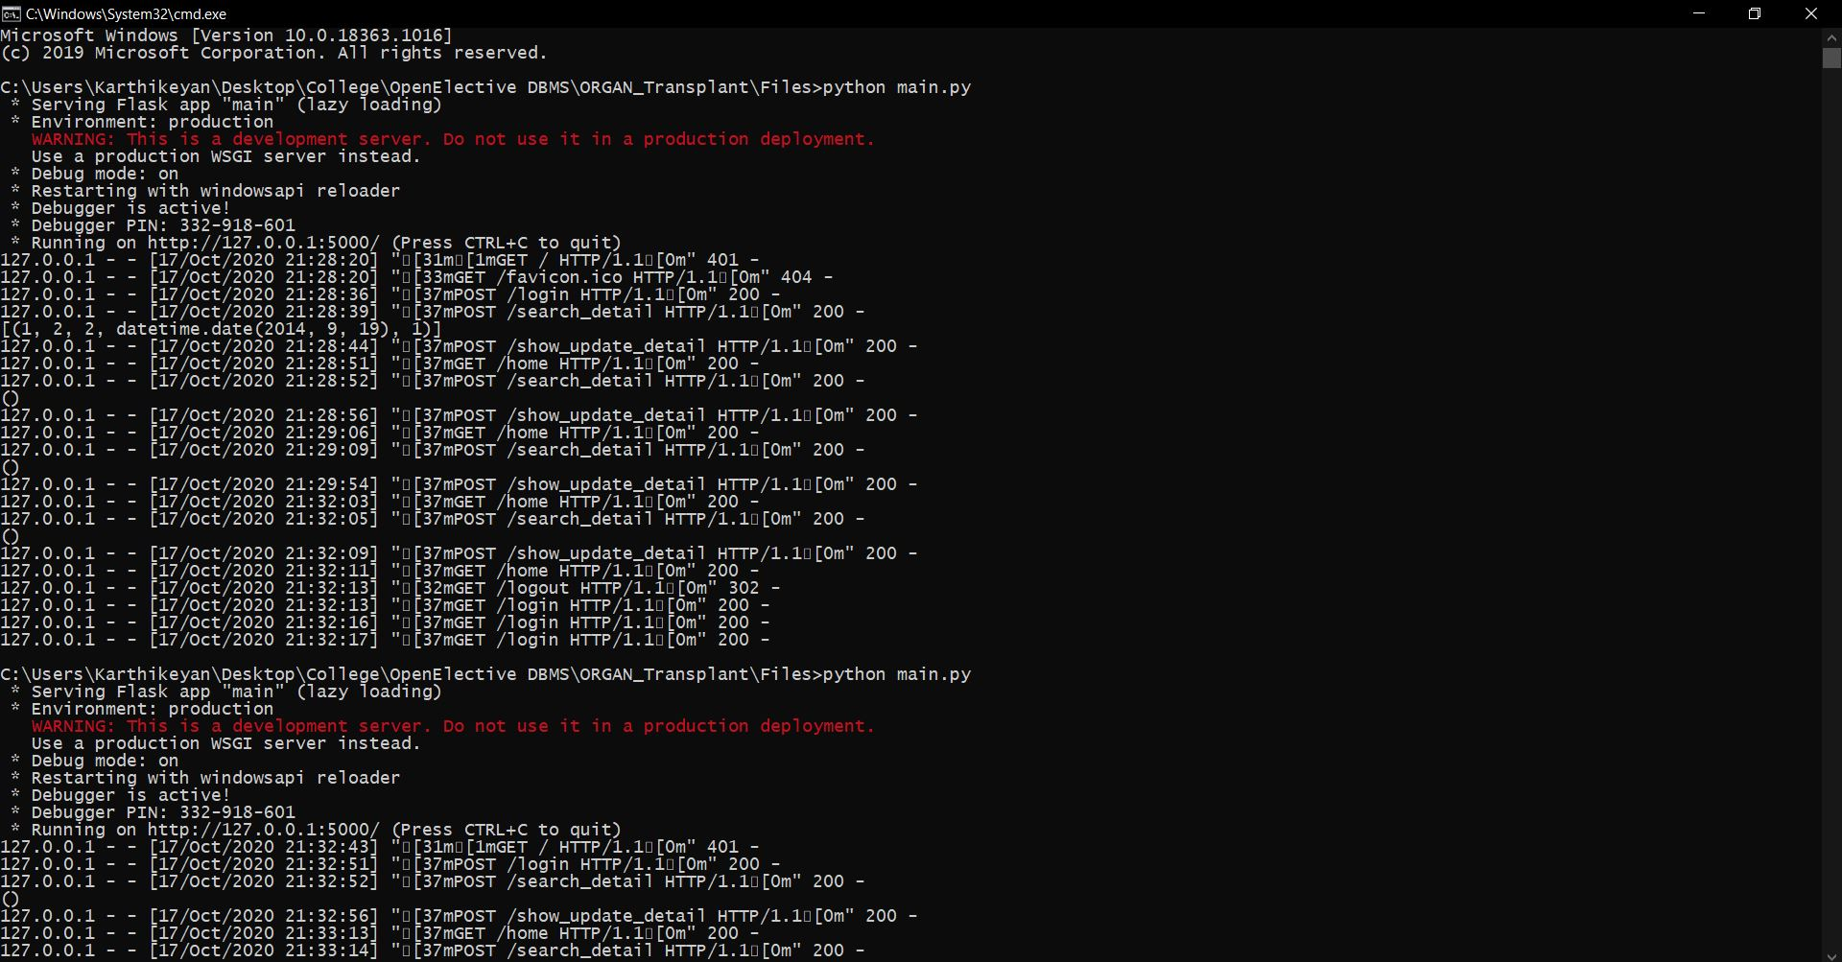

**OUTPUTS OF THE IMPLEMENTED WEB APPLICATION:**

**Webpages**

(**Note:** All the source code of the static webpages will be attached with this file in a zip file since it may take more pages if it is included in this file)

**Login page**

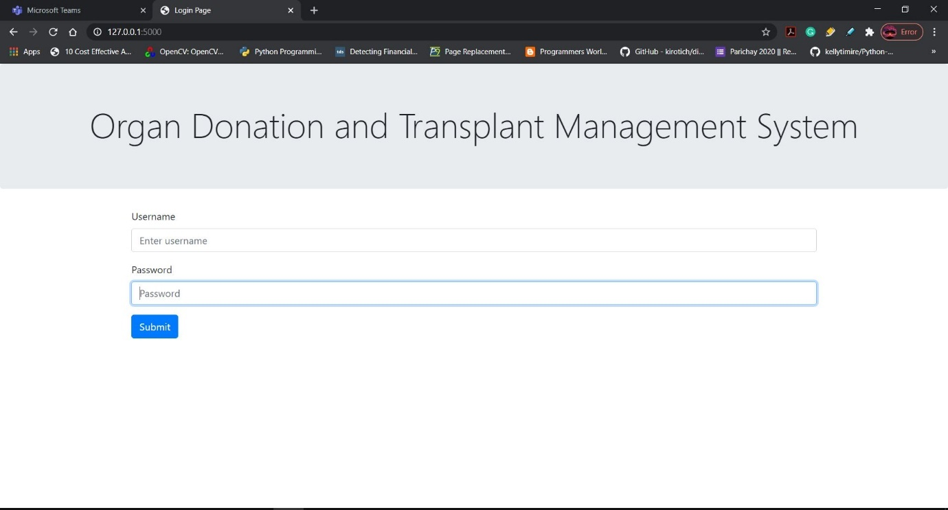

Login for Admin

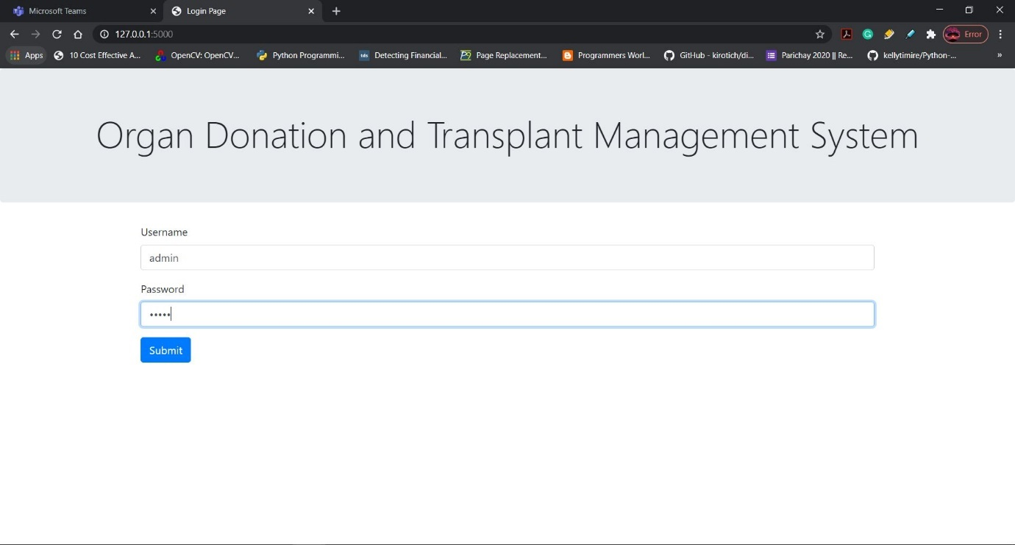

Login for normal users

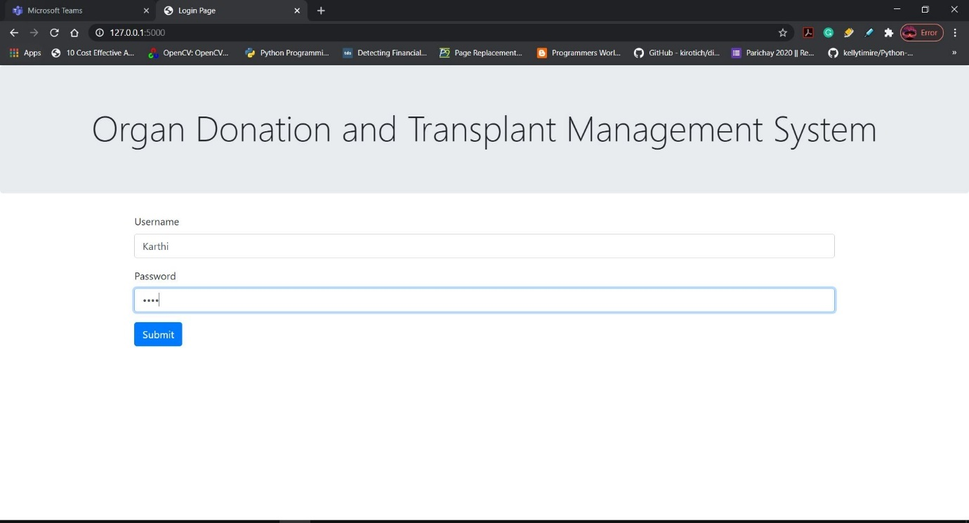

(**Note:** When admin logins he is directed to homepage where he can perform his operations but users are not allowed to enter the homepage since this application only outweighs admin usage as this application should be maintained and backed up by the admin for consistent and security purposes.)

(**Note:** This application allows only admins to perform operations and others are not allowed)

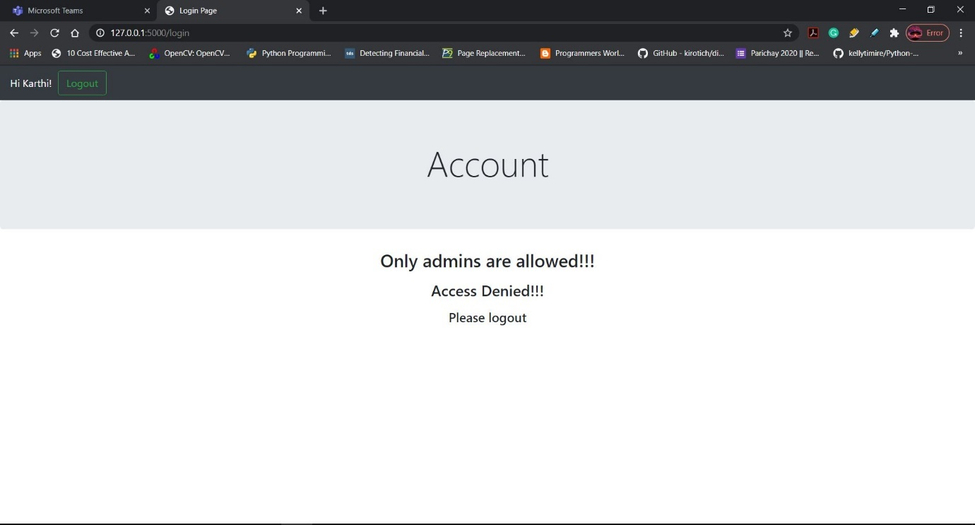

After clicking Logout:

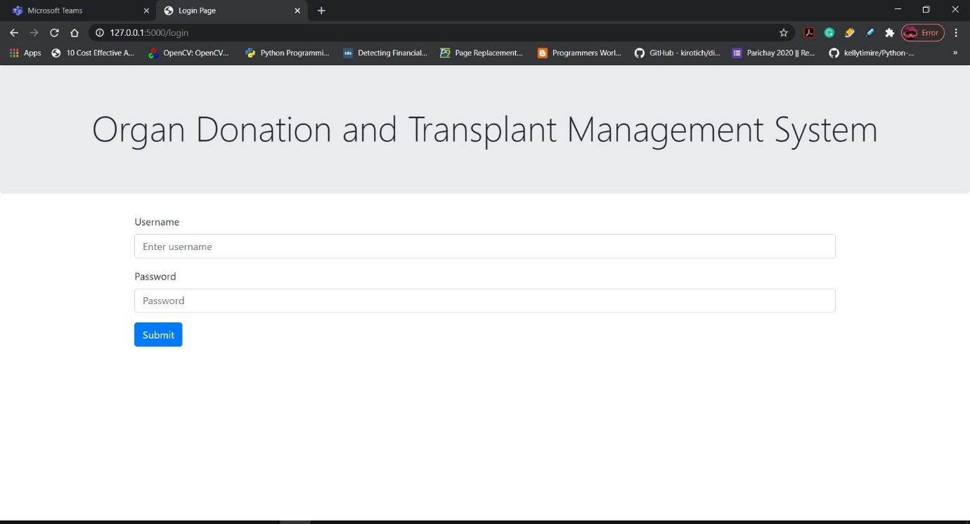

After admin logins with correct credentials he/she enters homepage

Homepage:

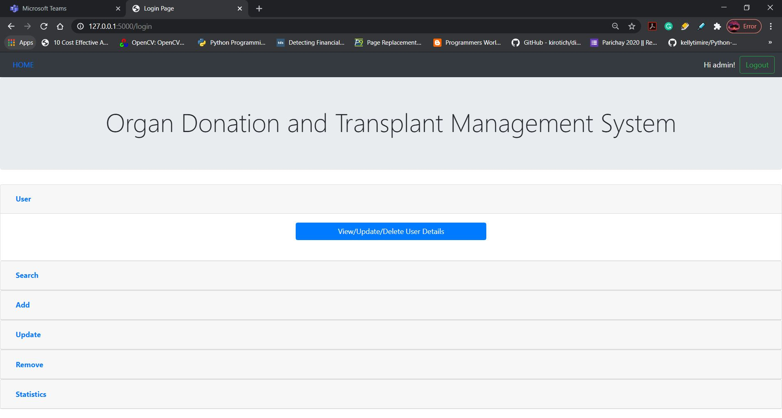

User page:

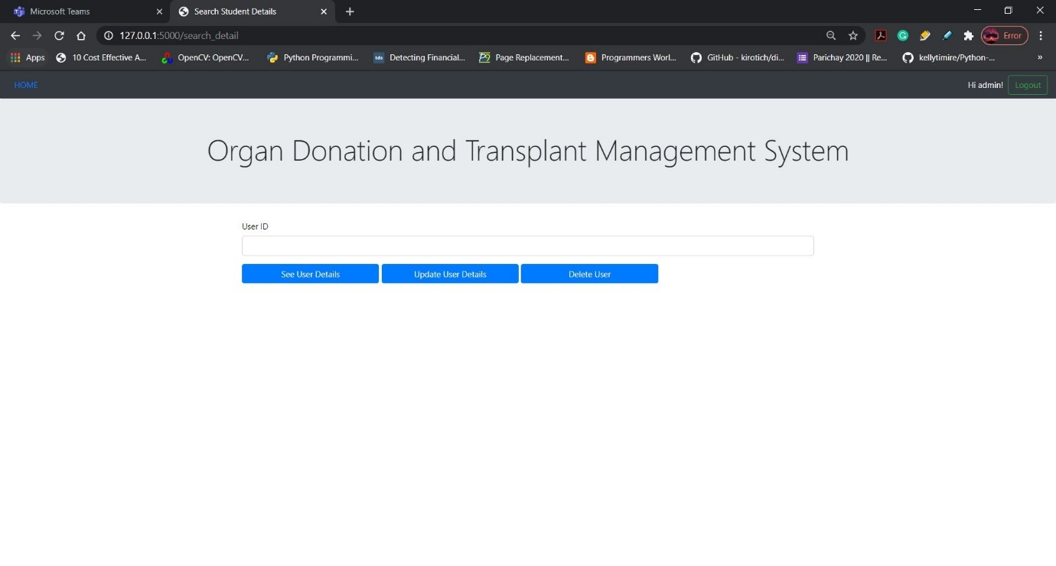

By entering user id we can see the details of the user when we click the first button and we can update the user details by clicking the second button and can delete the user by clicking the third button on the webpage respectively.

See User details:

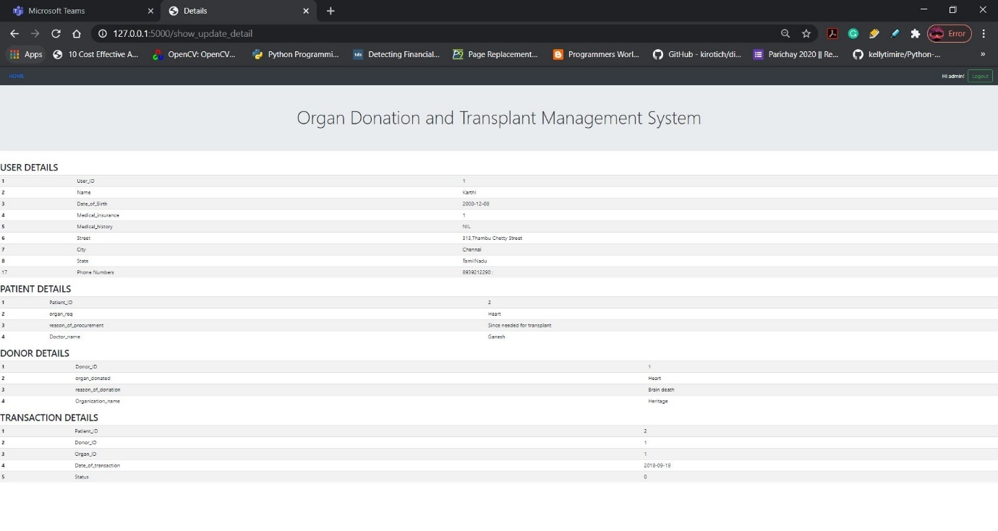

Update user details:

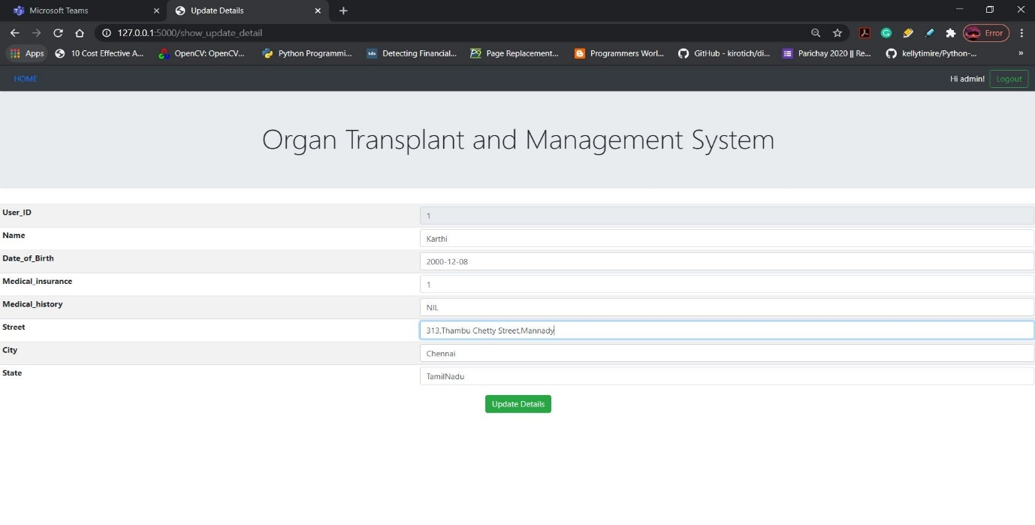

After updating user details it is reflected by the updated values in our case before the street was 313, Thambu Chetty Street and then it is updated to 313, Thambu Chetty Street, Mannady and it is reflected in the figure down.

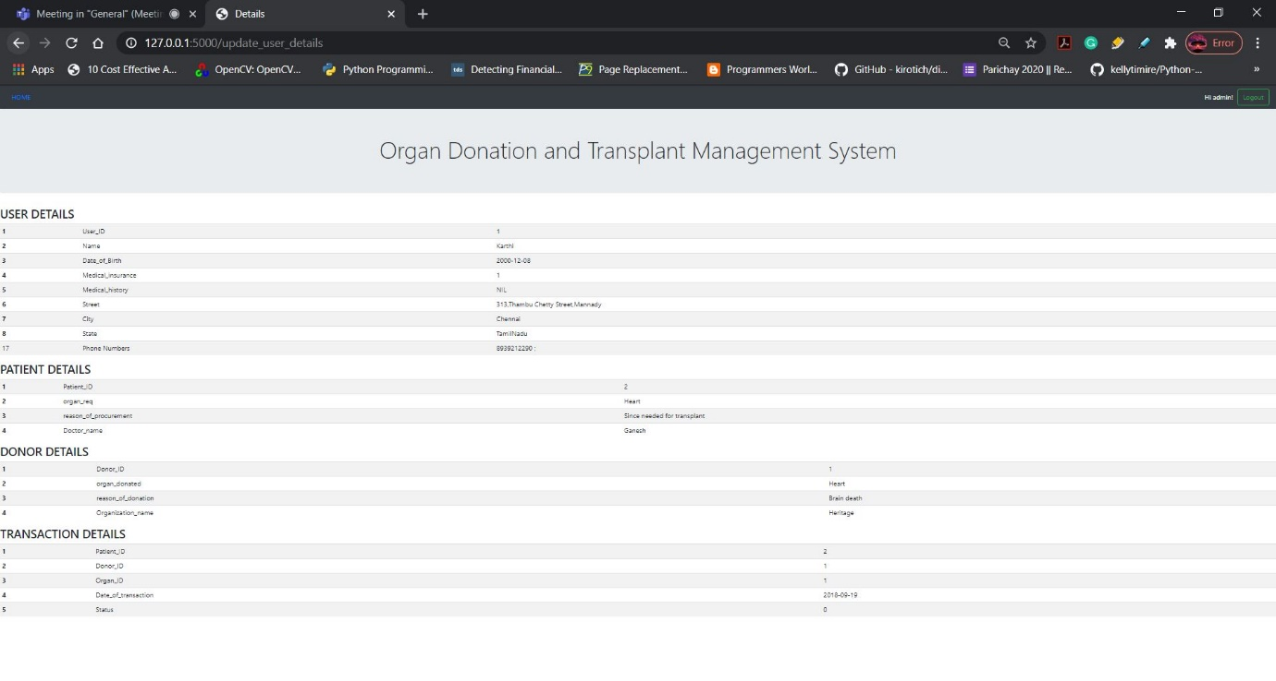

Another updation:

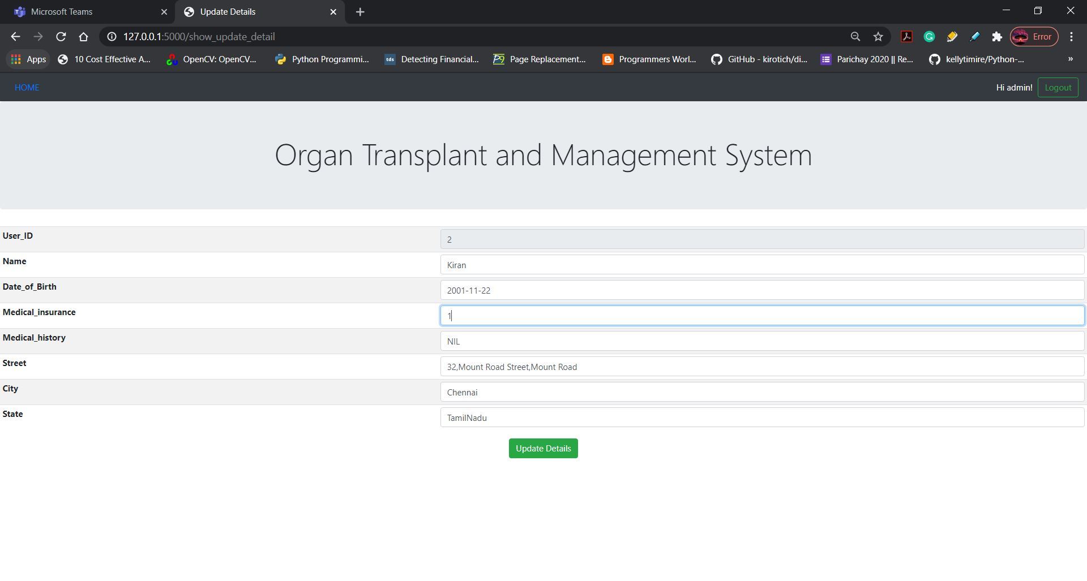

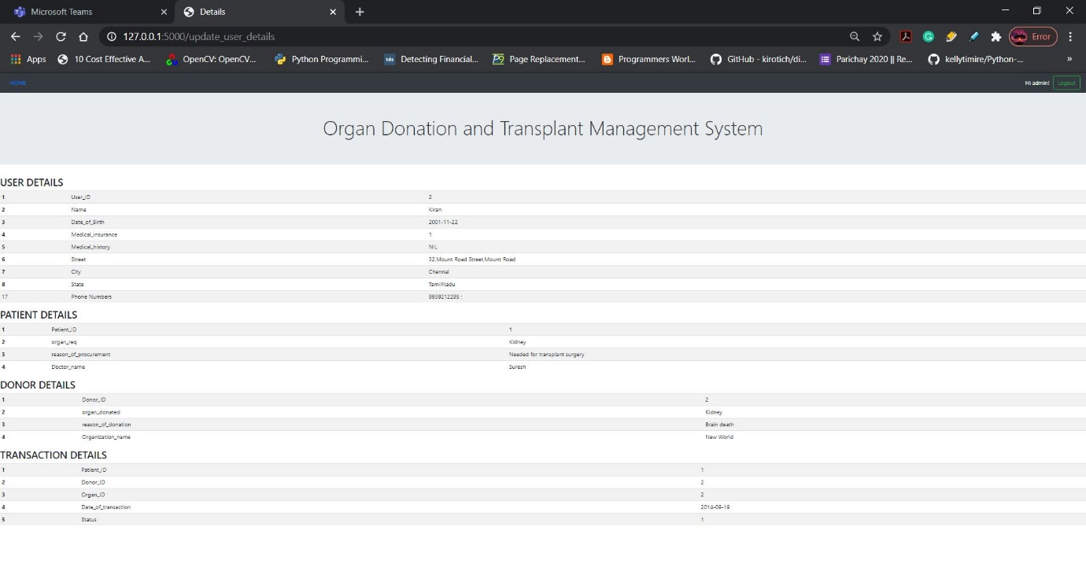

Before updation



After updation:

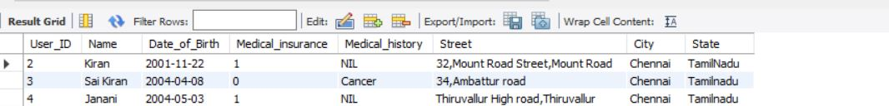

(Note: Here I deleted the 1st user id as a part of the next operation)

Delete the user id:

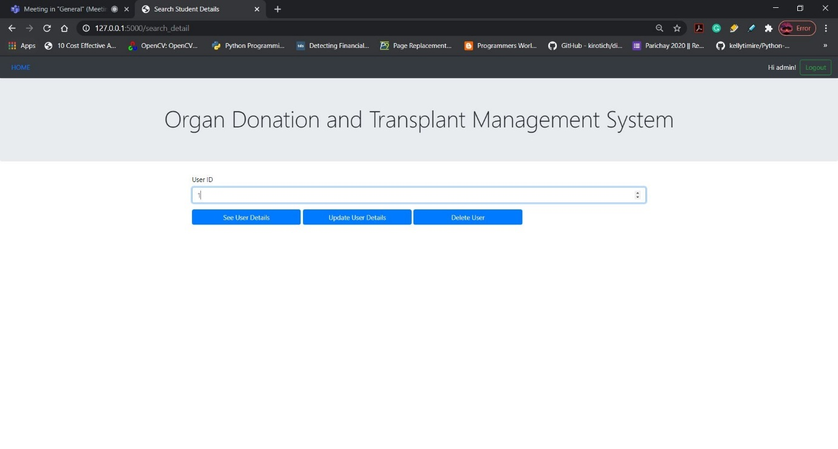

Seeing the user details for user id 1:

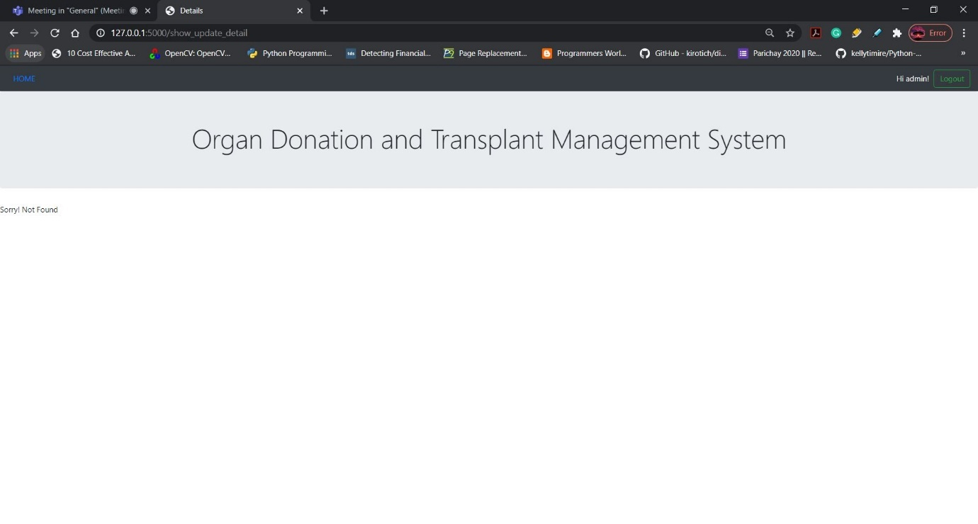

After deleting the user id 1:



**Search Page:**

When we click Search button we can see a dropdown of options if we click any options it redirects to the searching the page that we chose.

Searching user details:

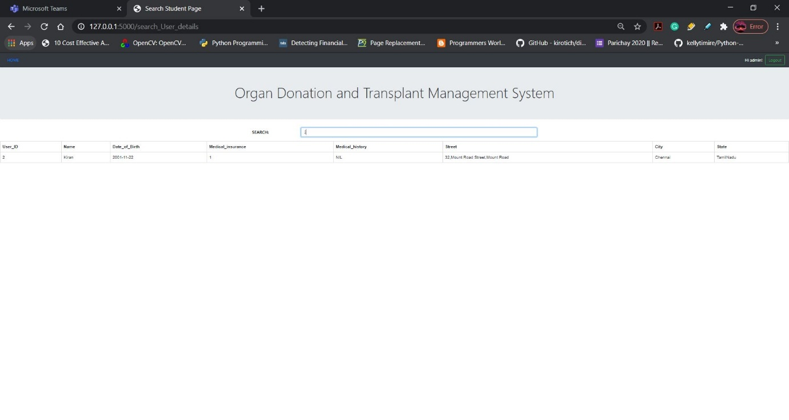

Searching Transaction details:

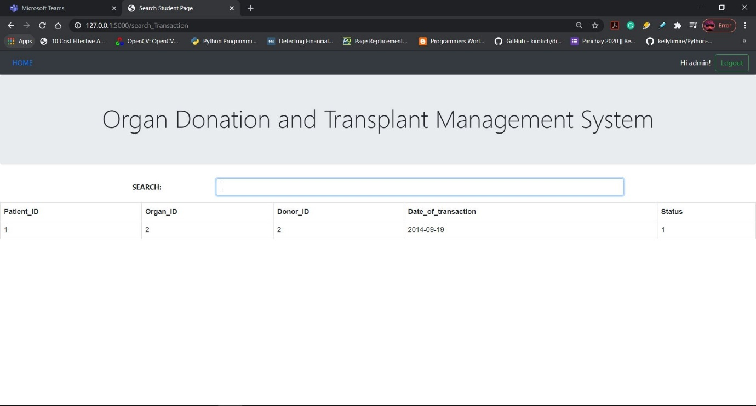

Search patient details:

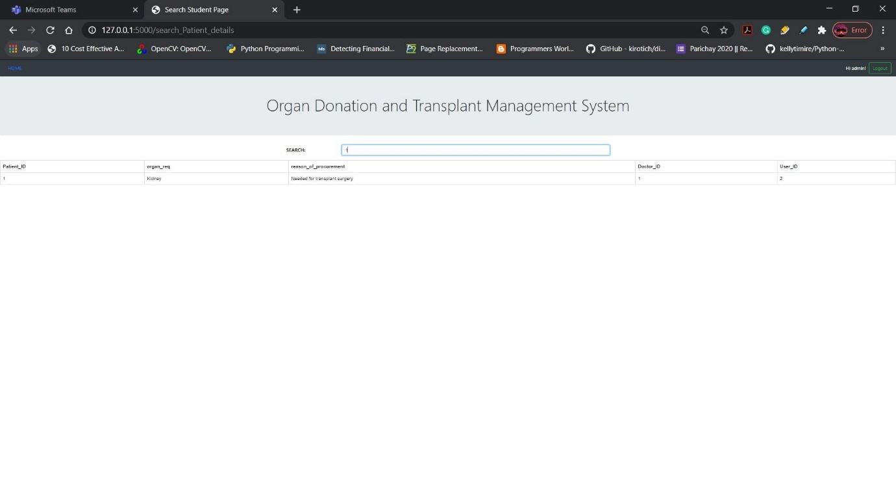

Search organization head details:

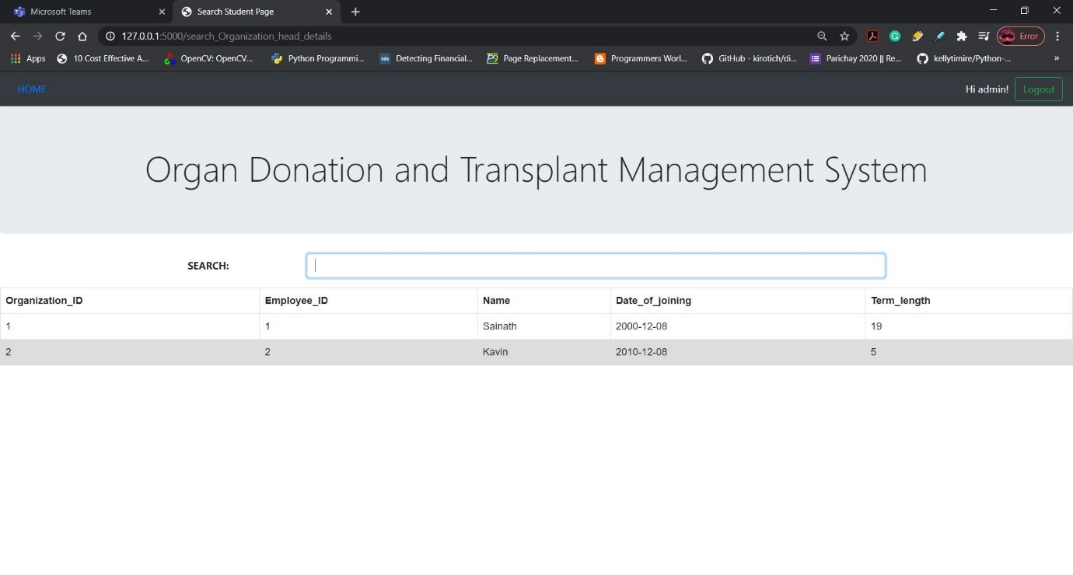

Search organization details:

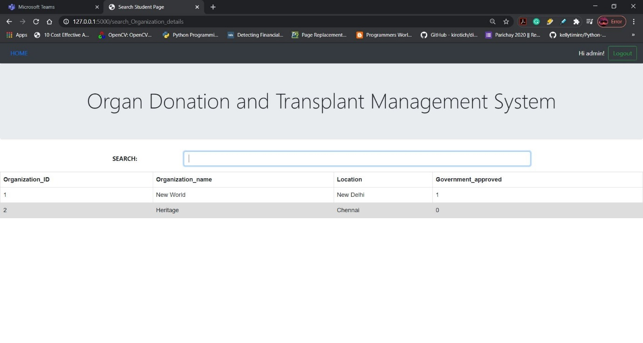

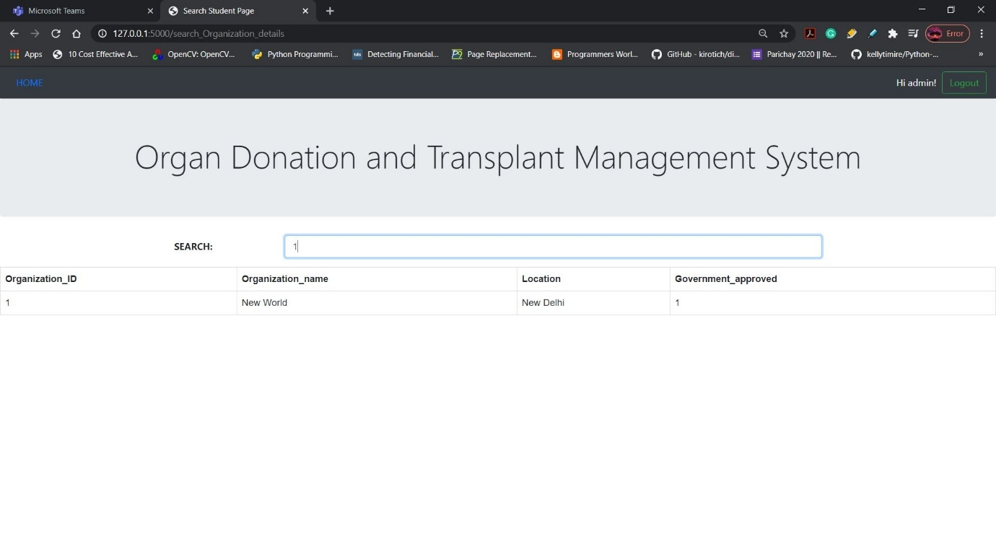

(**Note**: It fetches the record that you requested)

If requested page is not found it return empty page:

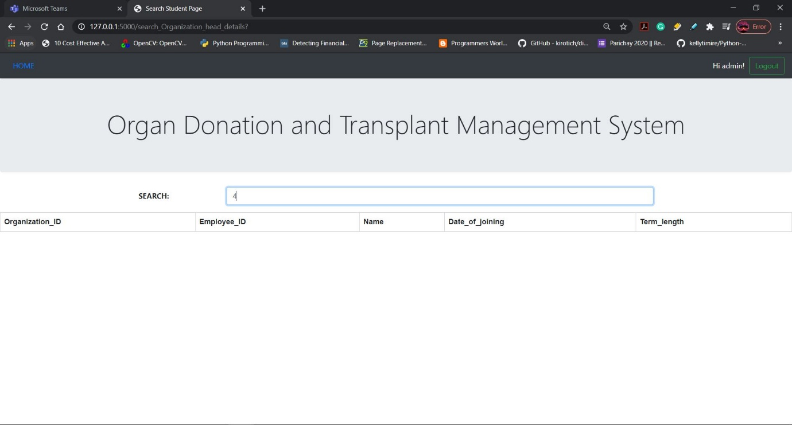

Search doctor details:

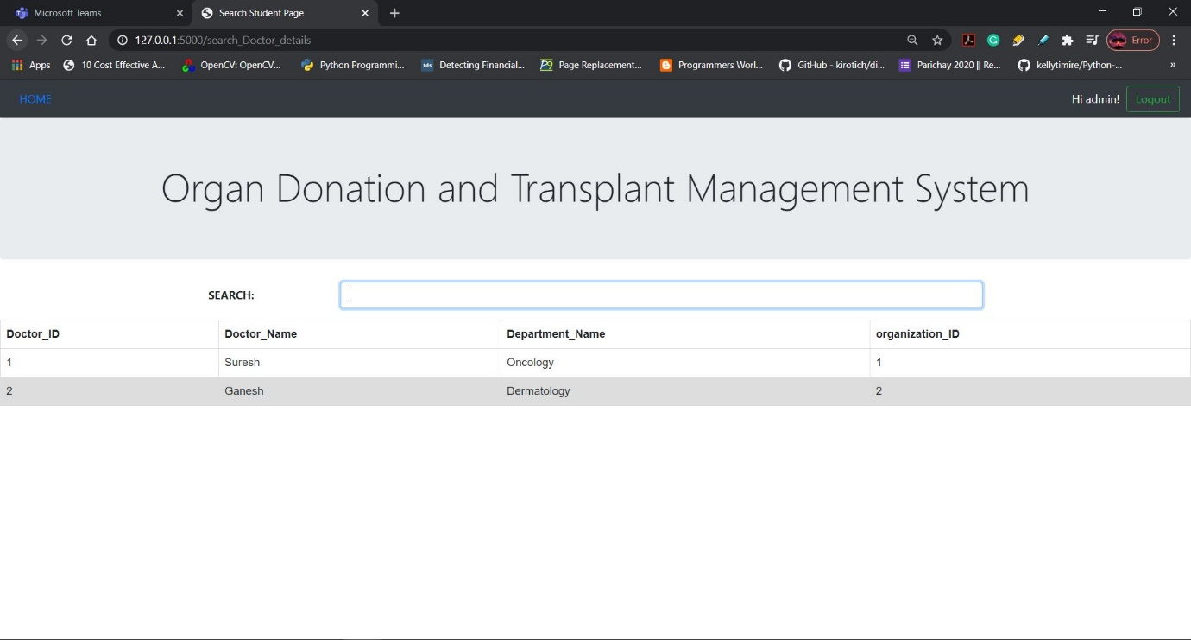

Search donor details:

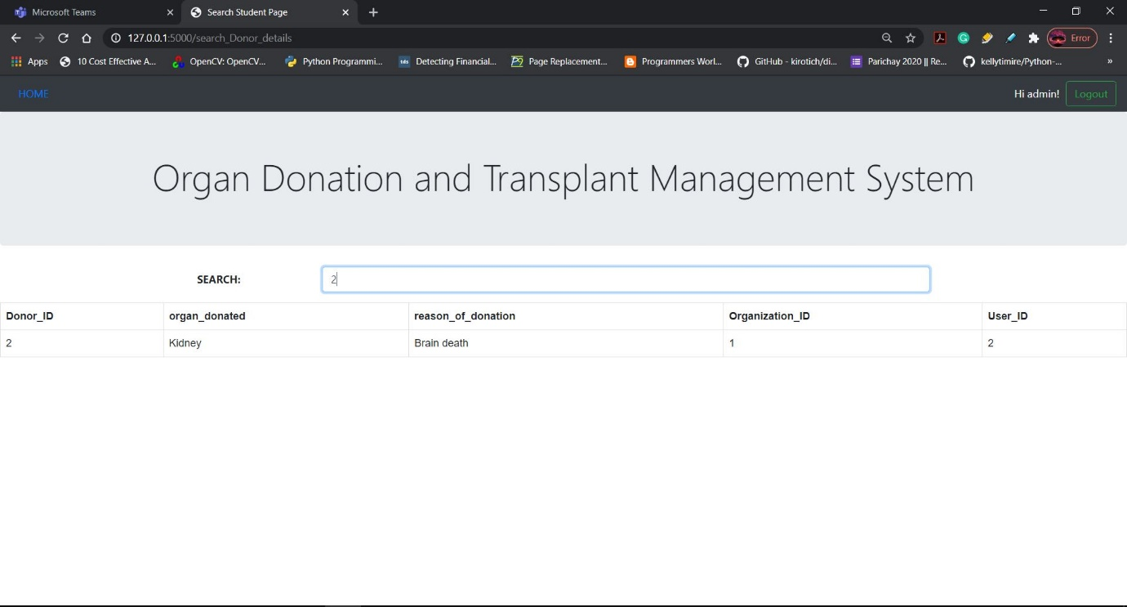

Search log details:

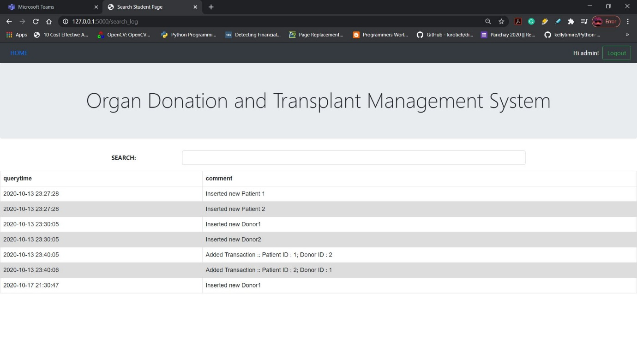

(**Note:** It maintains a log of the transactions such as add, delete and update of the tables)

Search organ details:

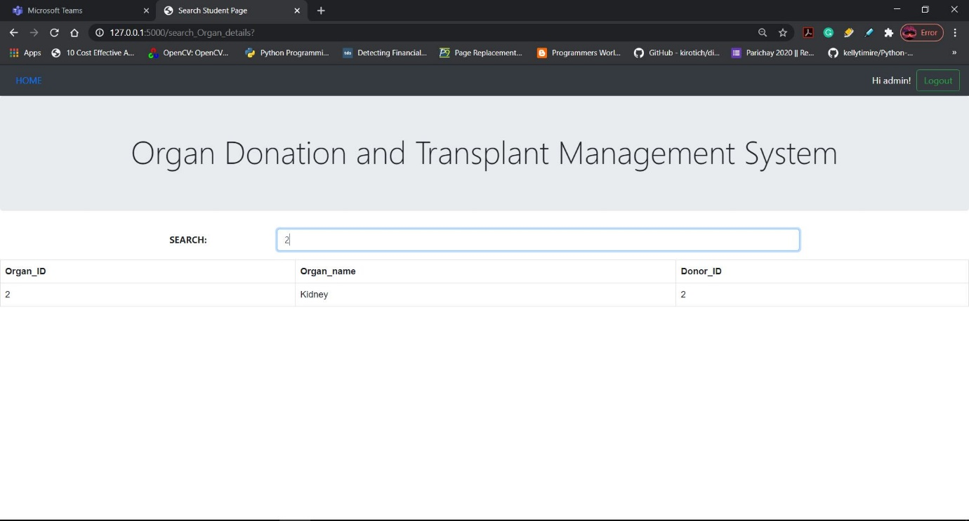

**Add page:**

In this webpage the admin can add the details to the database.

Add user details:

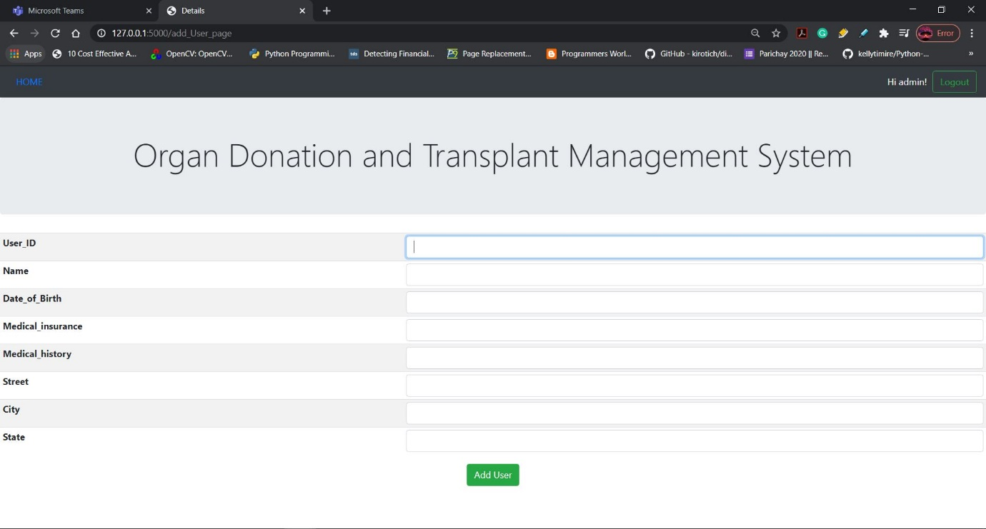

Before adding the user:

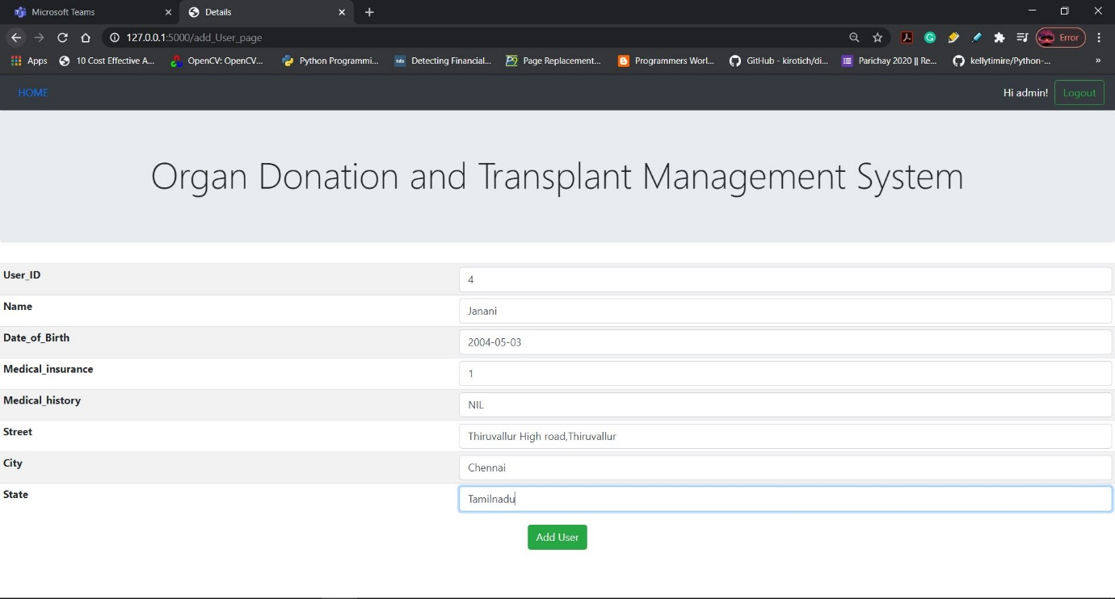

After adding the user:

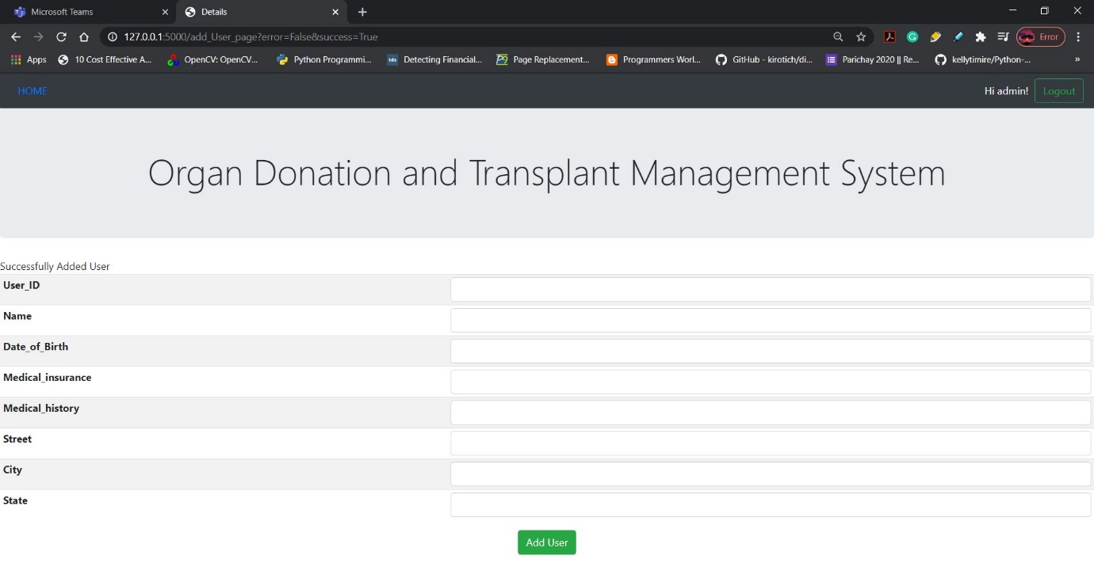

Checking if the added values are inserted in the backend database (MySQL):

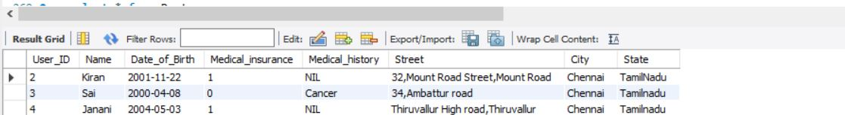

Adding user phone number details:

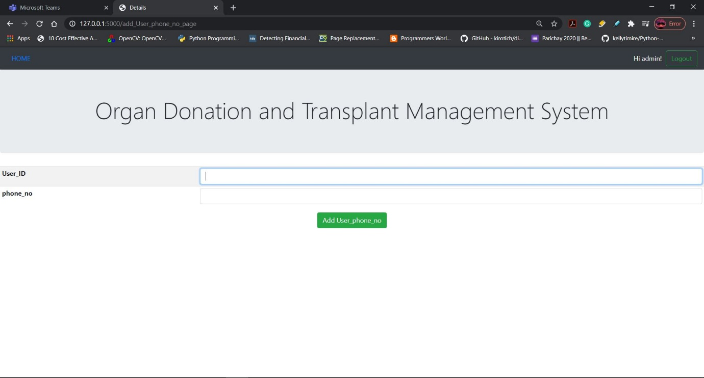

Before adding:

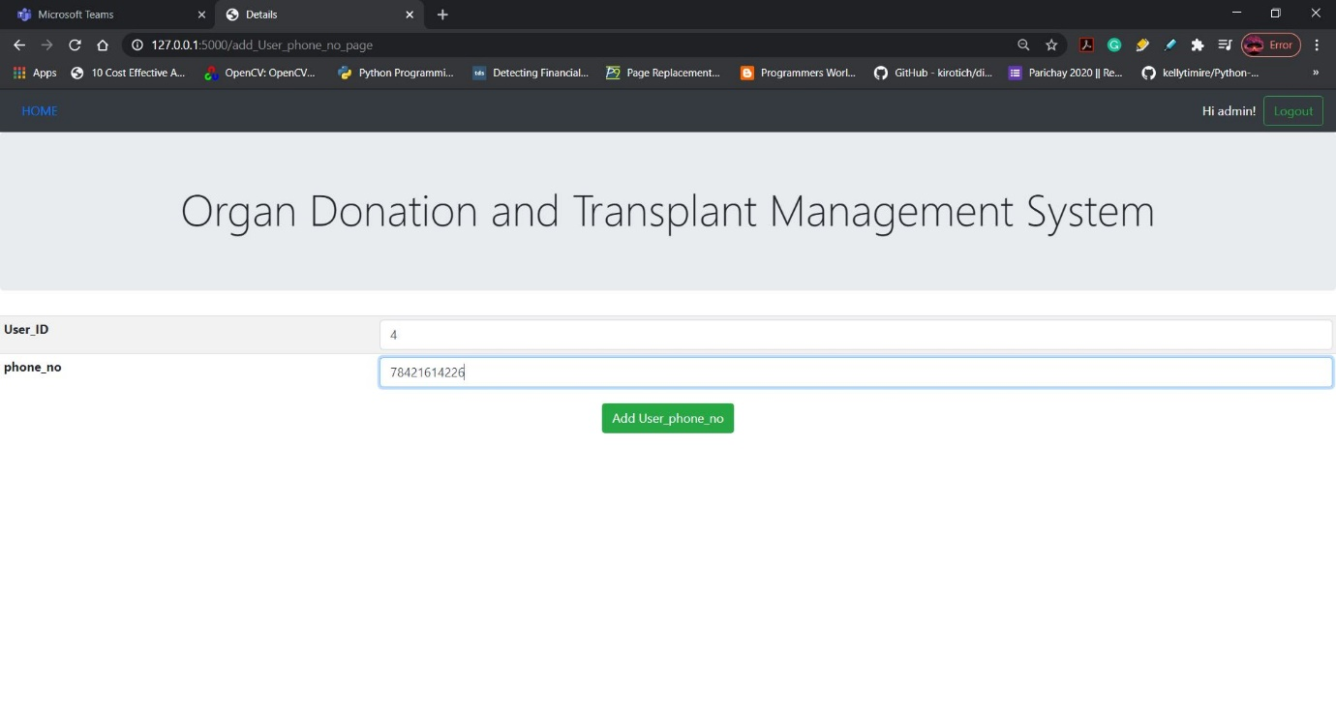

After adding:

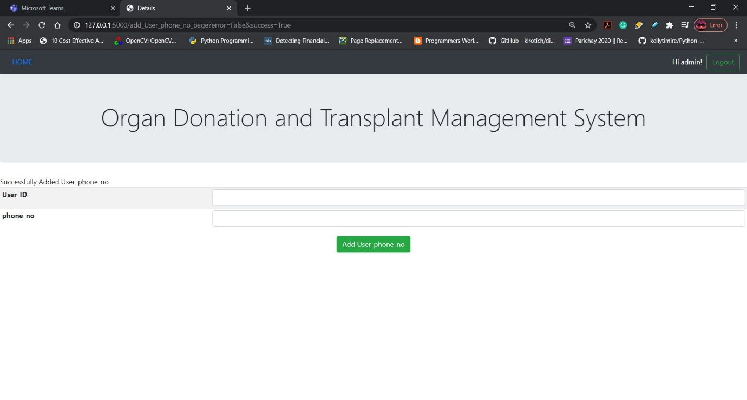

Checking if the added values are inserted in the backend database (MySQL):

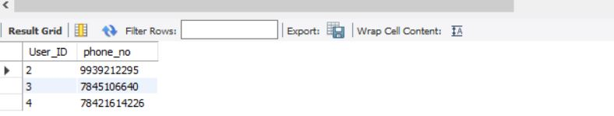

Adding doctor details:

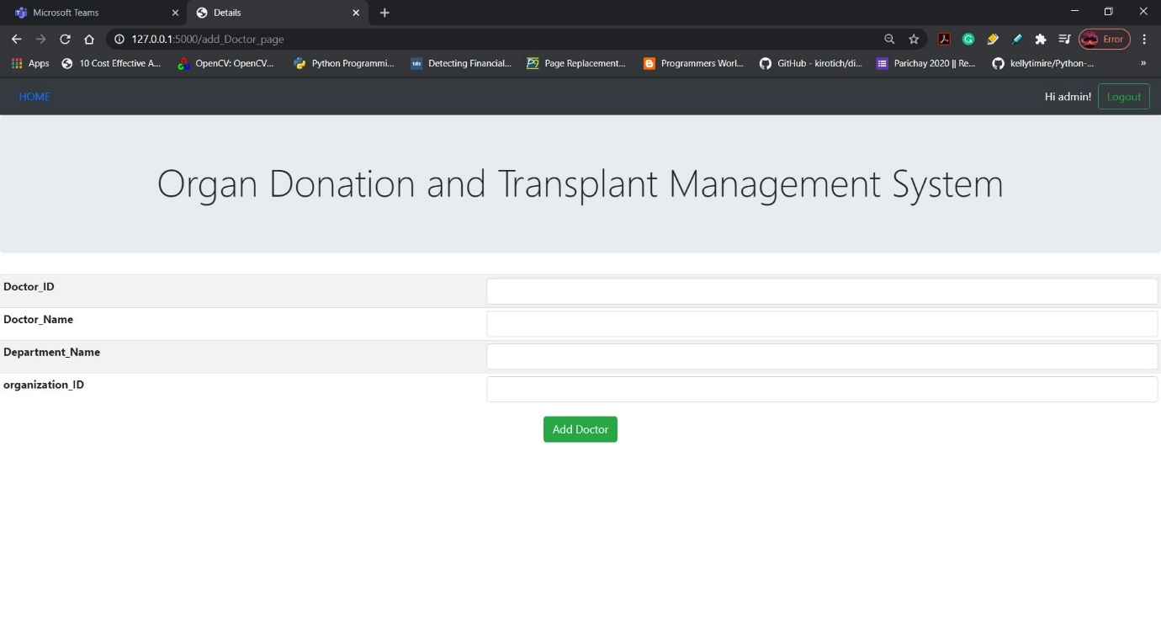

Before adding:

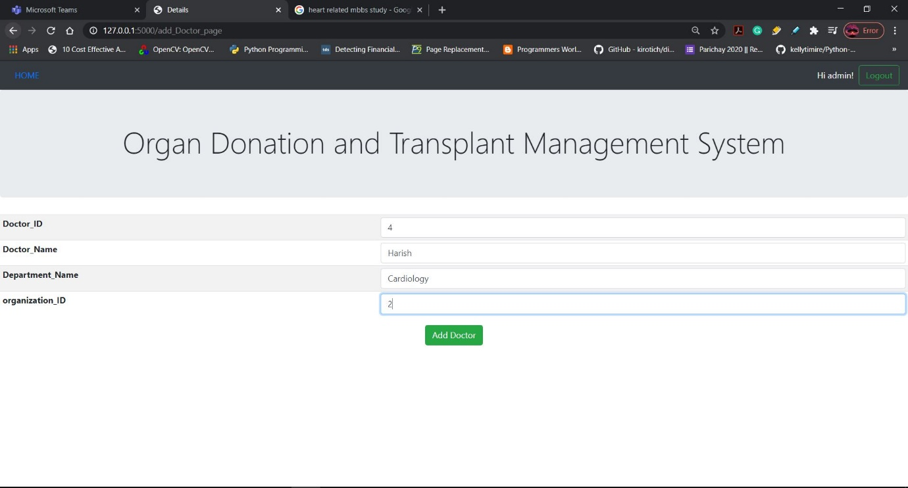

After adding:

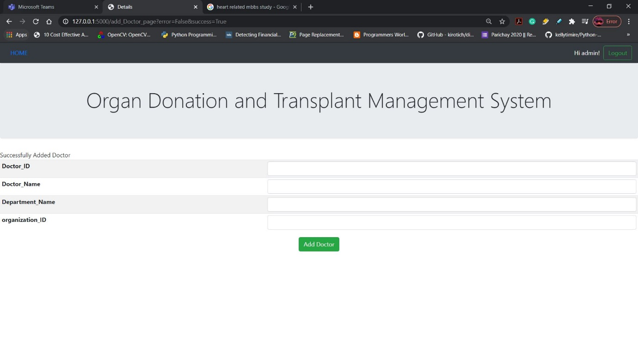

Checking if the added values are inserted in the backend database (MySQL):

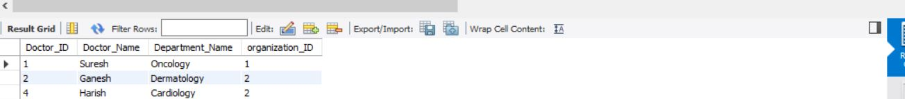

Adding doctor phone number details:

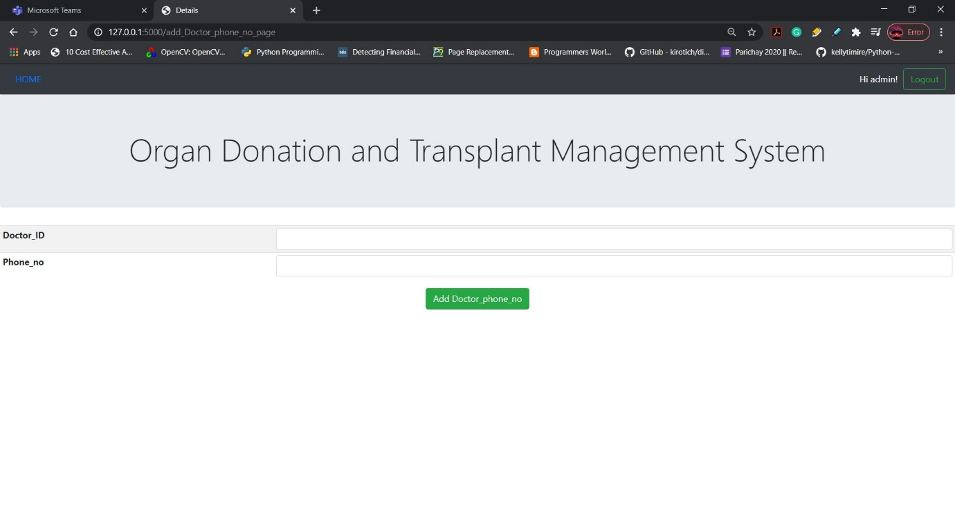

Before adding:

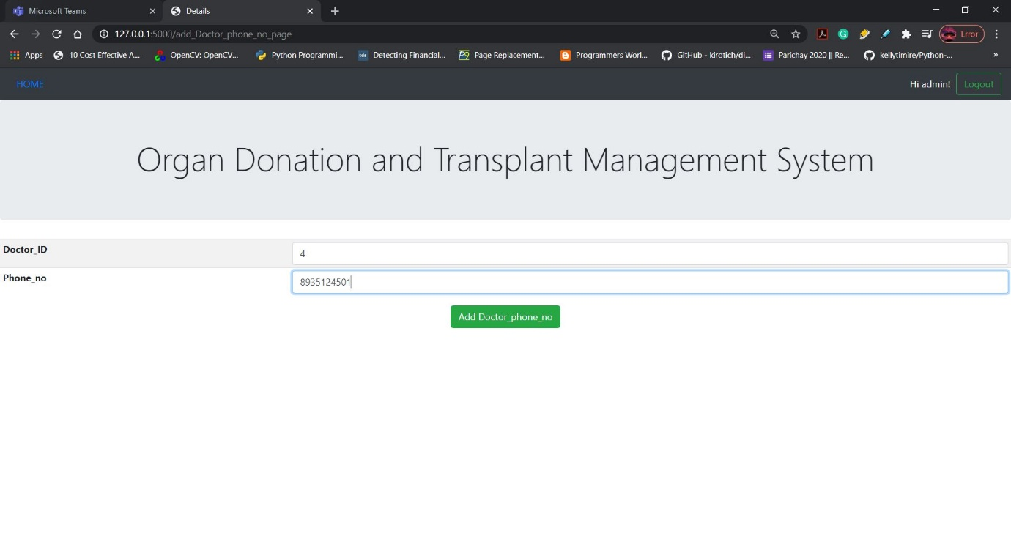

After adding:

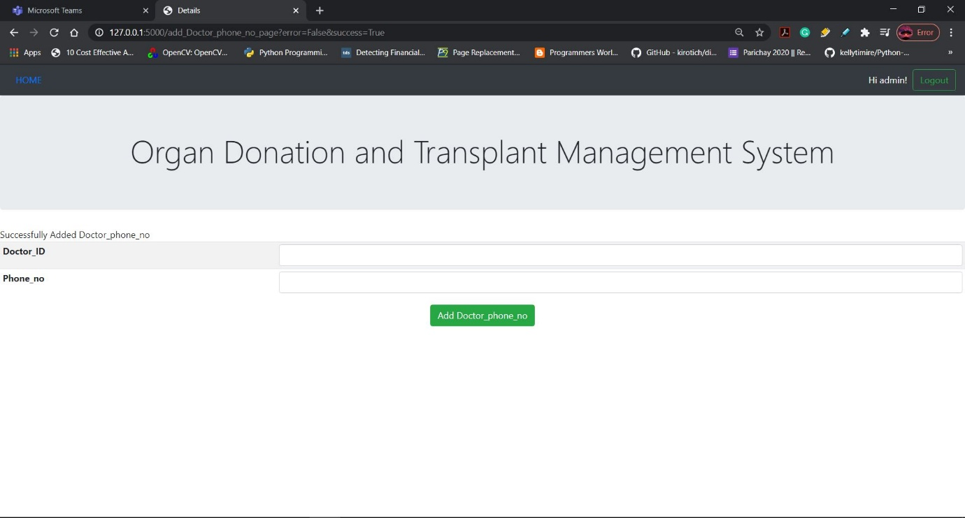

Checking if the added values are inserted in the backend database (MySQL):

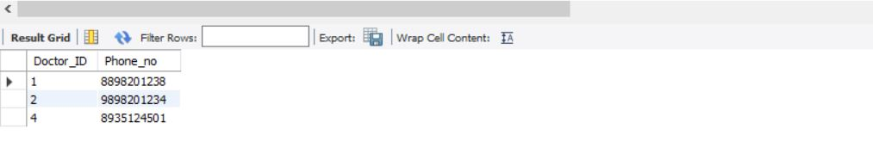

Adding donor details:

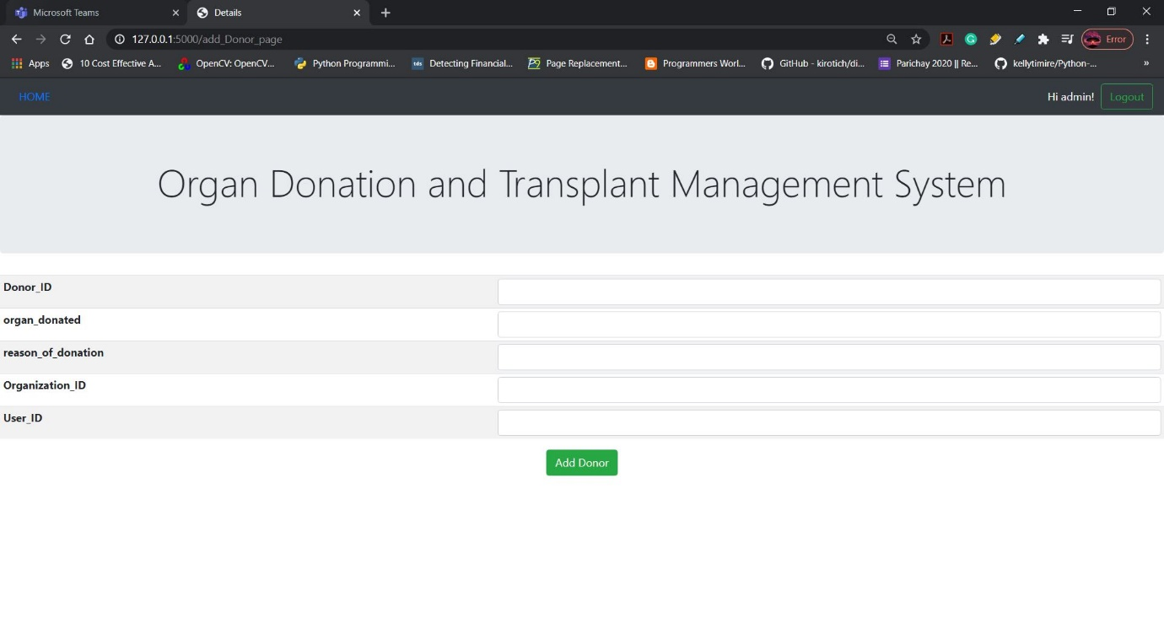

Before adding:

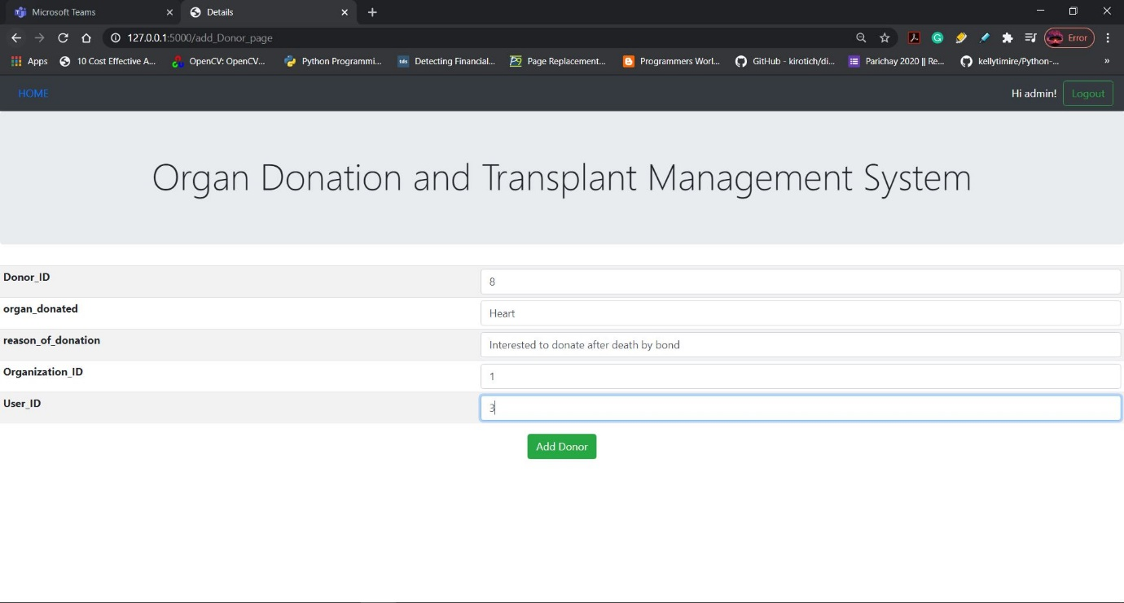

After adding:

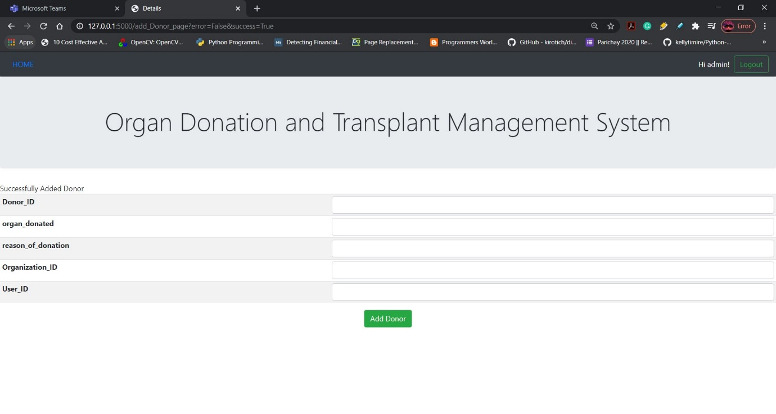

Checking if the added values are inserted in the backend database (MySQL):

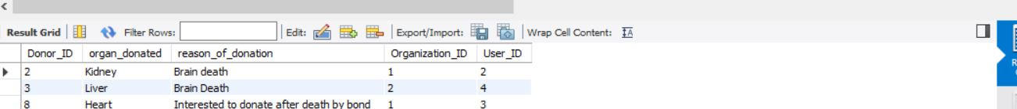

Adding organization details:

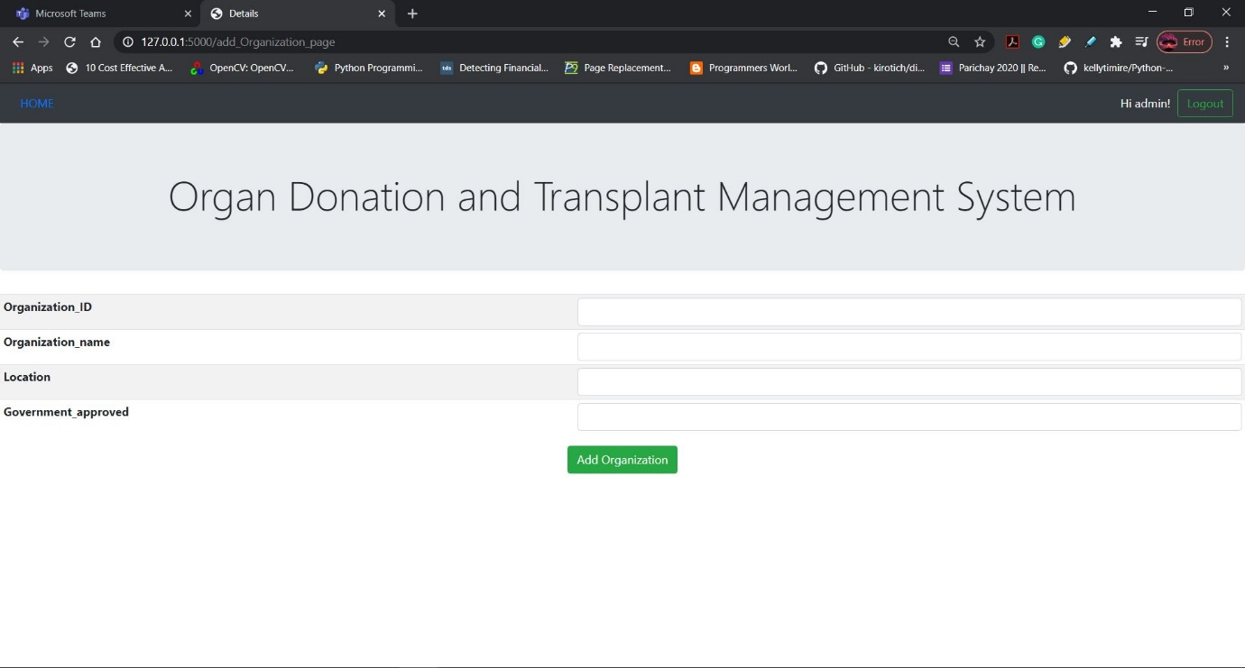

Before adding:

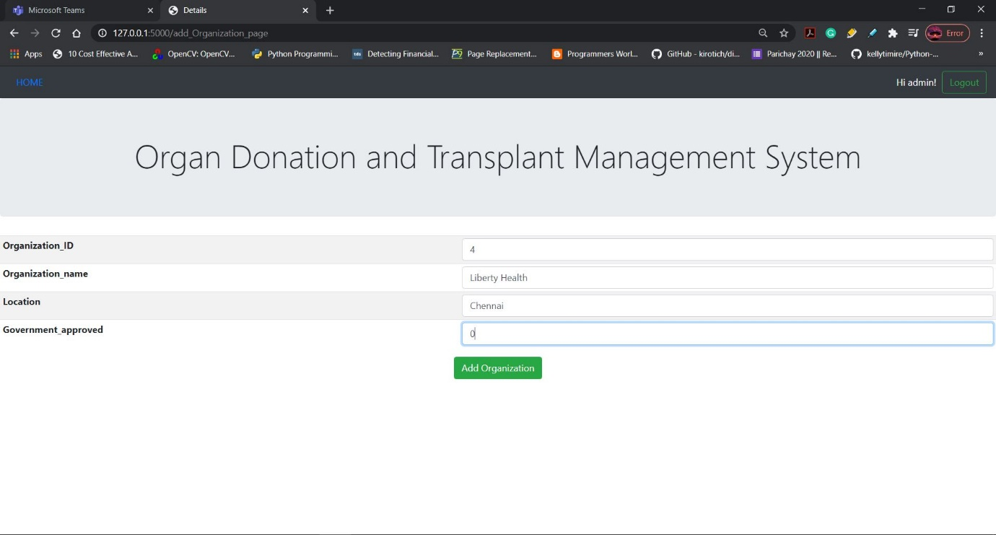

After adding:

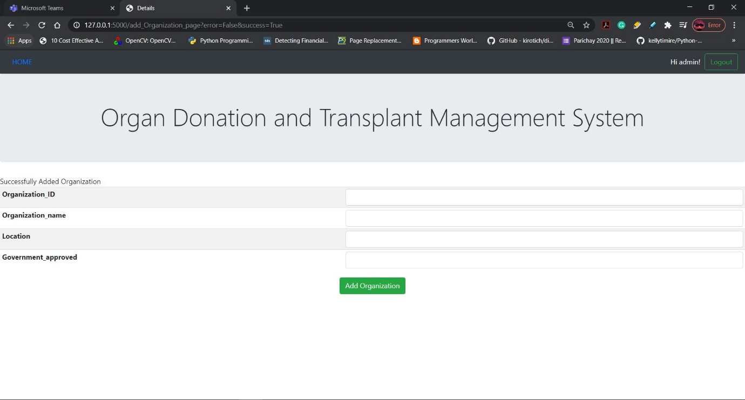

Checking if the added values are inserted in the backend database (MySQL):

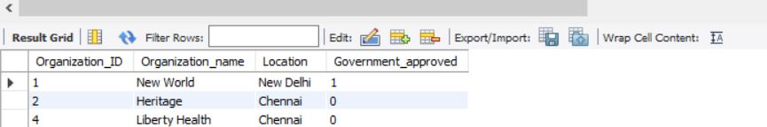

If correct values are not entered then it returns error:

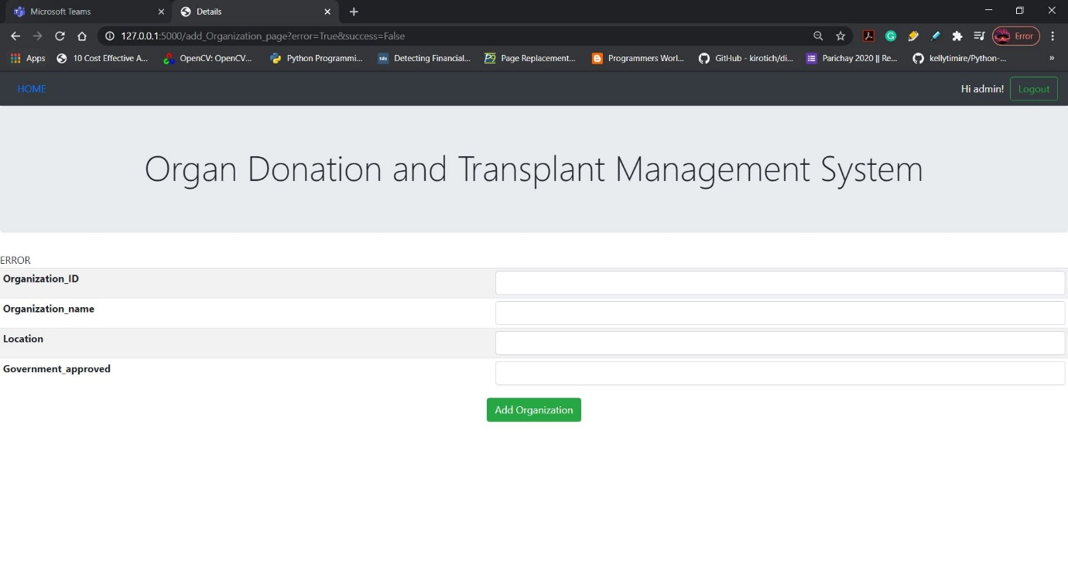

Adding organization head details:

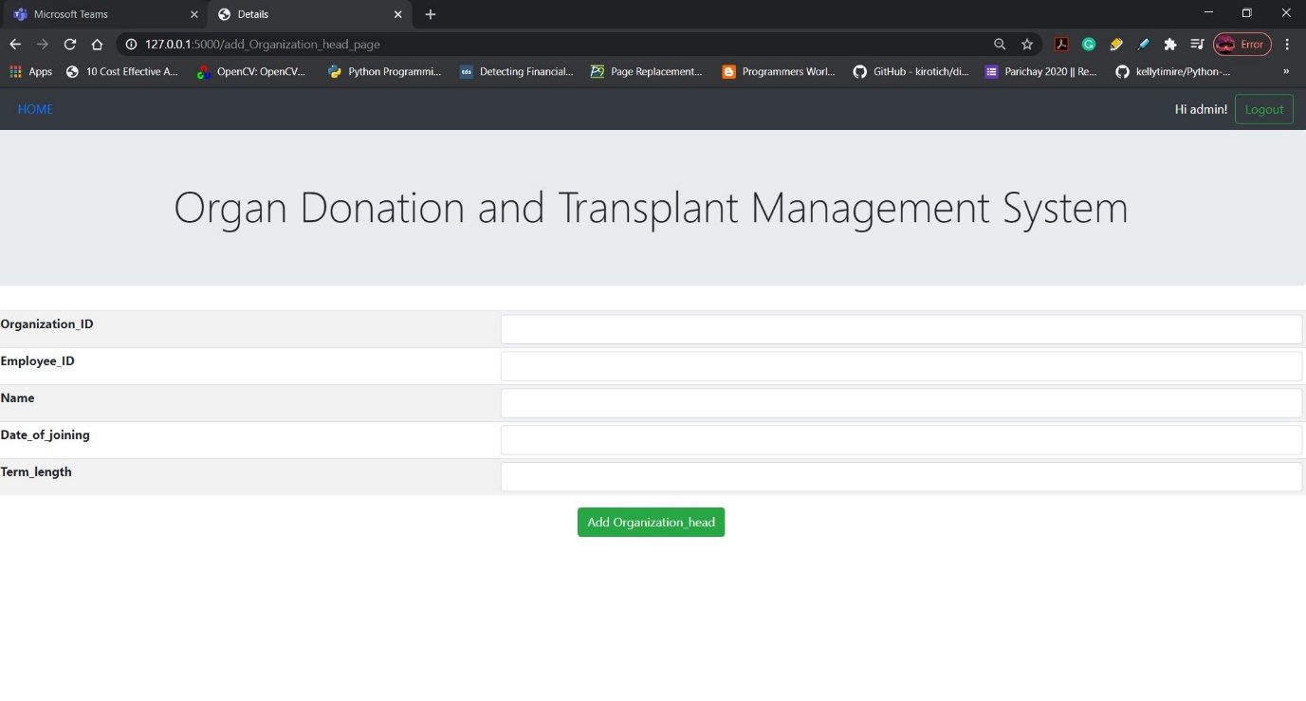

Before adding:

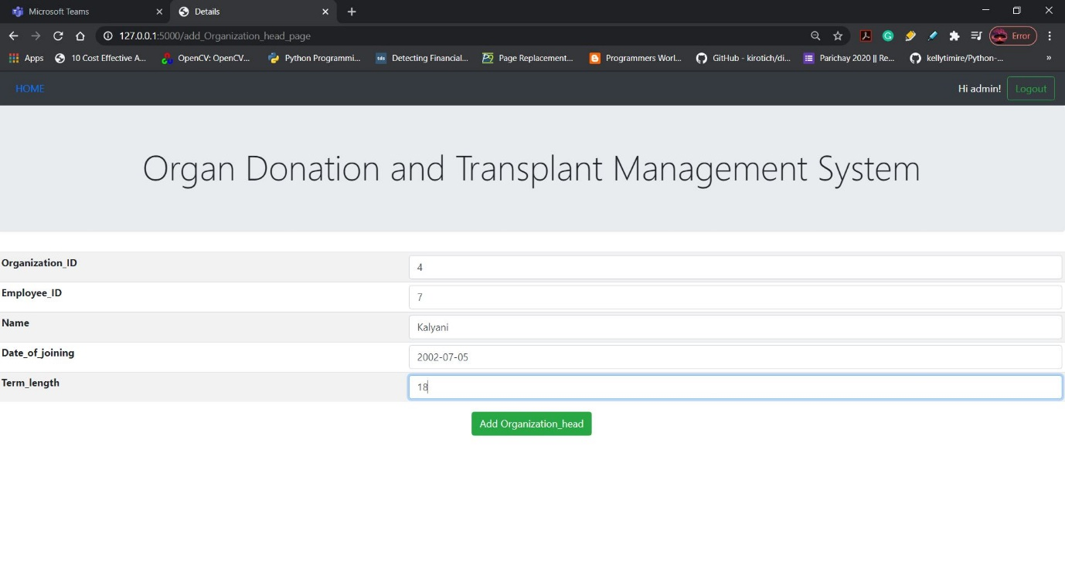

After adding:

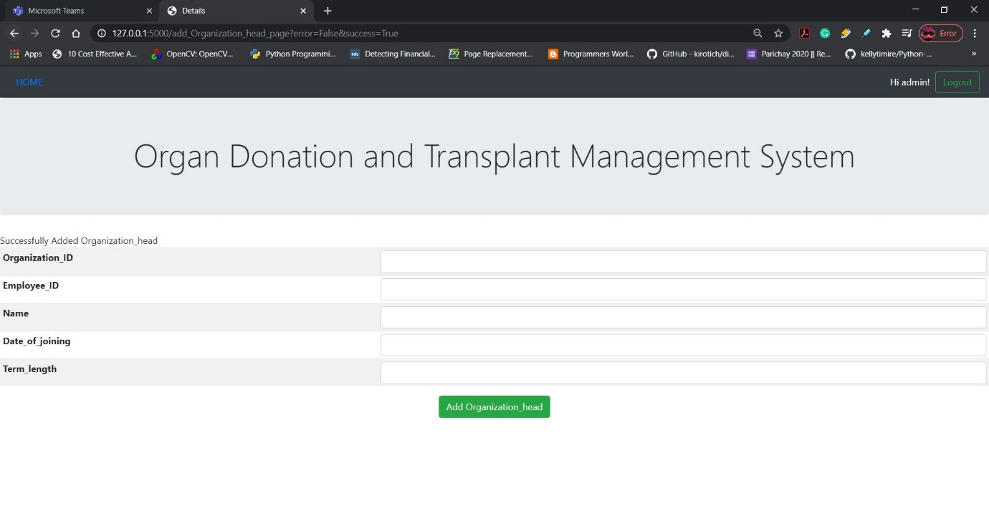

Checking if the added values are inserted in the backend database (MySQL):

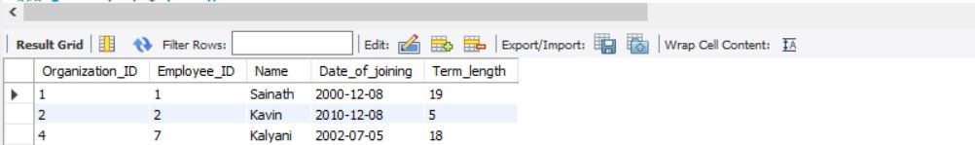

Adding organization phone number details:

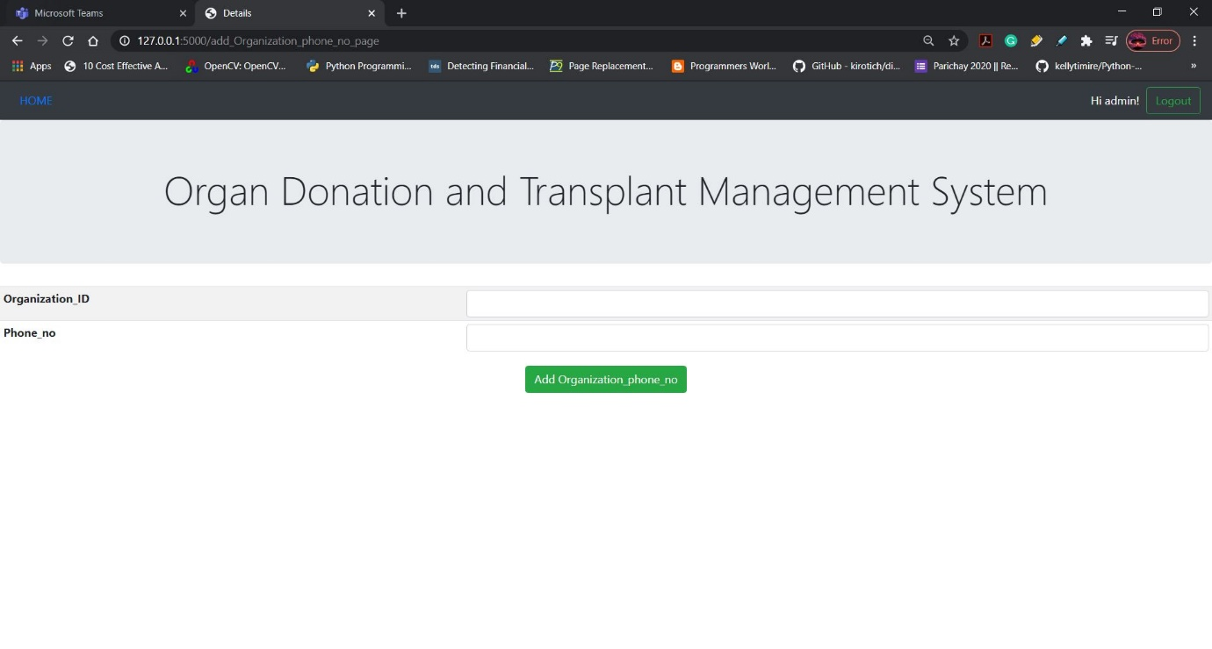

Before adding:

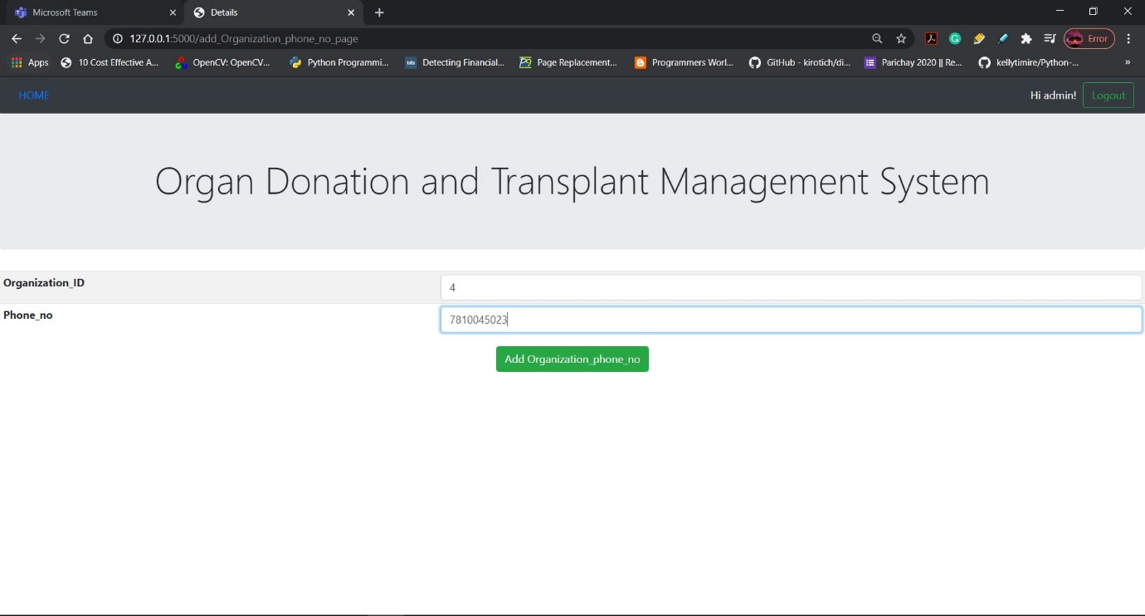

After adding:

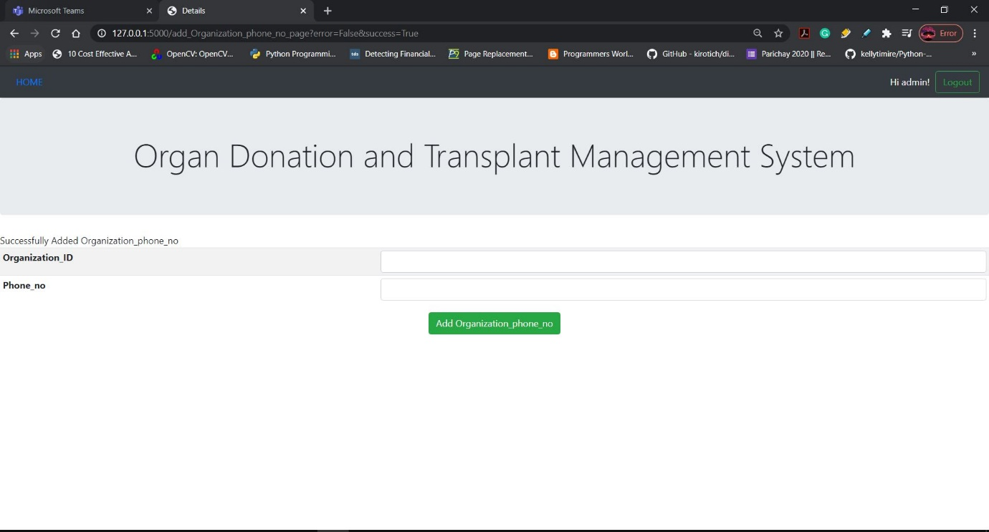

Checking if the added values are inserted in the backend database (MySQL):

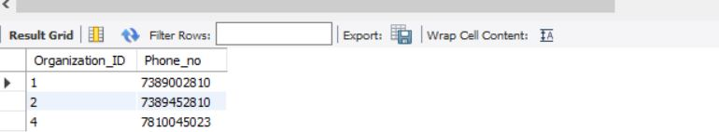

Adding patient details:

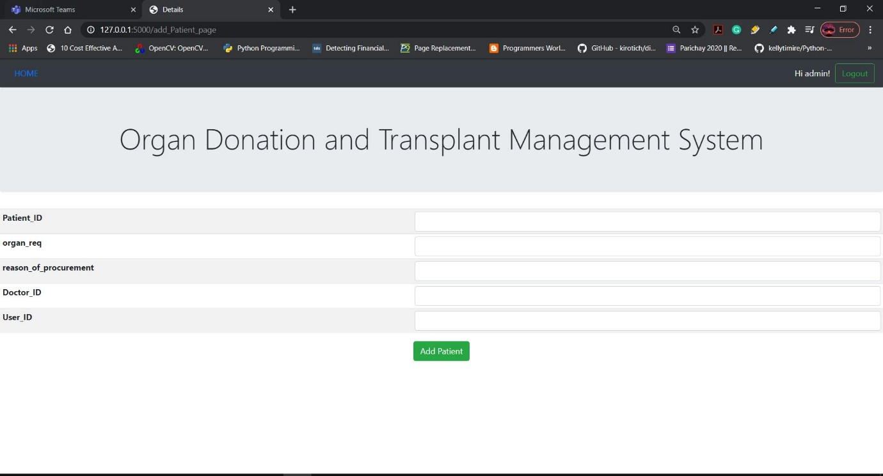

Before adding:

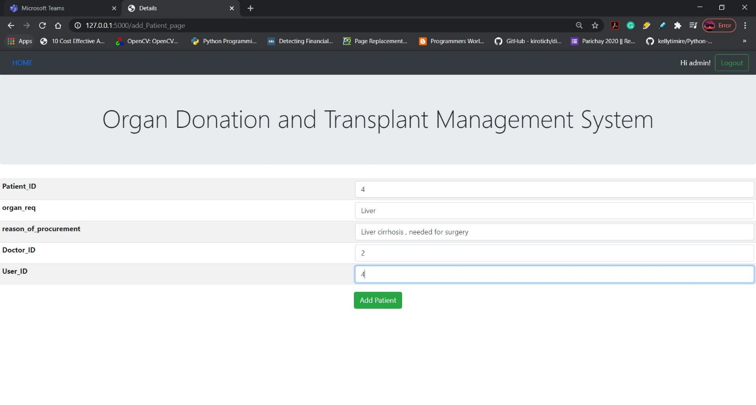

After adding:

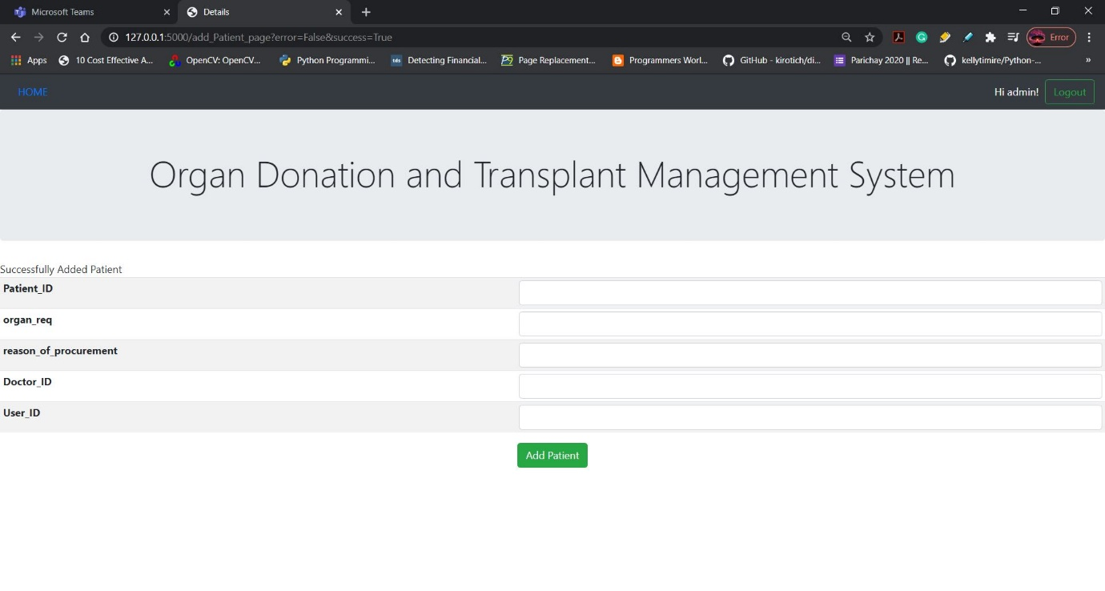

Checking if the added values are inserted in the backend database (MySQL):

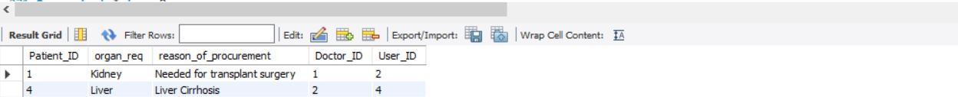

Adding the transaction details:

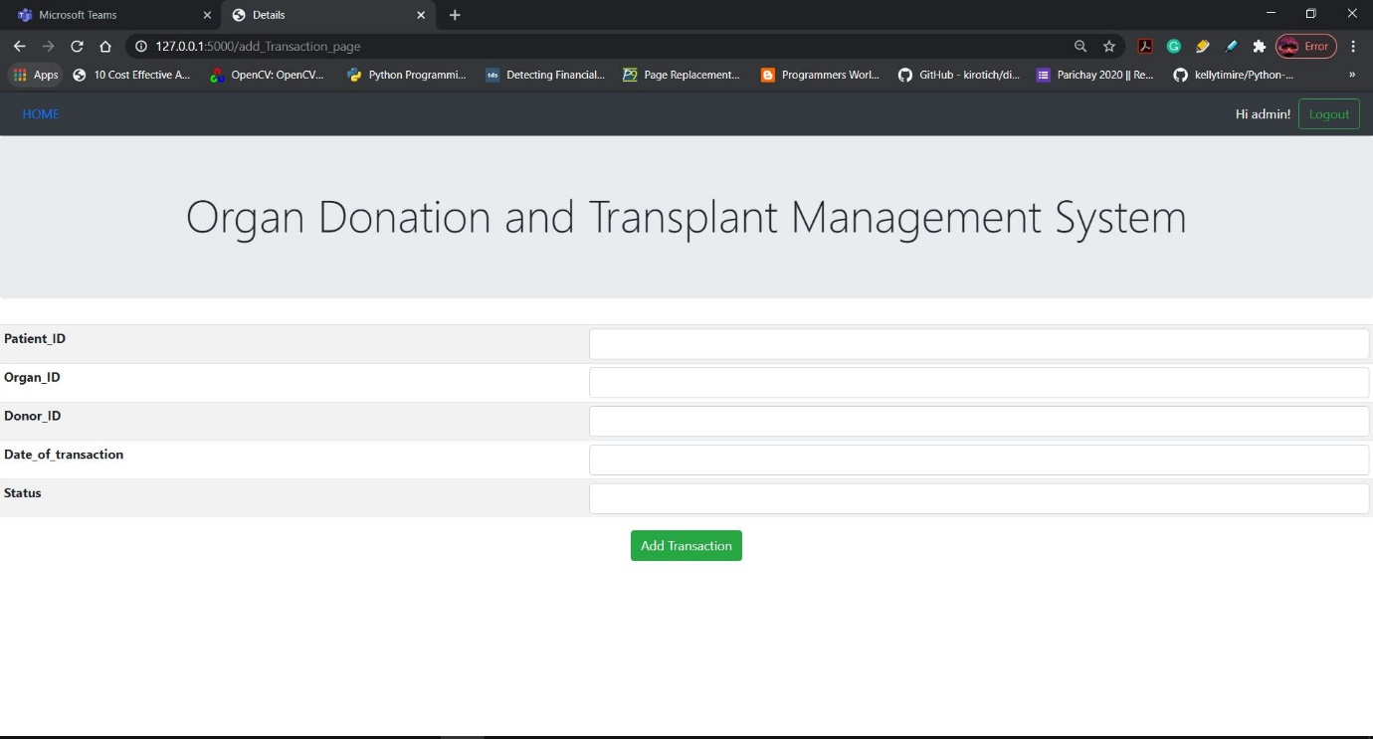

Before adding:

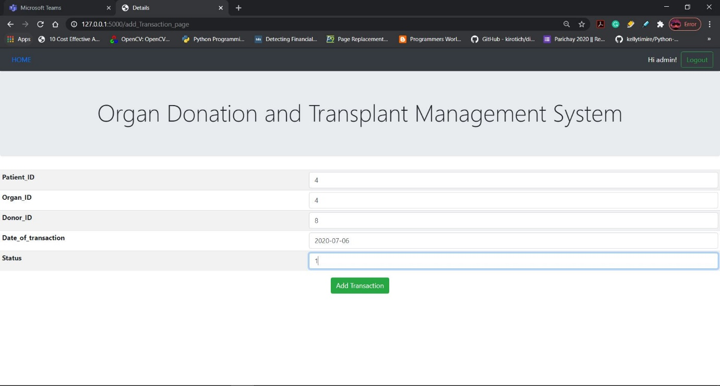

After adding:

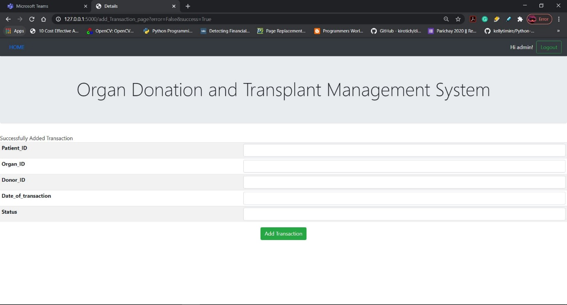

Checking if the added values are inserted in the backend database (MySQL):

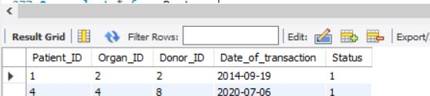

**Update page:**

In this page the admin can update the details in the database.

Update user details:

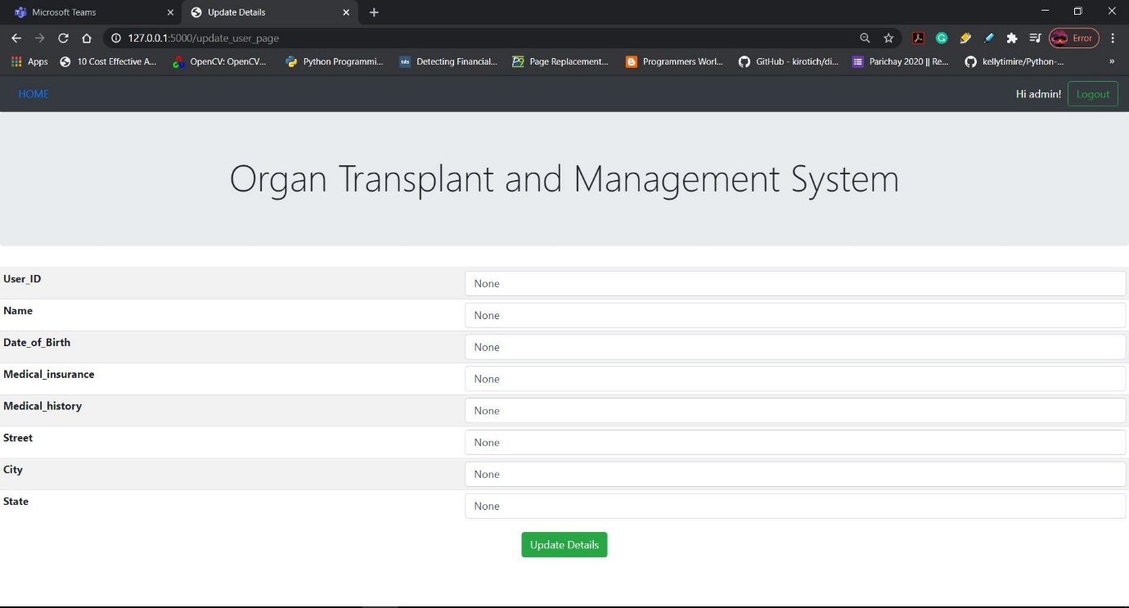

Before updating:

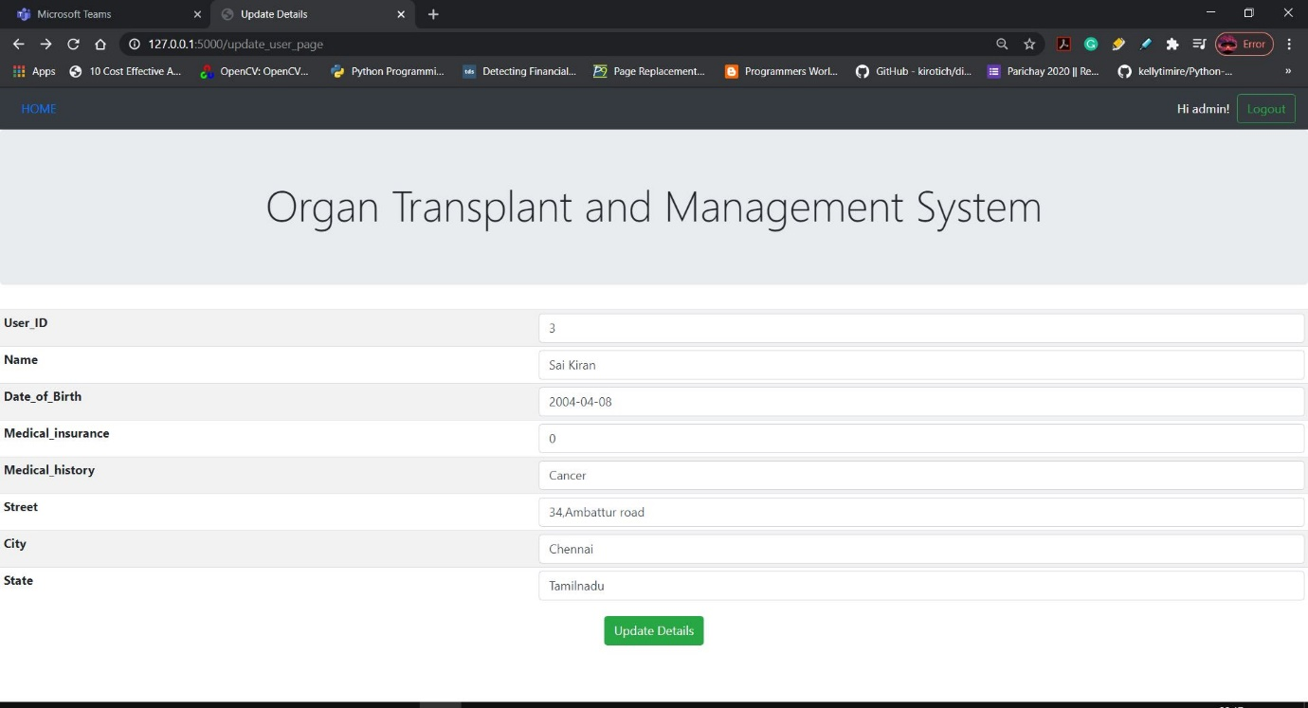

After updating:

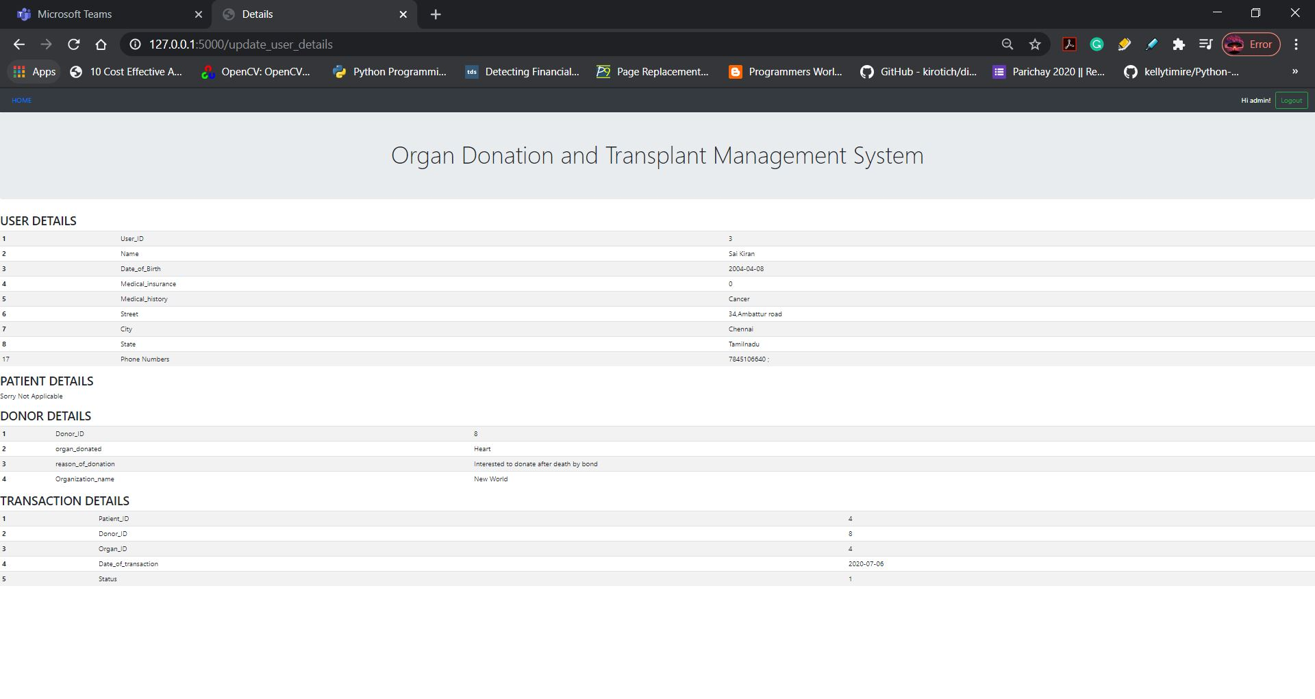

Checking if the updated values are updated in the backend database (MySQL):



Updating doctor details:

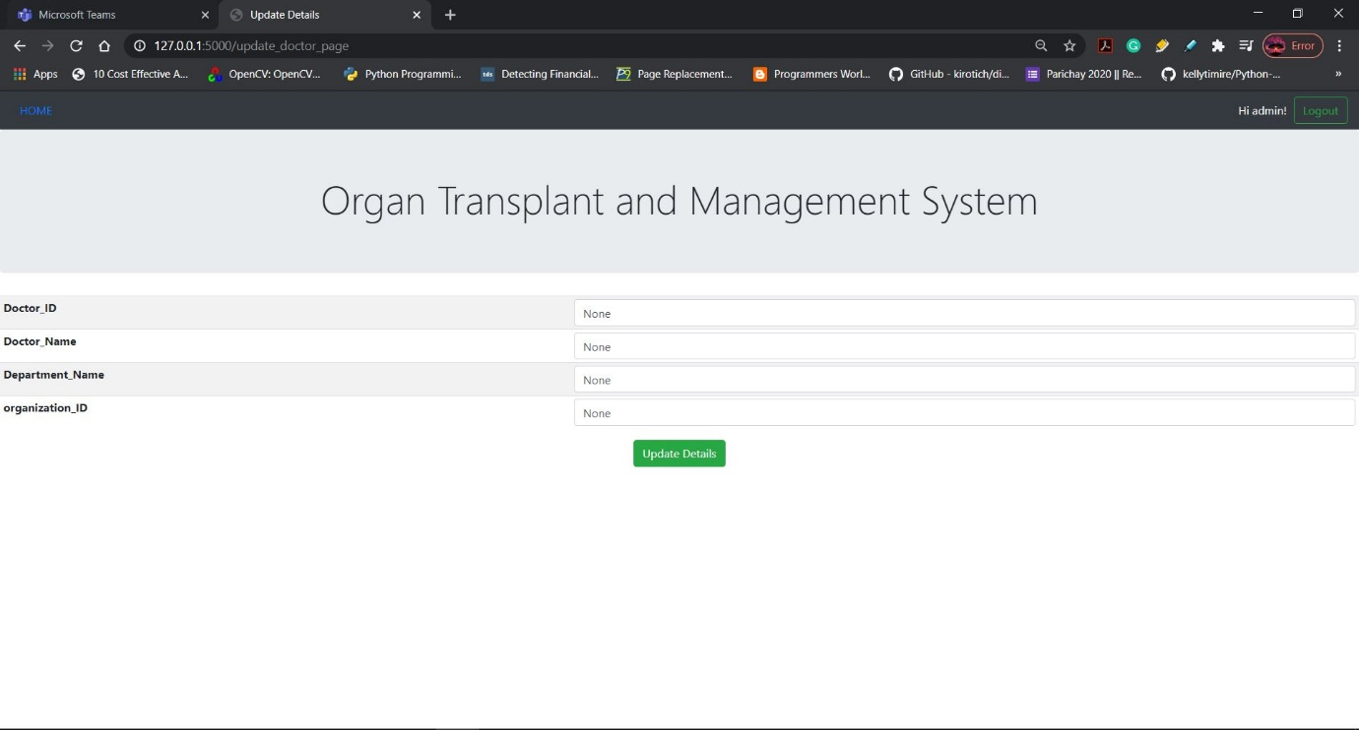

Before updating:

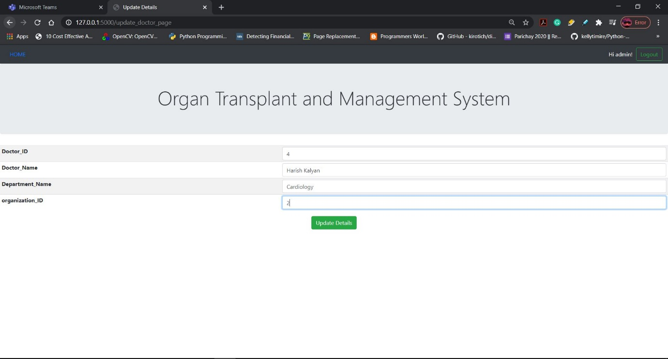

After updating:

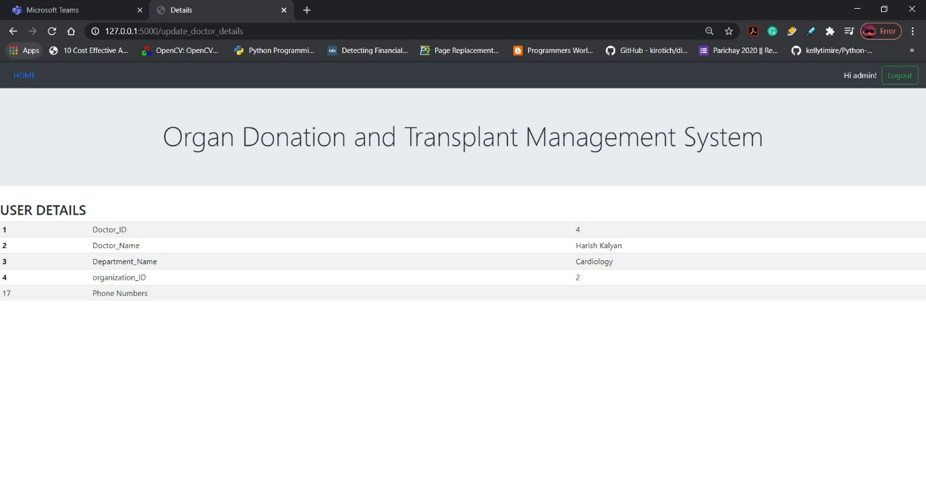

Checking if the updated values are updated in the backend database (MySQL):

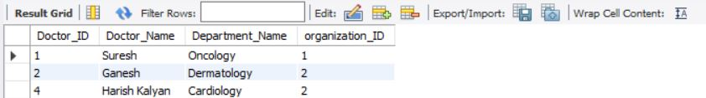

Updating the organization details:

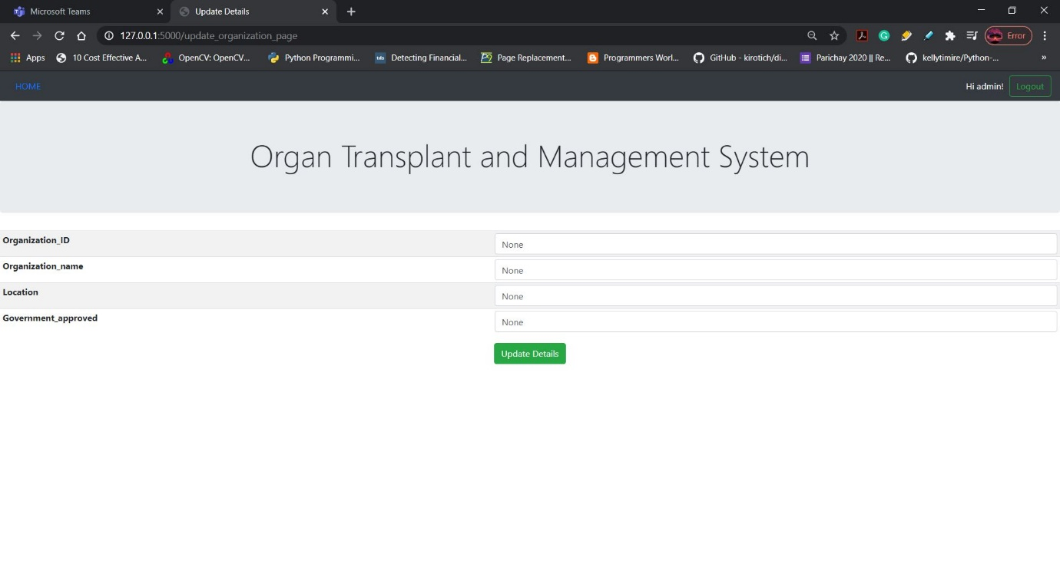

Before updating:

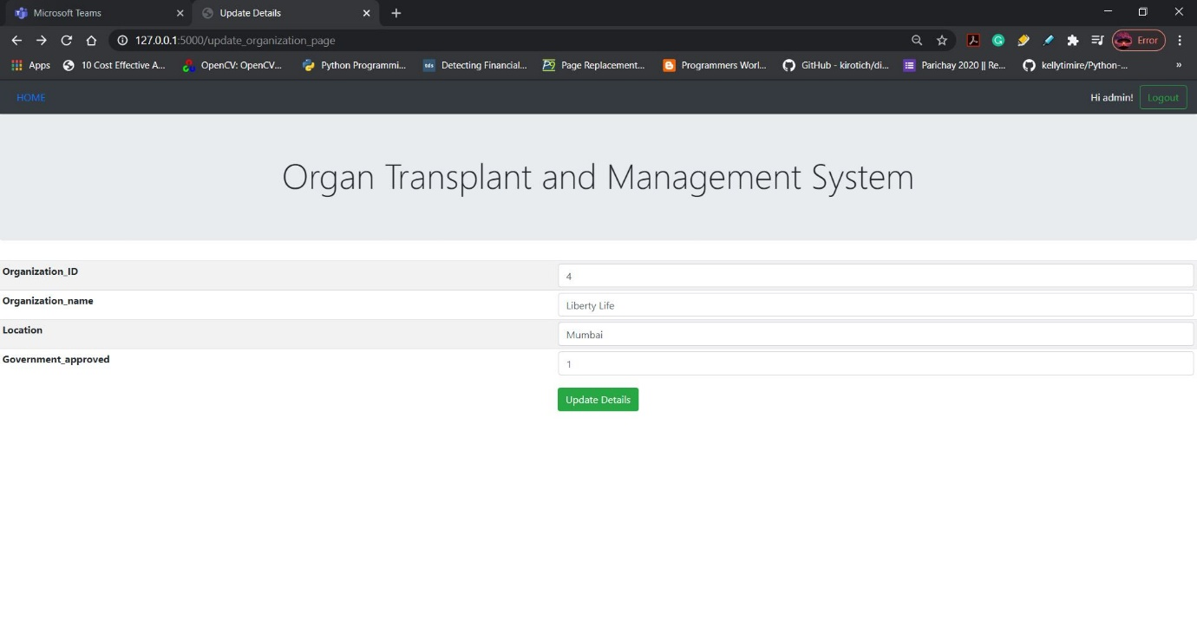

After updating:

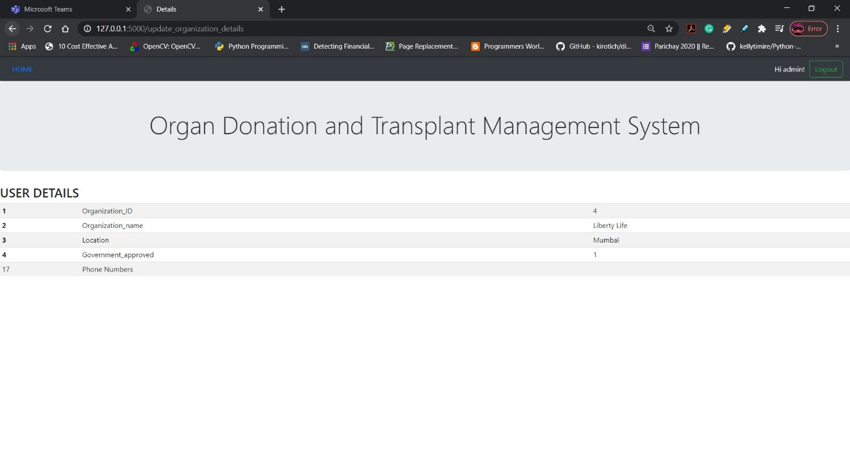

Checking if the updated values are updated in the backend database (MySQL):

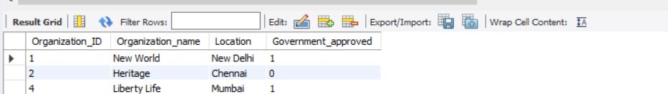

**Delete page:**

Delete user id:

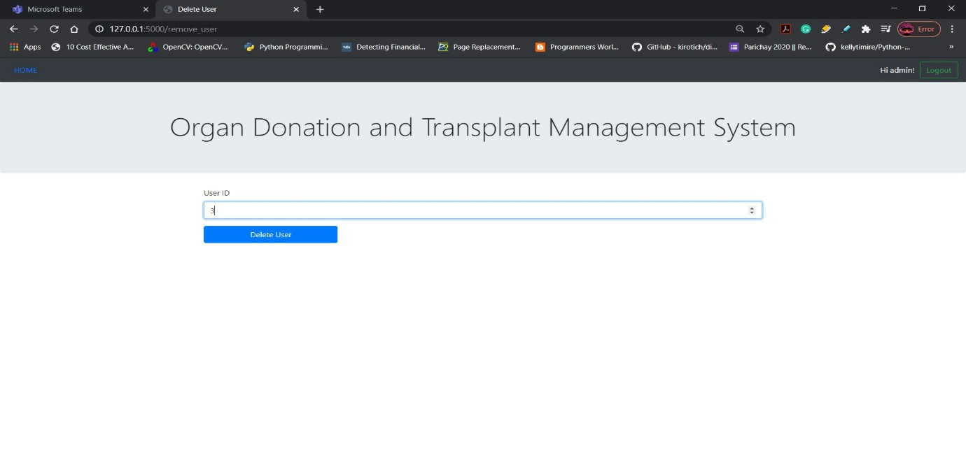

After deleting:

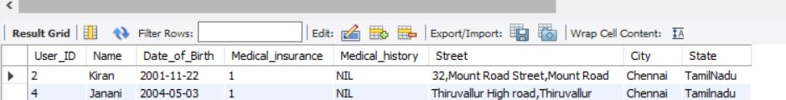

Delete a patient :

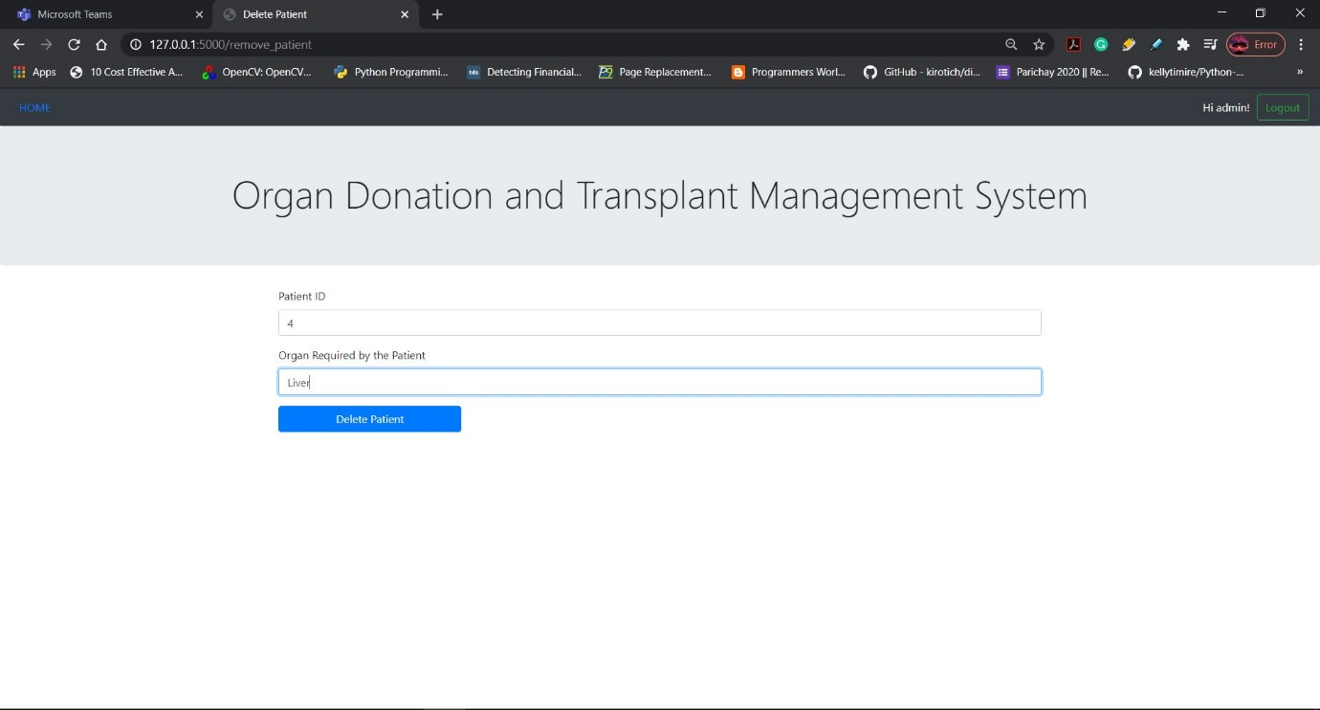

After deleting:

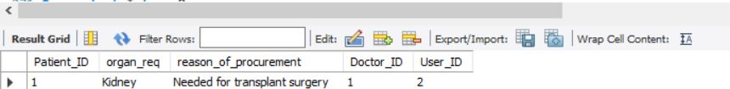

Delete the organization:

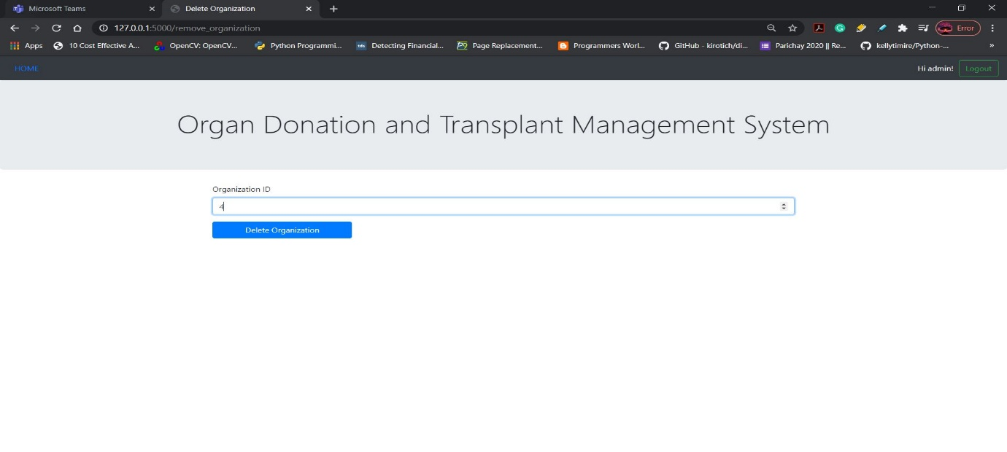

After deleting:

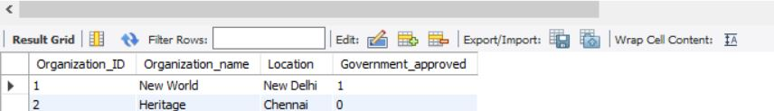

Delete the organization head:

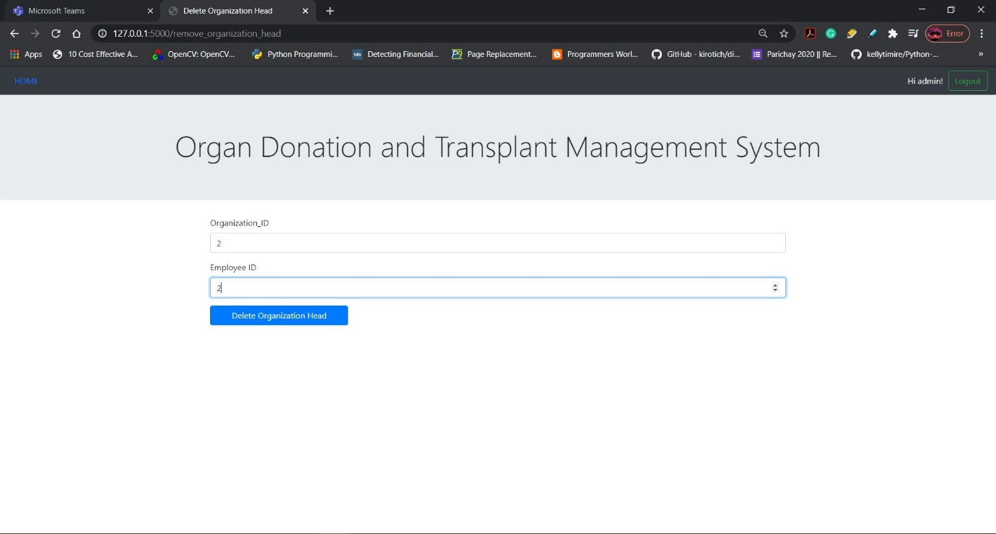

After deleting:

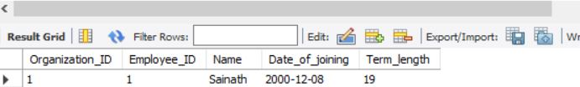

Delete a donor:

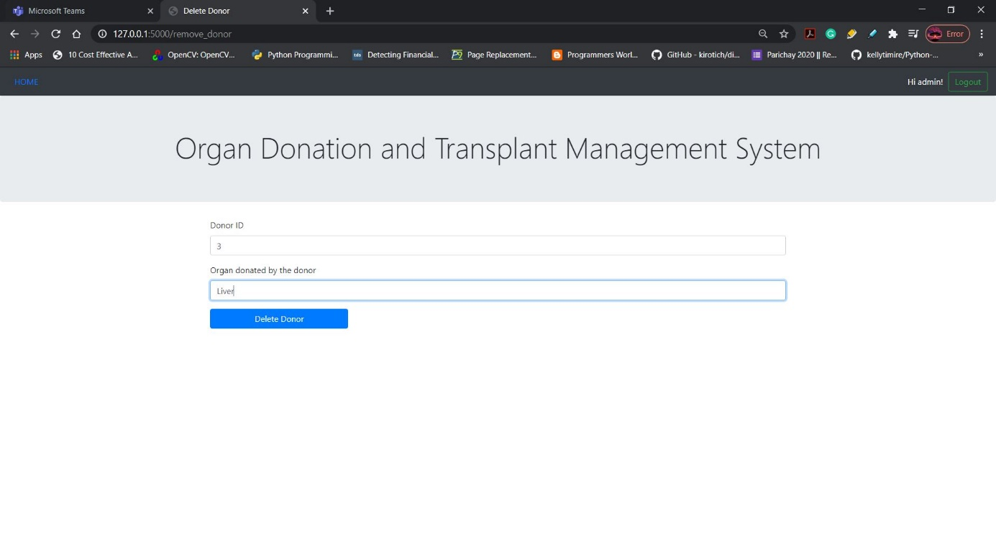

After deleting:

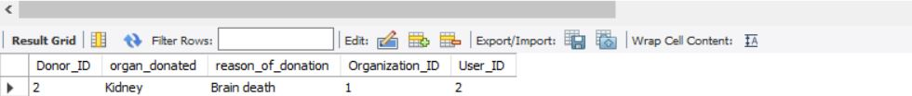

Delete a doctor:

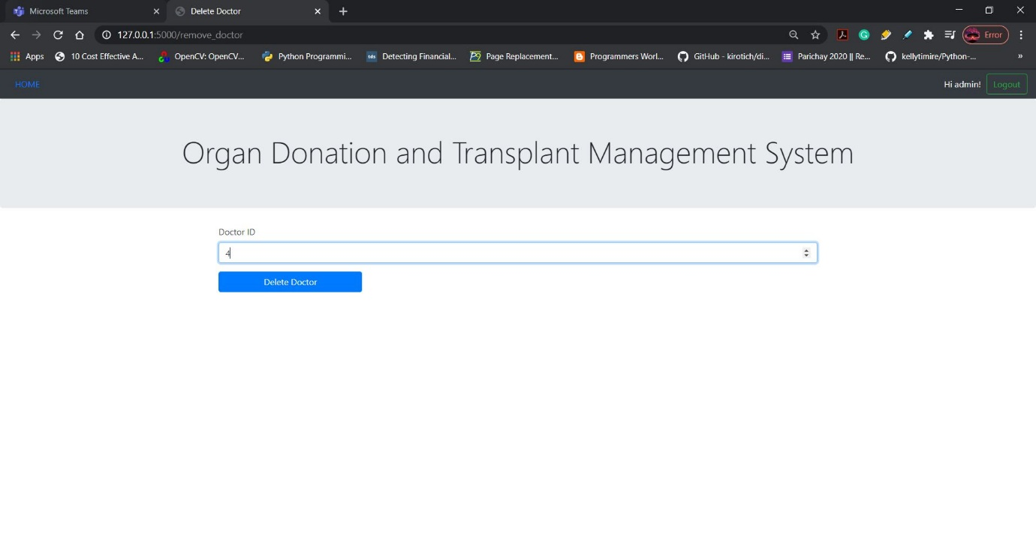

After deleting:

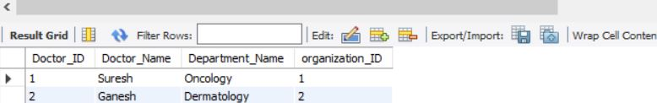

**Statistics:**

In this webpage I used python packages such as matplotlib to plot the bar graph and pie chart to analyse the trends statistically so that it can give an insight in the demand of the requested transaction needed for organ transplantation.

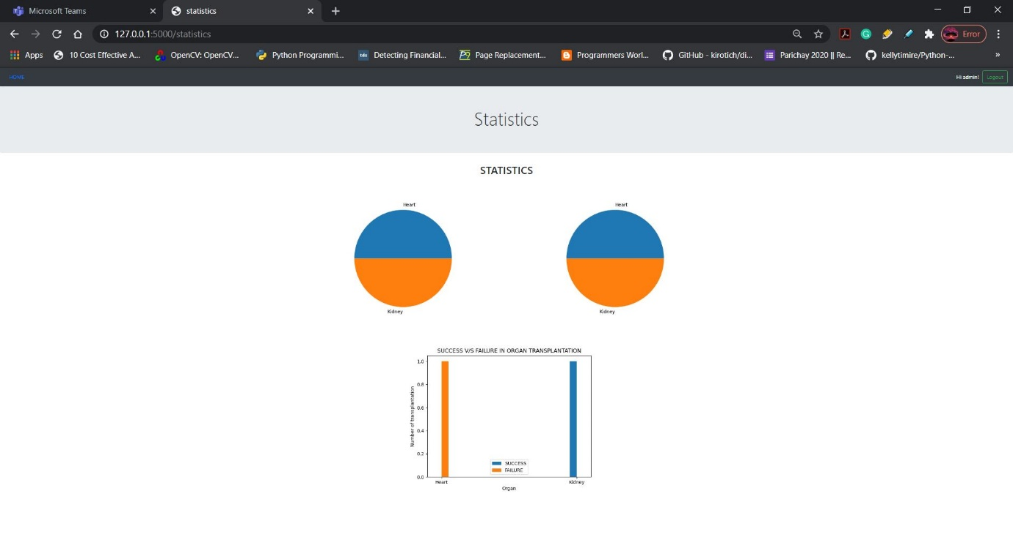

Outputs obtained in the static folder:

Donor information regarding the donation of organs:

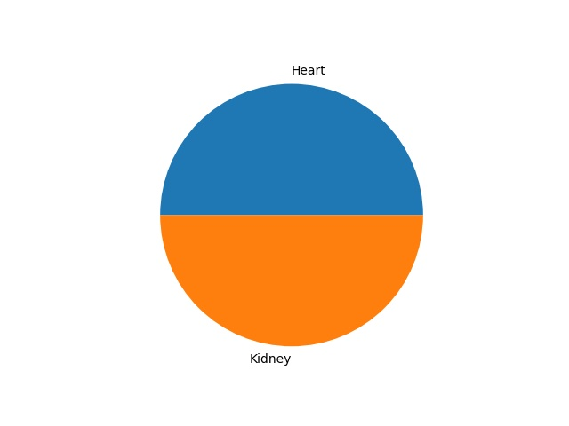

Patient information regarding the transplantation surgery:

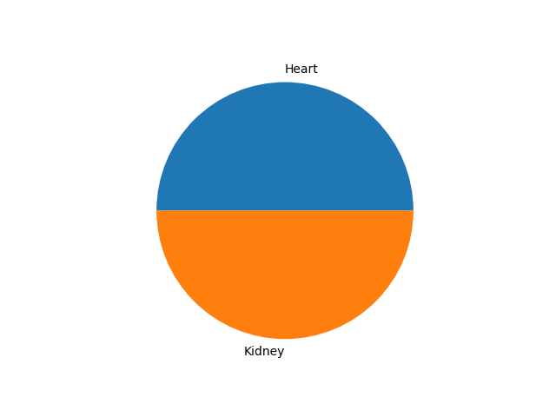

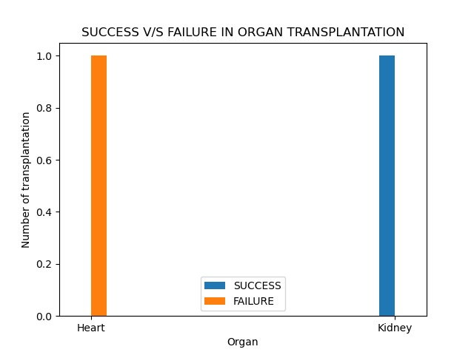

Thus, we have included the functionalities mentioned above and have illustrated the full stack application with the outputs.

**CONCLUSION:**

Hence the outline of the database application has been designed and has been implemented as a full stack web application which helps in management in organ transplantation management.